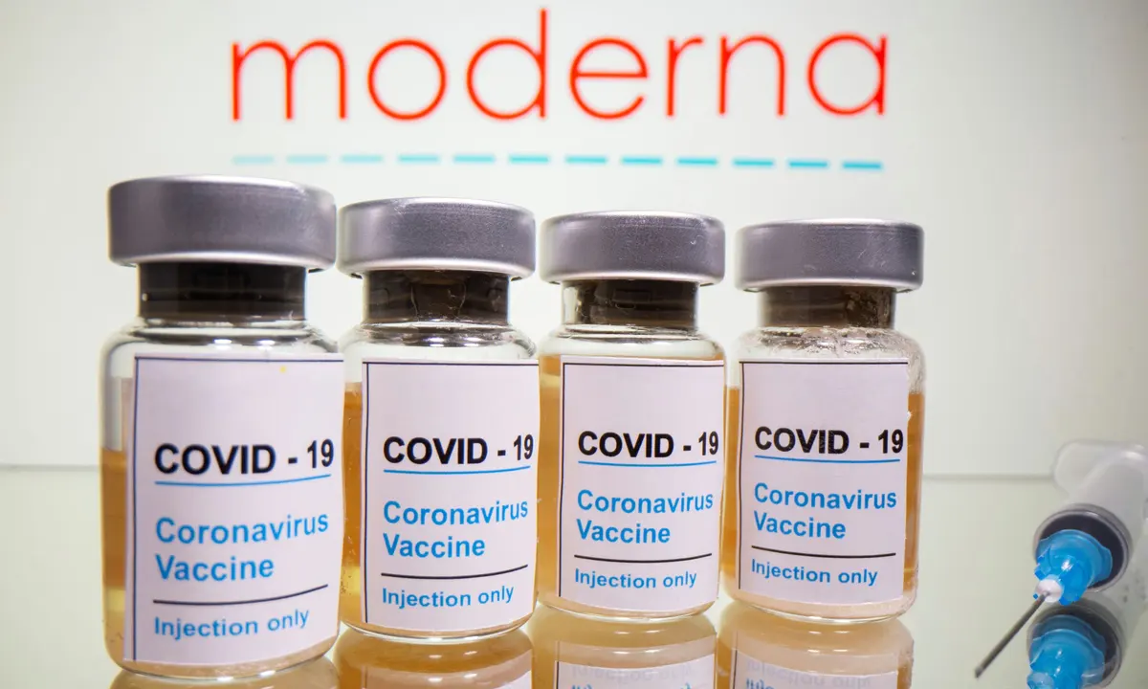

**Moderna Covid-19 Vaccine FAQ**

**As of April 21st 2021, adults under 40 with no underlying health conditions will be offered the Moderna vaccine, the UK’s Joint Committee on Vaccination and Immunisation has said.**

This decision, which is based on a risk-benefit calculation, was informed by the committee’s review of the latest evidence on the AstraZeneca vaccine and the extremely rare cases of blood clots.

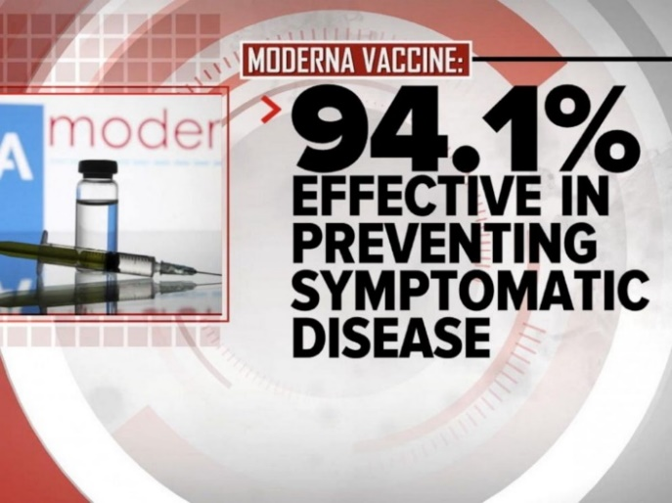Younger people with no underlying conditions are less likely to develop serious covid-19 illness than those with underlying conditions or older people, so their risk-benefit profile is different.

The Rollout of Moderna in prisons will follow the community, with deliveries to prisons from the 31st of May. **We encourage you to take the offer of the Moderna vaccine to protect yourself and others.** Below are some Frequently Asked Questions about the Moderna vaccine.

## Will Moderna affect my fertility?

There **is no evidence at all that any of the vaccines cause fertility problems** in men or women.

**Claims to the**[**contrary on social media are false**](https://www.bbc.co.uk/news/health-56012529/)**.**

In fact, getting coronavirus itself has the potential to affect fertility.

## What if I hate needles?

When you are vaccinated, say you don't like needles. Then look away.

Many people say the **injection is painless** and you hardly notice anything.

### Does the vaccine contain preservatives, antibiotics, or products from human or animal origin?

### No. The Moderna COVID-19 Vaccine **does not contain any preservatives, antibiotics, or products of human or animal origin.** Also, the vial stoppers are not made with natural rubber latex.

What Does the Vaccine do in the Body?

The Moderna COVID‑19 Vaccine **uses mRNA to provide a blueprint for your cells to build your body’s defence against SARS‑CoV‑2**, the virus that causes COVID‑19. The Moderna COVID‑19 Vaccine does not contain SARS‑CoV‑2, or any virus—just the blueprint to help fight against it.

How effective is the Moderna Vaccine?

Based on [evidence from clinical trials](https://www.cdc.gov/mmwr/volumes/69/wr/mm695152e1.htm?s_cid=mm695152e1_w), **the Moderna vaccine was 94.1% effective** at preventing laboratory-confirmed COVID-19 illness in people who received two doses and who had no evidence of being previously infected.