**HMPPS Vaccine Newsletter May 2021 Women’s Edition**

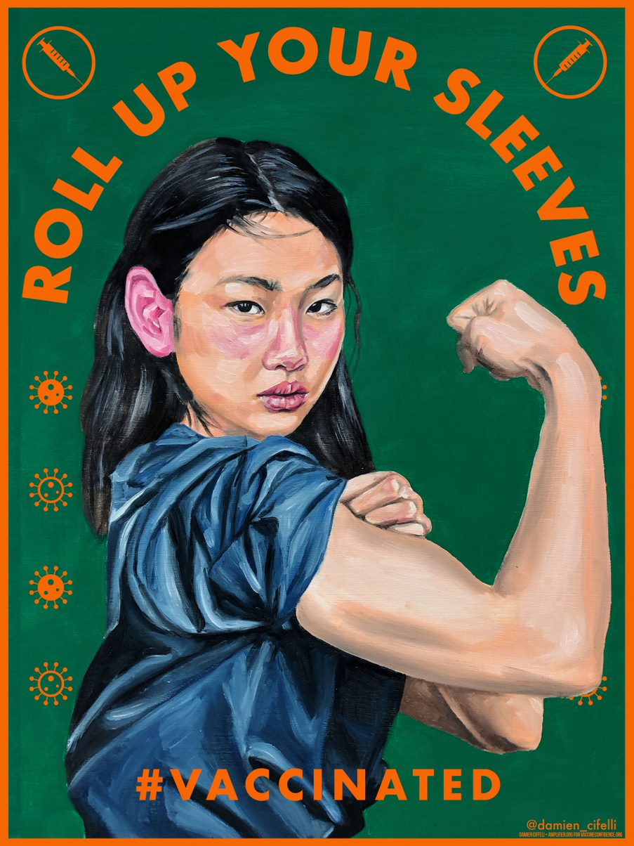

|  |  |
| --- | --- |
| The purpose of the HMPPS Vaccines Newsletter is to answer your questions on the vaccine and keep you informed of any updates or changes to the vaccine rollout in prisons.  In this themed issue of the HMPPS Vaccine Newsletter we are focusing our attention on women and the Covid 19 vaccination process.  We hope this newsletter will provide all the information you need to ease your worries and keep you informed.  All the best,  HMPPS Vaccines Team | **In this Issue**  **Vaccine Hesitancy Amongst Women**  **Blood Clot Fears**  **Pregnancy and Fertility**  **FAQs** |

**Vaccine Hesitancy Amongst Women**

Young women are most likely to display vaccine hesitancy than any other age group. The below table shows that 14% of women between the ages of 16 and 29 reported that they would be hesitant towards having a COVID-19 vaccine, this is higher than any other age group, with males of the same age reporting a 10% hesitancy rate.

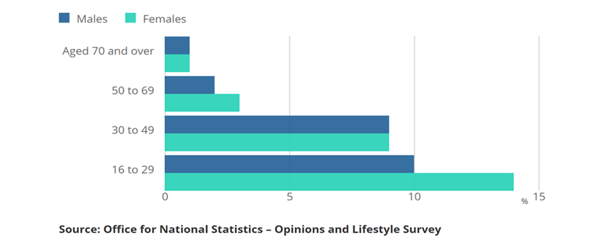

Great Britain, 17 February to 14 March 2021

Myths and fake news surrounding Covid 19 vaccinations have spread fear on social media and have influenced opinions throughout the pandemic. This has especially been the case for women, with conflicting news around fertility, pregnancy and blood clots. **It is important that you speak to your local healthcare provider to gain factual information from reliable sources.** Below we will address some of the myths around the Covid 19 vaccination and help provide current and trusted information.

**Blood Clot Fears**

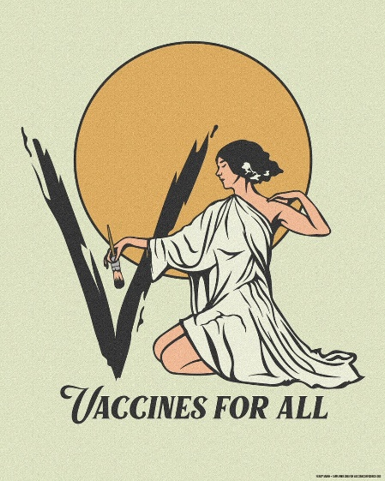You will have seen reports from the media regarding the AstraZeneca vaccine and fears that it could lead to an extremely rare type of blood clot.

A review by the Medicines and Healthcare products Regulatory Agency (MHRA) found that by the end of March 2021, just 79 people had suffered rare blood clots after having the AstraZeneca vaccination in the UK. This was out of 20 million administered doses **- giving a risk of about four in 1,000,000 of developing a blood clot.**

With this **all under 40s are to be offered an alternative to the Oxford-AstraZeneca coronavirus vaccine as a precaution**.

**Fertility/Pregnancy**

***You don’t have to choose between having the vaccine or having a baby, now or in the future.***

On the 16th April 2021, the UK’s Joint Committee on Vaccination and Immunisation (JCVI) published new advice on COVID-19 vaccination in pregnancy. **This is that COVID-19 vaccines should be offered to pregnant women** at the same time as the rest of the population, based on their age and clinical risk group.

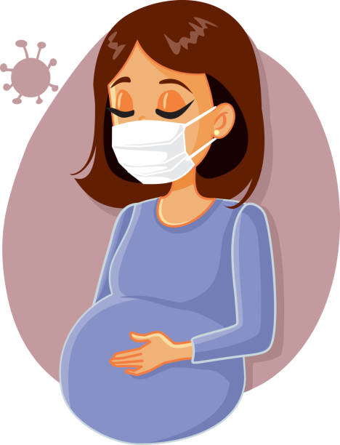The JCVI said **no specific safety concerns related to pregnancy have been identified**, but that real-world evidence from the US has shown around 90 000 pregnant women have been vaccinated—mainly with the Pfizer and Moderna vaccines—without any safety concerns being raised.

**Pfizer and Moderna vaccines are the preferred vaccines for pregnant women** of any age who are coming for their first dose.

Anyone who has already had a vaccination and is offered a second dose whilst pregnant, should have a second dose with the same vaccine unless they had a serious side effect after the first dose.

**FAQs**

## **There is nothing in the vaccine that can affect the fertility of women or men.**

## *Does the COVID vaccine affect fertility?*

**Yes.** There is no reason to postpone having your **COVID-19 vaccine** as it **does not affect your likelihood of having a miscarriage.**

## *Can people who have had recurrent*

*miscarriages have the vaccine?*

## 

There is **no known risk associated with any current COVID-19 vaccines whilst breastfeeding.** The JCVI advises that breastfeeding women may be offered any suitable COVID-19 vaccine.

*Can I breastfeed when I’ve*

*been vaccinated?*

**If you got a first dose of AstraZeneca**, it’s advised you complete with the same vaccine and **attend your second dose appointment as planned.**

*I’m pregnant and I got a first dose*

*of AstraZeneca, what do I do now?*

*Passing on of antibodies from mother to baby*

Early studies have shown that **antibodies from getting the COVID-19 vaccine are passed to the baby during pregnancy** and by breastfeeding (as expected).

*is a good thing. Would you expect the*

*antibodies from the Covid-19 vaccine*

*given to a pregnant woman*

*to pass onto the baby like they do for*

*other vaccines?*

*Why are you recommending Pfizer and Moderna over AstraZeneca?*

There is more real-world safety data on using the Pfizer and Moderna vaccines to vaccinate women who are pregnant. There is no evidence to suggest that other vaccines are unsafe for pregnant women, but more research is needed. All vaccines being used in the UK have undergone robust clinical trials and have met the Medicines and Healthcare products Regulatory Agency (MHRA)’s strict standards of safety, effectiveness and quality.