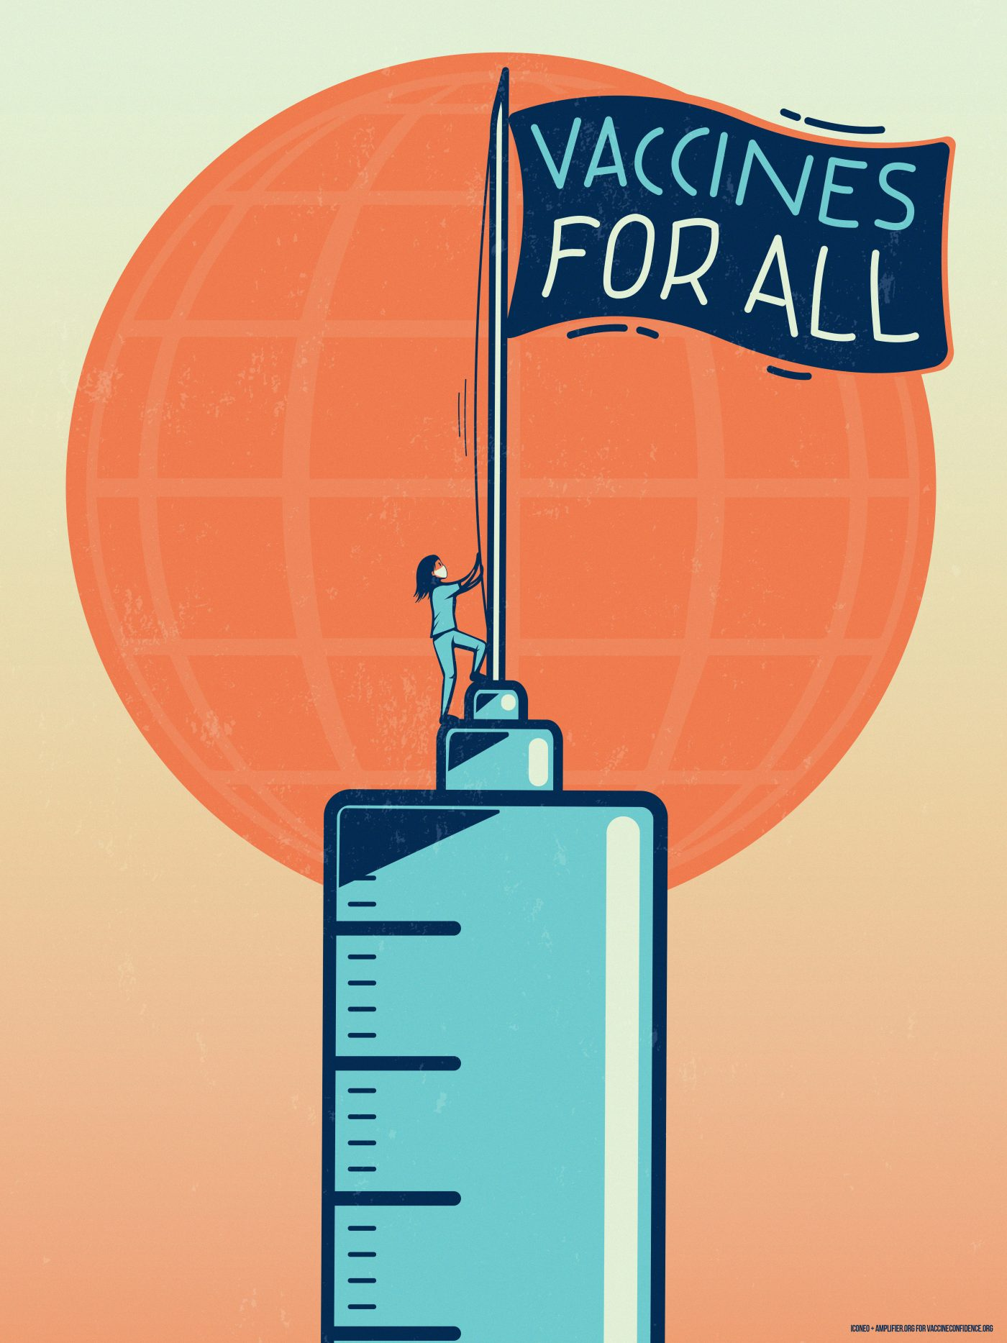
HMPPS Covid-19 Vaccine Newsletter and FAQs
The purpose of the HMPPS Vaccines Newsletter is to answer your questions on the vaccine and keep you informed of any updates or changes to the vaccine rollout in prisons.
In this issue we will attempt to fill in some of the blind spots in our communication by providing information and addressing fears held by those in groups that have previously been overlooked.
We hope this newsletter will provide all the information you need to ease your worries and keep you informed.

In this Issue
- Transgender People

- Substance Misuse

- Sex Workers

- Homelessness

- Refugees, asylum seekers and undocumented migrants

Transgender People
Vaccine hesitancy certainly exists among transgender people and you may not have seen data to address these fears. Trans people, along with other groups, are often underrepresented in medical trials. This lack of representation can create fear and uncertainty and sometimes lead to individuals feeling like ‘guineapigs’.
The LGBT foundation conducted a survey to find out your views and concerns about the COVID-19 vaccines. The answers to your main questions are below.

Will the vaccination interact with my PrEP or PEP medication?
There is no scientific reason to suggest that the COVID-19 vaccines could interact in any way with PrEP. You are encouraged to have a vaccination when it is offered to you and continue to take PrEP in the same way that you normally do, and PEP if you need it.

Will the vaccination interact with my HIV medication such as ART?
There is no scientific reason to suggest that the vaccination could interact in any way with your HIV medication. If you are living with HIV, it’s encouraged that you get a COVID-19 vaccination. There is no evidence that the vaccine will interact with ART, PrEP or PEP.

Will the vaccination interact with my hormone replacement treatment (HRT)?
If you are trans and are on HRT, there is no scientific reason to suggest that the vaccination could interact in any way with your HRT medication. There is also no reason to suggest it could impact on your hormone levels.

Substance Misuse
Substance misuse disorder is considered an underlying medical condition that increases the risk of serious, life-threatening complications from COVID-19. Research suggests that having a substance misuse disorder can make you more likely to get severely ill from COVID-19, as you are more likely to suffer from underlying health conditions such as chronic lung disease, chronic liver disease, or serious heart conditions.
We therefore encourage you to take the vaccine when offered by your local healthcare. Below are some FAQs by those who suffer with substance misuse problems.
Do people with substance misuse disorders face challenges accessing COVID-19 vaccines?
While data is still being collected on how well COVID-19 vaccines are reaching people with substance misuse disorders, to ensure timely preventative care to this population government agencies and non-government organisations have developed programmes to increase outreach to people with substance misuse disorders or in recovery.

Can people who use substances or who have substance misuse disorders receive a COVID-19 vaccine?
Yes. The Centres for Disease Control and Prevention encourage people with underlying medical conditions, which include substance misuse disorders, to be fully vaccinated against COVID-19 as soon as a vaccine becomes available to them.

Can people taking medications for opioid use disorder, such as methadone or buprenorphine, receive a COVID-19 vaccine?
Yes. No safety issues have been reported linking medications for opioid use disorder to adverse reactions to any of the COVID-19 vaccines. Experts recommend people taking medications for opioid use disorder receive a COVID-19 vaccine and continue their medications as directed by a healthcare professional.

Sex Workers
Sex workers are at increased risk of contracting COVID-19. Without access to financial aid, many sex workers are forced to continue engaging in sex work, exposing themselves to the COVID-19 virus in order to earn money to buy food or pay rent.
Increased prevalence of underlying health conditions among sex workers could increase their risk of severe illness from COVID-19. Local initiatives are now in place across various regions that provide an outreach-based support, that benefits socially excluded groups. For example, Manchester Action on Street Health (MASH) has partnered with the NHS to offer the Covid-19 vaccine to women in Manchester who may otherwise struggle to access it, including those experiencing homelessness. It offers expert support from its drop-in centre, on-foot team and drop-in van which travels around Manchester every weeknight. So far, 31 women who otherwise faced barriers to accessing the vaccine have received the first of two doses from the MASH clinic and van thanks to MASH and key partners.
Please Speak to your local healthcare provider in prison to find out more about your own local initiatives and take advantage of the vaccination programmes in prison to keep yourself and others safe.
Homelessness
People experiencing homelessness are more likely to suffer from underlying conditions which leave them vulnerable to Covid-19; as they often do not have access to somewhere safe to isolate, it is even more essential they take the opportunity to get vaccinated.
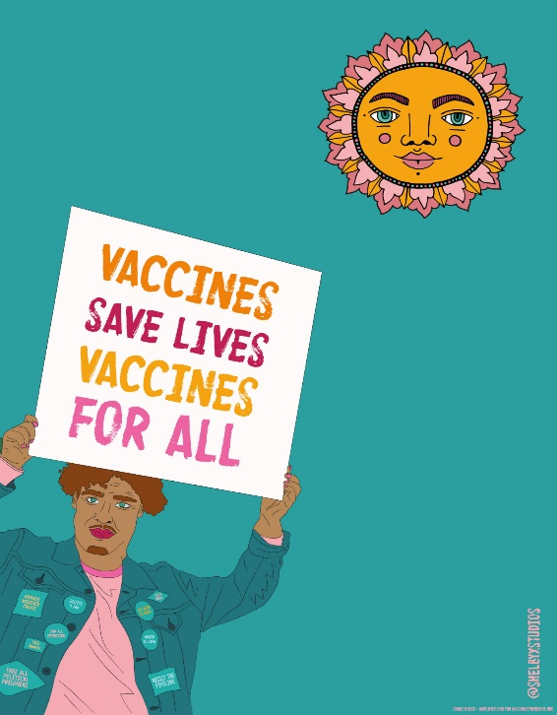
Due to this increased risk, people experiencing homelessness in Wales and England are already eligible for a Covid-19 jab as part of the sixth priority group alongside people aged between 16 and 65 with underlying health conditions.
Glass Door, a leading London homelessness charity, stated that homeless people are at greater risk of misinformation about the safety of the vaccines. The charity’s senior communications manager Melissa Kerschen said, ‘More needs to be done to counter conspiracy theories and misinformation and to build trust in our government and healthcare.’
It is important you speak to your local healthcare provider for factual and reliable information; below we have provided some FAQs specifically related to those experiencing homelessness.
Is there help available if people cannot physically access the vaccine (e.g., if they need money for travel, aren’t physically able to travel)?
This will vary depending on where you are located and the different support services and systems in your area. We recommend that you contact support staff from your accommodation, outreach team or local support service and let them know your situation.

Is there a Vaccine that is preferred for those people experience homelessness?
No. There is no preferred vaccine for people experiencing homelessness. There are currently three different COVID-19 vaccines that have been authorised for use in the U.K. None of which have been found to provide any negative impacts on people experiencing homelessness.

Refugees, Asylum Seekers and Undocumented Migrants
Migrants are considered a high-risk group and vulnerable to the catching and spreading of Covid 19. Many migrants live in shared accommodation, where it is difficult to practice social distancing and isolation. There have been several well publicised outbreaks in government provided asylum seeker accommodation. Many refugees, asylum seekers and undocumented migrants are from Black, Asian or minority ethnic (BAME) groups. Evidence

shows people from BAME groups are at greater risk of critical illness and death from COVID-19. We therefore encourage you to take the offer of a vaccine at the earliest opportunity. Below are a series of Frequently Asked Questions, specific to refugees, asylum seekers and undocumented migrants.
What happens if I give a doctor my details, won’t I be deported?
The UK government has announced that undocumented migrants can register with their doctors for a vaccine against COVID-19 without fear of being ejected by the Home Office.

Do I need and NHS number to get vaccinated?
Individuals do not require an NHS number or GP registration to receive the COVID-19 vaccination and should not be denied vaccination on this basis. Individuals who do not have an NHS number or are not registered with a GP are still entitled to free COVID-19 vaccinations.

Will I be charged for the vaccine because I’m not a British citizen?
Overseas visitors to England, including anyone living in the UK without permission, will not be charged for:
Testing for COVID-19 (even if the test shows they do not have COVID-19).
Treatment for COVID-19, including for a related problem called multisystem inflammatory syndrome that affects some children.
Vaccination against COVID-19.

