**HMPPS Vaccines Newsletter**

**April 2021**

|  |  |
| --- | --- |
| Welcome to the first update from the HMPPS Vaccines Team.  The purpose of the HMPPS Vaccines Newsletter is to answer your questions on the vaccine and keep you informed of any updates or changes to the vaccine rollout in prisons.  We hope this newsletter will provide all the information you need to ease your worries and keep you informed.  All the best,  HMPPS Vaccines Team | **In this Issue**   * Vaccine Progress Snapshot * Addressing Vaccine Uptake Inequalities * Addressing Blood Clot Fears * Frequently Asked Questions and Myth Busters |

**Vaccines Progress Snapshot**

Public Health England have so far gauged that very high levels of vaccine coverage in **prisoners (90% or more)** arerequired, to reduce transmission of the virus and prevent prison outbreaks. This is why it is so important tohave your vaccination**.**

As of 25th April 2021, NHS have reported that **85%** of those who are currently eligible for the vaccine have received their first dose. This is about **33%** of the overall prisoner population. We are making good progress but there is still a way to go!

**78,000**

The illustration to the right shows the amount of prisoners vaccinated per the population.

**Addressing Vaccine Uptake Inequalities**

**Vaccination status and attitudes vary by characteristics such as age, ethnicity, and health conditions.**

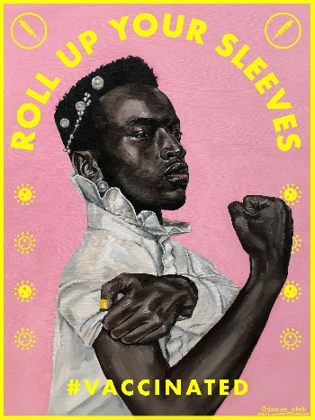According to the latest figures from the Office for National Statistics, actual vaccination rates for people in England identifying as having black African heritage stand at **58.8%,** the lowest among all ethnic minority groups, and **68.7%** within the black Caribbean community.

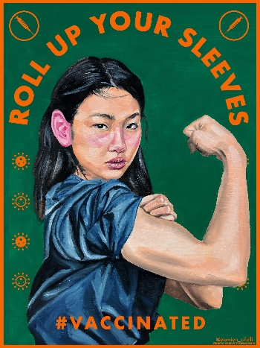

Fake news about the vaccine, particularly in the South Asian community, has also led to concerns about uptake, with Bangladeshi and Pakistani uptake rates at **72.7%** and **74%** respectively.

By contrast, for people identifying as white British, there is an estimated take-up rate of **91.3%.**

We are seeing these trends amongst our population too, which you can see in the graph below.

**There may be several reasons why you are hesitant to accept the vaccine – we want to take the time to listen to you and, where possible, ease your fears or concerns.**

**Sir Lenny Henry has written an open letter urging black Britons to take the Covid-19 vaccine.**

The comedian and actor said people should "trust the facts" and guard against misinformation.

The letter has been signed by high-profile figures such as actor Chiwetel Ejiofor, YouTube star KSI and actress Thandie Newton.

Asked why there was caution in the black community about having the vaccine, Sir Lenny blamed an "element of mistrust" in the system.

He said people felt "certain institutions and authorities haven't particularly done right by the black community in the past" so asked "why should they do something for us now? Why are they doing us all a big favour?"

Sir Lenny's letter recognises these historic "legitimate worries and concerns", but it adds: "We're asking you to trust the facts about the vaccine from our own professors, doctors, scientists involved in the vaccine's development, GPs, not just in the UK but across the world, including the Caribbean and Africa."

**Celebrities including comedians Romesh Ranganathan and Meera Syal and cricketer Moeen Ali have made a video urging people to get the Covid vaccine.**

The video was co-ordinated by Citizen Khan creator Adil Ray, who said he wanted to dispel vaccination myths for those from ethnic minority communities.

Mayor of London Sadiq Khan and former Conservative Party Chairman Baroness Warsi are among the others taking part.

Ray said: "For the British Asian and black communities, at the very beginning of the pandemic we were told they were perhaps the most vulnerable, that there was a disproportionate number of cases and even deaths. We felt that we've got to try and take the lead a little bit here and dispel some of these myths."

He added: "This was recorded entirely independently from the government - the only thing we did do was we went to the NHS website for the correct medical guidance."

**These videos are now showing on Wayout TV and are available for your prisons to download and show on Reception and Healthcare TVs.**

For those who may be hesitant on religious grounds, we have worked with HMPPS Chaplaincy to answer questions on the vaccine for each faith. Here are some key facts about the COVID-19 vaccines if you are hesitant on religious grounds:

* **They do not contain animal products**
* **They do not contain blood products**
* **They are Halal and Shariah-compliant**
* **Having a vaccine does not break a fast**
* **Tests were not carried out on aborted foetuses** (tests were carried out on ‘cell lines’ grown from two abortions carried out over 40 years ago)

**Please speak to a member of your chaplaincy team or your key worker for more information relating to your faith.**

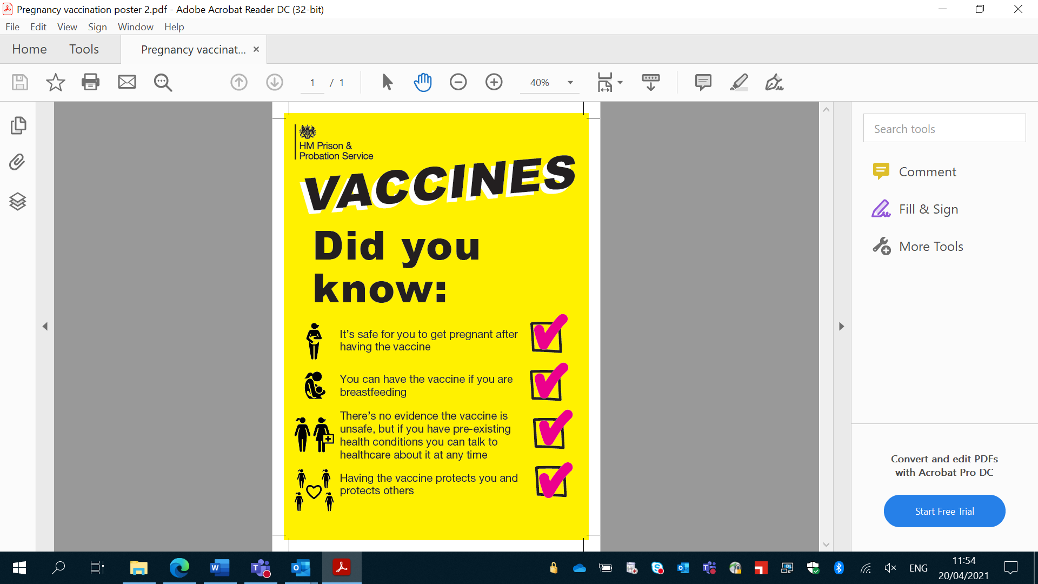For those who may be hesitant for fertility reasons:

* **The vaccine does not affect your fertility but catching COVID-19 might.** Initial studies have shown that COVID-19 may compromise sperm count and quality in men.
* A number of women who were vaccinated in the COVID-19 vaccination trials have since become pregnant. **There is no evidence to suggest that the COVID-19 vaccine causes infertility.**
* **There is no evidence that it is unsafe for pregnant women to have the vaccine**, but scientists want to get more evidence before it is routinely offered to those who are pregnant.
* **The vaccine cannot give you or your baby COVID-19.**

You do not have to have the vaccination, but it will help to protect you from potentially getting very unwell if you get coronavirus and may even save your life.

**If you decide you do not want the vaccination now, you can change your mind later.**

**Addressing Blood Clot Fears**

You will have seen reports from the media regarding the AstraZeneca vaccine and fears that it could lead to an extremely rare and unlikely to occur blood clot.

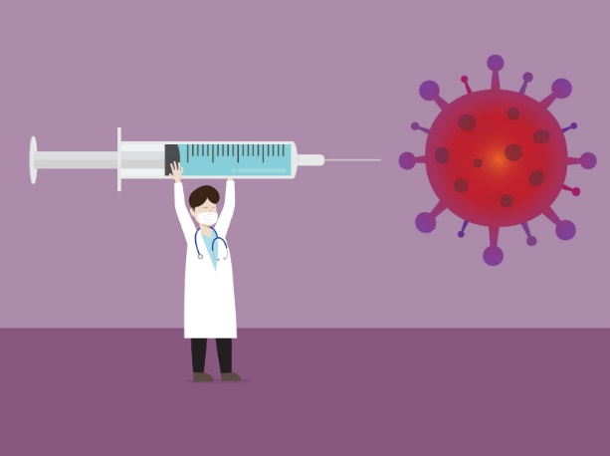By 31st March 20.2 million doses of the COVID-19 Vaccine AstraZeneca had been given in the UK, meaning the overall risk of these blood clots is approximately **4 people in a million** who receive the vaccine.

As of 7th April 2021, the UK regulator MHRA’s (Medicines and Healthcare products Regulatory Agency) advice remains that **the benefits of the vaccines against COVID-19 continue to outweigh any risks** and that the public should continue to get their vaccine when invited to do so, unless specifically advised otherwise.

Pregnancy increases the risk of developing a blood clot; therefore, women should discuss with healthcare whether the benefits of having the vaccine outweigh the risks for them.

**Anyone who did not have these side effects after first vaccination should come forward for their second dose when invited.**

**Joint Committee for Vaccination and Immunisation (JCVI) issued a statement containing the following points:**

* The benefits of having the AstraZeneca COVID-19 vaccine far outweigh the risk of developing a blood clot for; **people who are 30 years of age or older or anyone of any age who has an underlying health condition.**
* For those aged 18-29 without an underlying health condition, it is better to be offered an alternative COVID-19 vaccine, like Moderna or Pfizer.
* **To date there are no reports of blood clots following the second dose of the AstraZeneca vaccine.** If you have already received your first dose of the vaccine, then you should have your second dose of AstraZeneca too, as this second dose is important for longer lasting protection against COVID-19.



In future issues of the HMPPS Vaccines newsletter, we will update you on NHS’ response to the above recommendation, for those under 30 with no underlying health conditions to receive a different vaccine to AstraZeneca.

**Frequently Asked Questions and Myth Busters**

Below are a series of frequently asked questions or myths relating to the COVID-19 vaccine. Sources are the World Health Organisation, NHS and British Islamic Medical Association.

**Your concerns?**

*‘No one knows the long-term effects, and no one can convince me it’s safe’*

*‘Vaccines like this take years and years to develop, it can’t be done in a few months, it will go wrong or kill someone’*

*‘No, I don’t trust the vaccine or who made it, we don’t have vaccines and don’t believe in them’*

**How will we know if COVID vaccines are safe?**

Ensuring the safety and quality of vaccines is one of the World Health Organisation’s (WHO) highest priorities. WHO works closely with national authorities to ensure that global norms and standards are developed and implemented to assess the quality, safety, and efficacy of vaccines.

**The process to develop COVID vaccines is** **fast-tracked while maintaining the highest standards**; pauses between steps have been shortened, removed, or are being carried out at the same time to speed up the process, wherever that is safe to do.

Like all vaccines, **COVID-19 vaccines are going through a strict, multi-stage testing process**, including large trials that involve tens of thousands of people. These trials, which include some groups at high risk for COVID-19, are **designed to identify any common side effects or other safety concerns.**

**An external panel of experts analyse the results from clinical trials** and then recommend whether and how the vaccines should be used.

Once a clinical trial shows that a COVID-19 vaccine is safe and effective, a **series of independent reviews to test safety and effectiveness** are required before the vaccine can be given approval to be mass produced.

After a COVID-19 vaccine is introduced, WHO and health officials in each country **monitor the vaccine for any safety concerns on an ongoing basis.**

**What are the benefits of getting vaccinated?**

The COVID-19 vaccines produce protection against the disease, developing an immune response to the SARS-Cov-2 virus. This means there is a **reduced risk of developing the illness and its consequences**. This immunity helps you fight the virus if exposed. Getting vaccinated may also **protect people around you**, because if you are protected from getting infected and from disease, you are **less likely to infect someone else**. This is particularly important to protect people at increased risk for severe illness from COVID-19, such as healthcare providers, older or elderly adults, and people with other medical conditions.

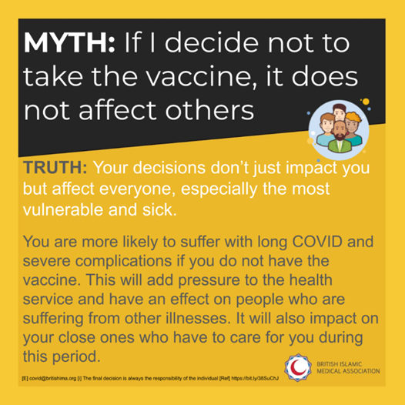Myth: COVID is no more dangerous than flu.
Truth: COVID kills up to 10 times more than flu. Research at John Hopkins University indicates that COVID is more fatal, impacts more people for longer (up to 30 days) and spreads faster than flu. Claiming that COVID is no more dangerous than the flu trivialises the destruction this virus has brought to so many lives.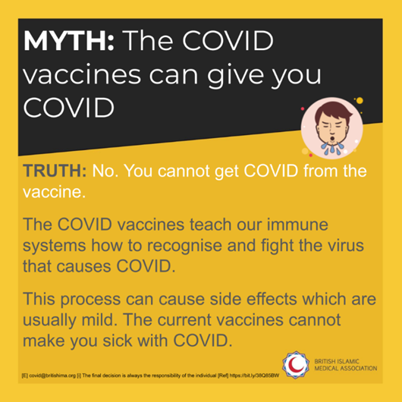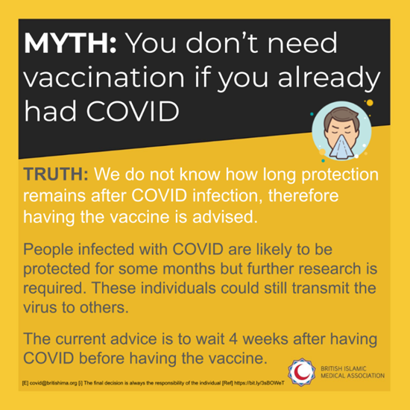

Myth: I'm young and low risk so the COVID vaccine isn't for me.
Truth: In the last few weeks, adults ages 18-64 have accounted for 40% of daily COVID admissions to hospital. Although the risk is higher with age an comorbidities, COVID can affect people of any age. COVID can cause long term complications and death. The vaccine is designed to reduce the risk of these disastrous consequences.Myth: Vaccines contain pork or other animal derivatives.
Truth: There are no pork or other animal ingredients in the current available vaccines. Even in circumstances where there are impermissible ingredients in a vaccine, many renowned scholars have  concluded that they are permissible if no other alternative options and the data suggests that the vaccine is of benefit.Myth: Vaccines contain alcohol and therefore are impermissible.
Truth: The Oxford AstraZeneca vaccine contains ethanol at any amount that is less than what is found in natural foods or bread. Many scholars have deemed the Oxford AZ vaccine to be permissible as the amount of ethanol is negligible The religious permissibility of any product is for scholars to decide, so please refer to those you trust.Myth: Vaccines are being used to chip and track the population.
Truth: Vaccines do not contain any chips or trackers for surveillance. Independent authorities across the world from countries that compete with each other have approved the vaccine and not found any microchips. The truth is that there are far easier ways to track the population (mobile phones/bank cards etc.) than biological trackers.

We hope this Newsletter provided some clarity and useful information around the COVID-19 vaccine.

**Remember, Covid does not discriminate and we are all in this together.**

Please seek advice from Prison Staff and Healthcare for further support and information.