**HMPPS Vaccine Newsletter May 2021**

The purpose of the HMPPS Vaccines Newsletter is to answer your questions on the vaccine and keep you informed of any updates or changes to the vaccine rollout in prisons.

In this themed issue of the HMPPS Vaccine Newsletter we are focusing our attention on those aged 18-29 years old and the Covid 19 vaccination process.

We hope this newsletter will provide all the information you need to ease your worries and keep you informed.

All the best,

HMPPS Vaccines Team

**In this Issue**

* Vaccine Hesitancy Amongst 18-29 Year Olds
* Long Covid
* Protecting Others

**Vaccine Hesitancy Amongst 18-29 Year Olds**

Figures from the Office for National Statistics (ONS) **showed adults aged 16-29 are the most likely to report hesitancy**. Based on Adults in Great Britain around 1 in 8 (13%) aged 16 to 29 reported vaccine hesitancy, **the highest of all age groups**.

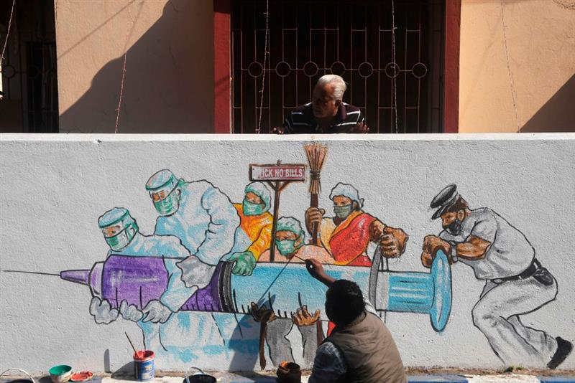Safety concerns surrounding the vaccine have led to an increase in vaccine hesitancy amongst young people, with many of these concerns coming from fake news, which has been seen a lot in social media.

The Centre for Countering Digital Hate (CCDH) released a report, stating: ‘Anti-vaccine activists on Facebook, YouTube, Instagram and Twitter reach more than 59 million followers, making these the largest and most important social-media platforms for anti-vaxxers." These platforms have been rife with inconsistent messaging and fake news. **It is important to gain information through trusted sources or by speaking to your local healthcare provider.**’

Below we have provided Myth Busters addressing some of young people’s vaccine concerns:

* I have heard that the vaccine was rushed and not properly tested, is this true?

**FALSE: The development of the COVID-19 vaccines did not cut corners on testing for**[**safety**](https://www.hopkinsmedicine.org/health/conditions-and-diseases/coronavirus/is-the-covid19-vaccine-safe)**and efficacy.** The vaccines were made using processes that have been developed and tested over many years, and which are designed to make — and thoroughly test — vaccines quickly in case of an infectious disease pandemic like we are seeing with COVID-19.

* Is it safe for me to get a COVID-19 vaccine if I would like to have a baby one day?



**Yes.** If you are trying to become pregnant now or want to get pregnant in the future, you may get a COVID-19 vaccine when one is available to you. **There is currently no evidence that COVID-19 vaccination causes any problems with pregnancy**, including the development of the placenta. In addition, **there is no evidence that fertility problems are a side effect of any vaccine, for men or women, including COVID-19 vaccines**. Like all vaccines, scientists are studying COVID-19 vaccines carefully for side effects now and will continue to study them for many years.

**WARNING: Studies conducted in March 2021 have shown that Covid-19 can potentially reduce testicular function and fertility in males. The vaccine will not affect your fertility but will help protect it from being impacted by Covid-19.**

* 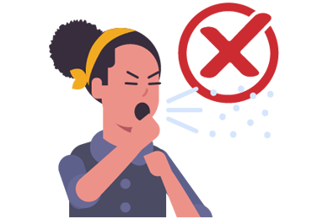Will the vaccine side effects make me sick?

The vaccines do not contain live coronavirus, and **you cannot get COVID-19 from having a vaccine**. After vaccination, you might experience a sore arm, a mild fever or body aches, but this doesn’t mean you have COVID-19. These symptoms, if they happen at all, are temporary, usually lasting only a day or two. They signal a natural response as your body’s immune system learns how to recognise and fight coronavirus for the future.

* I’ve already had Covid, is it true I am already protected and don’t need the vaccine?



**FALSE: Even if you have already had COVID-19, you can still get a vaccine.** Current guidelines suggest that anyone previously infected with COVID-19 should be vaccinated, as we don’t know how long natural immunity will last for. Some people who have been vaccinated after having COVID-19 have observed a strong immune reaction after the first of the two shots with the Pfizer and Moderna vaccines, with evidence also showing that **the Covid-19 vaccine can improve symptoms of Long Covid.**

* Which vaccine will I receive?



The MHRA is carrying out a detailed review of reports of an extremely rare blood clotting problem affecting a small number of people who have had the Oxford/AstraZeneca vaccine. **For people aged 40 or over and those with other health conditions, the benefits of being vaccinated with the Oxford/AstraZeneca vaccine outweigh any risk of clotting problems.**

**For people under 40 without other health conditions**, it's currently advised that it's preferable to have another COVID-19 vaccine instead of the Oxford/AstraZeneca vaccine - in prisons it has been confirmed that **they will be given the Moderna vaccine.**

**Long Covid**

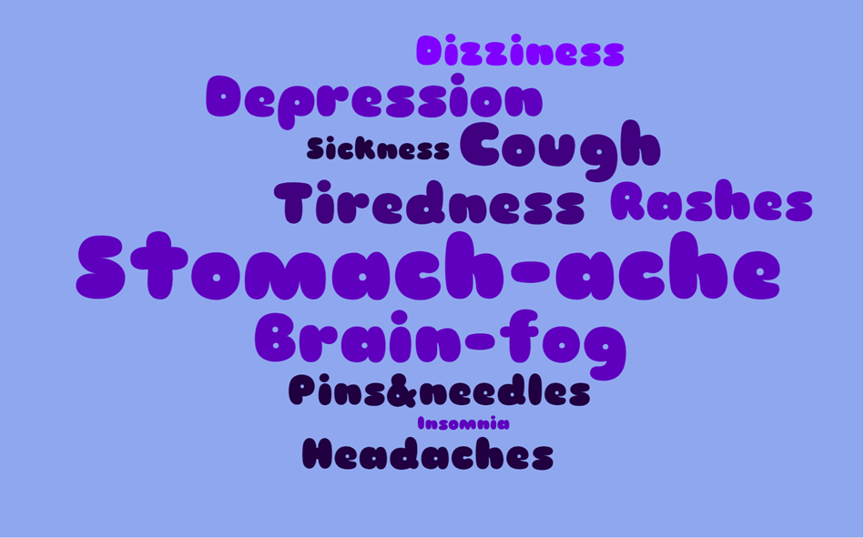Long Covid is a term to describe the effects of Covid-19 that continue for weeks or months beyond the initial illness and affect 1 in 5 people who test positive for Covid-19. The NHS identifies the following common Long Covid symptoms:

**Research from the British Medical Journal (BMJ) has found an increase in young people suffering from Long Covid after having Covid-19**. The study saw that the most commonly reported ongoing symptoms - regardless of whether you had been hospitalised from Covid-19 or only suffered mild symptoms - were **fatigue, muscle ache, shortness of breath, and headache**. There 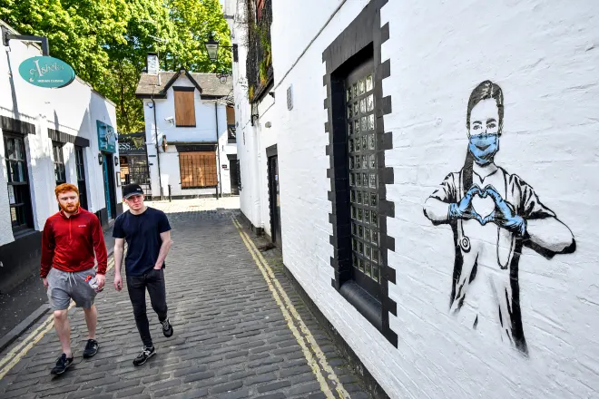was evidence of mild impairment in various organs, with two thirds of patients reporting this in the heart or lungs.

Prof Danny Altmann, an immunologist at Imperial College London, said:

‘It's a real kind of Russian roulette. **Even if you are** **low risk and might not die... you do not know if you will be better in a few weeks or one of the ones on crutches or in a wheelchair**’.

**Protecting Others**

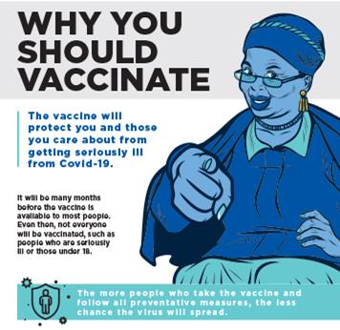Even if the benefits of being vaccinated are not immediately obvious to you, it is important to consider the bigger picture and the benefits of being vaccinated. Older people and those living with chronic medical conditions such as heart disease and diabetes are more likely to experience severe — even fatal — cases of COVID-19 if they catch it. The more people who receive the coronavirus vaccines, the sooner vulnerable people can feel safe among others.

New Public Health England (PHE) analysis shows that **individuals who receive a single dose of one of the Covid-19 vaccines available in the UK have approximately 80% lower risk of death with COVID-19 compared with unvaccinated individuals.**

PHE analysis also indicates that the **COVID-19 vaccination programme prevented 11,700 deaths** in those aged 60 and older in England up to the end of April and that at least **33,000 hospitalisations were prevented** in those aged 65 and older in England, in the same time period.

As well as preventing deaths and serious illness, accepting the vaccine is the quickest and most efficient way of us all getting our lives back to normality, whether this be in prison or in the community. High numbers of vaccinated prisoners provide higher protection against Covid-19, which will lead to less restrictions in prisons. This includes time in the gym, work and education and offending behaviour programmes, as well as less restrictive social visits and increased time with families.

The government has set out a road map that is based on four tests, one of which is:

* **The vaccine programme continues to be successful, with high uptake amongst all ages.**

The next evaluation of the government roadmap is the 21st of June when the government hopes to be able to remove all legal limits on social contact and return our lives in the community back to normality. We will also review restrictions in prisons at this time but are reliant on people getting vaccinated in prison, in the same way the Prime Minister is reliant on people getting vaccinated in the community. **By getting vaccinated we are all contributing to making this decision easier, whilst doing our bit to stop the spread and save lives.**