A picture containing knife

Description generated with very high confidence

**Mental Health Allies Training**

**Part 2 - Virtual Workshop**

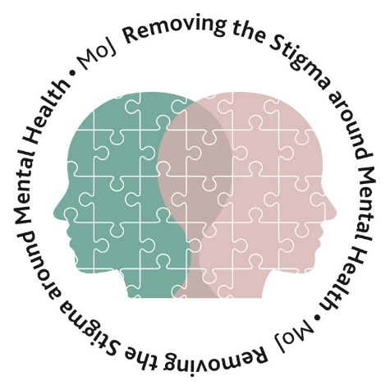



Contents

Part 2 3

How You Can Help 3

Confidentiality 3

A Four Step Approach 4

Case Studies 4

Supporting a Person in Crisis or Distress 5

Listening Tips 5

Things to Avoid 6

Wanting to Harm Others 6

Crisis & Emotional Support Helplines for Everyone 6

Summary 7

Next Steps as a Mental Health Ally 7

Further Support & Resources: 8

Mentoring Scheme 8

Debrief Allies 9

Documents to Know 10

Resources for Ministry of Justice 10

Resources for HMPPS 11

PAM Assist 12

Evaluation 13



# Part 2

Welcome to Part 2 of your Mental Health Allies training. You should have completed your pre-workshop material and we hope you have found it informative. Part 2 will be facilitated using a live broadcast or dial in facilities. Please ensure you have this information to refer to throughout the workshop.

**You will also find at the end of this material an evaluation form. We would be grateful if you could complete this at the end of the workshop and return following the instructions on the form.**

## 

## How You Can Help

Image 1: Overview of how you can help colleagues as a Mental Health Ally.

### Confidentiality

For individuals to feel comfortable in being as open as possible, Allies are governed by the following confidentiality rules. All information shared during discussions is kept confidential and is not divulged to other people, unless:

* The individual has expressly consented to an Ally talking to someone on their behalf. Any decision to disclose information should be fully documented and written consent received from the person concerned.
* The individual gives concern that they might seriously harm themselves or others.
* Disclosing personal information may be justified as in the public interest if failure to do so may expose others to a risk of death or serious harm.
* Such a situation might arise, for example, if a disclosure will be deemed to be necessary for the prevention, detection or prosecution of crime, especially crimes against the person.

**If the above is necessary, report the situation to your own line manager who will refer such incidents to senior managers within HR.**

Page 3

### A Four Step Approach

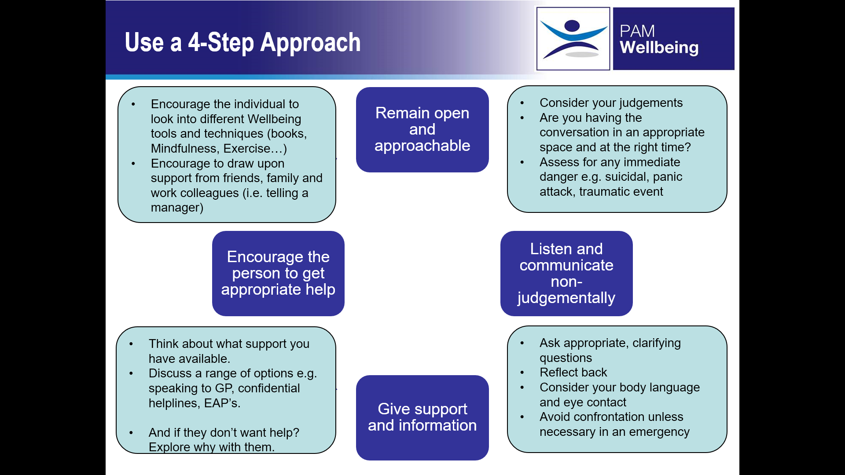

### 

### Case Studies

**Case Study 1:**

A member of staff has recently separated from their long-term partner. They are experiencing financial hardship and having difficulty concentrating when at work. The concerns are heightened as they have indicated thoughts of suicide.

**Case Study 2:**

A member of staff has recently been diagnosed with depression following a family bereavement. They have made a self-referral to counselling services and are receiving new medication from their doctor. However, they find it difficult to get out of bed on a morning and their line manager has expressed concerns to them.

## 

Image of a man standing by a sign saying case study

Page 4

### Supporting a Person in Crisis or Distress

Whilst rare, it is important to know how to respond within your role as an Ally, if a person is in crisis or distress. The following guidance is taken from Mental Health First Aid England (2016).

If someone is at an immediate risk of suicide:

* **Ensure your own personal safety**
  1. Don’t get involved physically if the person is distressed and threatening
  2. Call for assistance (see step 3 below), particularly if someone is threatening to self-harm or threatening harm to others.
  3. Observe from a safe position until help arrives
* **Ensure the person is not left alone**

Stay with the person if you think that the risk of suicide is high or

Arrange for someone to be with them while they get through the immediate crisis.

* **Arrange immediate help**
  1. Phone their GP and ask for an emergency home visit or
  2. Call 999 or
  3. Call the Samaritans on 116 123 (24 hours a day)
* **If the person is consuming alcohol or drugs, try to discourage them from taking anymore**
* **Try to ensure that the person does not have ready access to some means to take their life**
* **Encourage the person to talk**
  1. Listen without judgment
  2. Be polite and respectful
  3. Don’t deny the persons feelings
  4. Don’t try to give advice
  5. Give reassurance that help is available (BUT DON’T MAKE PROMISES!)

### Listening Tips

* Be patient and calm
* Listen to the person without expressing judgement, accepting what they are saying **without agreeing or disagreeing** with their behaviour or point of view.
* Remember that these problems are not due to laziness or weakness – the person is unwell and trying to cope.
* Ask open-ended questions to find out more about the suicidal thoughts, feelings and problems behind these.
* Show that you are listening by summarizing what the suicidal person is saying.

Page 5

### Things to Avoid

* It is common to feel panic or shock when someone discloses thoughts of suicide, but it is important to avoid expressing negative reactions.
* Do your best to appear calm, confident and empathetic in the face of suicide crisis as this may have reassuring effects for the suicidal person.

Don’t’:

* argue or debate with the person about their thoughts of suicide.
* discuss with the person whether suicide is right or wrong.
* use guilt or threats to prevent suicide (e.g. don’t tell the person that they will go to hell or ruin other people’s lives if they die by suicide).
* minimize the suicidal person’s concerns.
* give glib ‘reassurances’ such as “don’t worry”, “cheer up”, “you have everything going for you” or “everything will be alright”.
* interrupt with stories of your own.
* call their bluff’ (dare or tell the person to ‘just do it’).
* attempt to give the suicidal person a diagnosis of mental ill health.

### Wanting to Harm Others

In very rare circumstances, an individual may express an intention to harm others. An Ally should:

* Try to remain as calm as possible and do not become physically engaged.
* In the case of an immediate threat ensure your own safety by withdrawing from the immediate area and try and ensure other people are not in danger.
* Call the police and inform the local security/site lead.
* In the case of an expressed intention which does not pose an immediate threat, it may be appropriate to talk to them about why they are feeling like they are, and explore whether they have a plan, alternative ways of dealing with the situation, etc.

If you remain concerned, inform them that will need to inform someone about the situation and discuss with EAP/ line manager.

### Crisis & Emotional Support Helplines for Everyone

* If you, or someone you know is in a mental health crisis and needs medical help fast:
  + Ring 999 to contact the emergency services
  + Go to your nearest A&E department – need to be clear here that you would not accompany someone else to A&E
* Samaritans: provide emotional support.

Phone: 116 123 (Freephone, 24 hrs a day, 7 days a week)

Email: [jo@Samaritans.org](mailto:jo@Samaritans.org)

Website: [www.Samaritans.org](http://www.samaritans.org/)

Page 6

## Summary

You’ve now completed your Mental Health Ally training – well done!

Before we consider the next steps and your continuing journey as a Mental Health Ally, below is a summary of what you’ve learnt in Part 2:

* The key elements in the role of a Mental Health Ally are to: -
  + - Be a good listener
    - Be non-judgmental
    - Be empathetic, supportive and look for the positives
    - Be aware of who unfinished sentence
* All information shared during discussions is kept confidential and is not divulged to other people, unless the individual gives rise to concern that they might harm themselves or others, or it is in the public interest if failure to break confidentiality may expose others to risk of death or serious harm.
* The 4-step approach is there as a guide to help you structure your conversations.
* Remember that support services available to your colleagues, are also available to **YOU.** You might need support if you’re hearing distressing things, so consider what support you might like from another Ally, debrief Allies, the EAP or a line manager.

Consider implementing tools and techniques to promote Mental Wellbeing such as Mindfulness, Nutrition, Physical Activity, Good Sleep and the 5 Ways to Wellbeing – you could even use these as Health Promotion events.

## Next Steps as a Mental Health Ally

## 

Page 7

**Activity:**

**What will you do as a Mental Health Ally?**

___________________________________________________________________________________________________________________________________________________________________________________________________________________________________________________________________________________________________________________________________________________________________________________

**How can you work collaboratively with other allies and champions?**

____________________________________________________________________________________________________________________________________________________________________________________________________________________________________________________________________________________________________________________________________________________________________________________

**What extra support might you need?**

____________________________________________________________________________________________________________________________________________________________________________________________________________________________________________________________________________________________________________________________________________________________________________________

# Further Support & Resources:

The Mental Health Allies Programme has a range of support available to allies to assist them in carrying out their role.

### Mentoring Scheme

**What is it?**

Mentoring is a confidential process that is about being committed, having respect and mutual trust, setting goals and challenges, giving encouragement and constructive feedback. The mentoring relationship can be both short and long term.

**Purpose of a mentor**

**Enable the mentee to find their own way through a situation**

**Provide access to knowledge, situations or networks**

**Offer information (but not advice)**

**What are the benefits of mentoring?**

Mentoring can give you room to discuss specific matters or concerns which will support your role as a mental health ally on a one to one basis or as part of a wider network.

Mentoring offers the opportunity to hear the perspective of someone with more experience in dealing with difficult issues.

|  |  |
| --- | --- |
| Mentor - Expectations | Mentee - Expectations |
| A mentor will:   * Give support, guidance and reassurance * Share good practice and network experiences * Give detail of signposting services * Encourage and develop the MHA network community * Build confidence of MHAs * Have excellent communication skills * Continue to break the stigma surrounding mental health * The mentor is not there to provide ‘the answers’, but to guide the mentee towards an answer that is right for them * Promote a better understanding of positive mental health actions through regular communications and initiatives.   A mentor will not:   * Offer medical advice or make referrals on behalf of an individual * Provide representation in official meetings | A mentee will:   * Be clear and open about your aims and objectives and discuss them with your mentor * Be clear about your needs so that your mentor can offer you the right support to help you meet your aims whether you want something structured or something more like a friendly coffee. * Discuss how/when you would like to be contacted by your mentor * Formally agree that both you and your mentor will keep the contents of your discussion confidential, except in circumstances where the mentor has undue concerns for your wellbeing * Mentee should actively participate in group activities with other allies |

Page 8

**Why is this important for your own wellbeing?**

Being a mental health ally is very rewarding, and may present some potentially challenging situations, depending the issues you are dealing with. It can be extremely valuable to have someone to talk to.

**There are many benefits to this;**

* + Time out to think, reflect and plan
  + Encourage the sharing of best practice
  + Having someone available who can act as a sounding board

**This works both ways and can benefit the mentor as well as the mentee, increasing an overall sense of wellbeing;**

* + Working with others you can develop your talents and abilities
  + It can increase levels of empowerment, self-esteem and confidence

**Would you like a mentor?**

Most Mental Health Allies who completed the survey said they would find a mentoring relationship helpful.

If you are interested please complete the form on our intranet page [request a mentor](https://intranet.justice.gov.uk/documents/2018/10/mental-health-mentee-registration-form.docx) and email it to [MentalHealthAllies@Justice.gov.uk](mailto:MentalHealthAllies@Justice.gov.uk)



### Debrief Allies

Mental Health Allies may need time to talk and share in a controlled, structured environment.  An opportunity to speak with a trained Debrief Ally will enable individuals to reflect upon a recent experience, discuss what went well, and access individual support that may be required.

Debriefing is usually carried out within three to seven days of an incident, when colleagues have had enough time to take in the experience. Debriefing is not counselling. It is a structured voluntary discussion aimed at putting an upsetting event into perspective.

Debrief allies are trained to:

* Recognise vulnerable people
* Assess the Emotional Health Scale
* Use effective listening tools and techniques to acknowledge difficult feelings and circumstances
* Show you have listened and understood
* Use strategies to de-escalate difficult circumstances and emotions
* End conversations effectively
* Sign post people to support

Page 9

### Documents to Know

* Stress awareness and management policy – For information about the duty of care as a manager, employee responsibility, potential causes of stress and potential solutions to reduce stress and build resilience.
* Individual stress awareness guidance
* Mental Health Allies Framework
* Keep up to date with support offered in the workplace
* Stress awareness intranet page add link
* Your Mental Health Allies Intranet Page: [https://intranet.justice.gov.uk/guidance/hr/support-and-wellbeing/mental-wellbeing/mental-health-Allies/](https://intranet.justice.gov.uk/guidance/hr/support-and-wellbeing/mental-wellbeing/mental-health-allies/)

### Resources for Ministry of Justice

* [Mental Health Allies](https://intranet.justice.gov.uk/guidance/hr/support-and-wellbeing/mental-wellbeing/mental-health-Allies/)
* [Employee Assistance Programme (EAP)](https://intranet.justice.gov.uk/guidance/hr/support-and-wellbeing/employee-assistance-programme/)
* [Mental Wellbeing pages of the intranet](https://justiceuk-my.sharepoint.com/personal/rowena_littlewood_justice_gov_uk/Documents/MHA%20-%20MHA%20Workshops/MHA%20-%20Virtual%20Workshop/•%09%20https:/intranet.justice.gov.uk/guidance/hr/support-and-wellbeing/mental-wellbeing/)
* [Health & Wellbeing Be Well strategy 2019 - 2021](https://intranet.justice.gov.uk/documents/2019/12/moj-health-and-wellbeing-pdf.pdf)
* [Remploy Workplace Mental Health Support Service](https://www.remploy.co.uk/)
* [BDF “Mental Health at Work” and “Managing Difficult Conversations”](https://businessdisabilityforum.org.uk/)
* [Attendance Management guidance](https://justiceuk-my.sharepoint.com/personal/rowena_littlewood_justice_gov_uk/Documents/MHA%20-%20MHA%20Workshops/MHA%20-%20Virtual%20Workshop/•%09https:/intranet.justice.gov.uk/guidance/hr/sick-absence/attendance-management-policy/)
* [Performance Management guidance](https://justiceuk-my.sharepoint.com/personal/rowena_littlewood_justice_gov_uk/Documents/MHA%20-%20MHA%20Workshops/MHA%20-%20Virtual%20Workshop/•%09https:/intranet.justice.gov.uk/guidance/hr/performance-management/)

* [Diversity Networks](https://intranet.justice.gov.uk/guidance/equality-and-diversity/diversity-networks/) (Staff Support Networks)
* [Disability Support pages of the intranet](https://justiceuk-my.sharepoint.com/personal/rowena_littlewood_justice_gov_uk/Documents/MHA - MHA Workshops/MHA - Virtual Workshop/•%09https:/intranet.justice.gov.uk/guidance/hr/support-and-wellbeing/disability-support/)
  + Ability Manual
  + Disability Quick Guides
  + Workplace Adjustment Passport (& guidance)
  + Access to Work eligibility
* [Talent Schemes for disabled employees](https://justiceuk-my.sharepoint.com/personal/rowena_littlewood_justice_gov_uk/Documents/MHA%20-%20MHA%20Workshops/MHA%20-%20Virtual%20Workshop/•%09https:/intranet.justice.gov.uk/guidance/equality-and-diversity/learning-zone/)
* [MoJ Inclusion & Diversity Strategy](https://justiceuk-my.sharepoint.com/personal/rowena_littlewood_justice_gov_uk/Documents/MHA%20-%20MHA%20Workshops/MHA%20-%20Virtual%20Workshop/•%09https:/intranet.justice.gov.uk/guidance/equality-and-diversity/diversity-strategy/)



Page 10

### Resources for HMPPS

* [Mental Health Allies](https://intranet.justice.gov.uk/guidance/hr/support-and-wellbeing/mental-wellbeing/mental-health-Allies/)
* [Employee Assistance Programme (EAP)](https://intranet.justice.gov.uk/guidance/hr/support-and-wellbeing/employee-assistance-programme/)
* [Mental Wellbeing pages of the intranet](https://intranet.justice.gov.uk/guidance/hr/support-and-wellbeing/mental-wellbeing/)
* [Remploy Workplace Mental Health Support Service](https://www.remploy.co.uk/)
* [Attendance Management guidance](https://intranet.noms.gsi.gov.uk/news-and-updates/notices/new-attendance-management-policy2)
* [Performance Management guidance](https://intranet.noms.gsi.gov.uk/policies-and-subjects/probation/probation-instructions/Probation-Instructions-2017/pi-2017-13)
* Staff Support Networks
  + [Disability staff programme](mailto:dawn@justice.gov.uk)
  + [LGBT+ staff programme](mailto:PiPP@justice.gov.uk)
  + [BAME staff programme](mailto:RISE@justice.gov.uk)
* Disability Support pages of the intranet
  + - * [Workplace Adjustment Passport](https://justiceuk-my.sharepoint.com/personal/rowena_littlewood_justice_gov_uk/Documents/MHA%20-%20MHA%20Workshops/MHA%20-%20Virtual%20Workshop/•%09https:/intranet.noms.gsi.gov.uk/__data/assets/word_doc/0007/944890/HMPPS-Workplace-Adjustment-Passport.docx)
      * [Workplace Adjustment Passport Guidance](https://justiceuk-my.sharepoint.com/personal/rowena_littlewood_justice_gov_uk/Documents/MHA%20-%20MHA%20Workshops/MHA%20-%20Virtual%20Workshop/•%09https:/intranet.noms.gsi.gov.uk/__data/assets/word_doc/0012/944895/HMPPS-Workplace-Adjustment-Passport-Guidance.docx)
      * [Common Workplace Adjustments](https://intranet.noms.gsi.gov.uk/__data/assets/word_doc/0004/944887/HMPPS-List-of-Common-Workplace-Adjustments.docx)
* [Talent Schemes for disabled employees](https://justiceuk-my.sharepoint.com/personal/rowena_littlewood_justice_gov_uk/Documents/MHA%20-%20MHA%20Workshops/MHA%20-%20Virtual%20Workshop/•%09https:/intranet.justice.gov.uk/guidance/equality-and-diversity/learning-zone/)
* [HMPPS Inclusion & Diversity Strategy](https://intranet.noms.gsi.gov.uk/news-and-updates/news/hmpps-equality-strategy-2018-2020)



Page 11

### PAM Assist

**About PAM Assist**

Sometimes it can be difficult to balance the pressures of work with the needs of home life. **MOJ & HMPPS** recognises that help is sometimes needed to deal with the challenges you may face in life, both practical and emotional. PAM Assist is a free and confidential life management and personal support service that is available to you 24 hours a day, any day of the year. You simply pick up the phone and self-refer via the 080 number above. You do not need to get anyone’s permission/approval to use this service. To confirm you are eligible to use the service, you simply need to tell us that you are employed by **MOJ or HMPPS**.

**What sort of issues can I call with?**

here to help. As an independent, free and confidential service, provided by your employer, we can offer you information, guidance and counselling on self-referral basis. You don’t need to register or sign up to use the service, just call the 0800 number.

We’re not just here for life’s crises, but also to offer support and advice for everyday issues such as getting married, moving to a new house and even childcare. These issues can raise questions or concerns that may be helped with a discussion with an EAP counsellor or advisor. Whether you need a shoulder to cry on or just a sounding board to talk to; you can rely on PAM Assist.

Through PAM Assist, you have telephone access to qualified advisers who are trained to help. Whether it’s to help you prepare for a challenge and gather essential information or get some sound and confidential guidance on a life event that’s affecting you or your family, you should feel free to call us whenever you need to. We can help with both the expected challenges and the unexpected crises.

**How can I get help?**

By phoning the dedicated number listed above you will reach a PAM Assist Advisor, who will assess the nature of your enquiry and offer the most suitable advice or assistance. If they cannot deal with your query immediately or you require counselling then they will arrange for you to be contacted within 24 hours.

**What help is available?**

The benefits of the service include:

* Provision of initial telephone advice and assistance to you and your partner or resident children including information on relevant specialist organisations and voluntary services in your local area.
* Telephone counselling for employees.
* Up to six sessions of face-to-face counselling at a location convenient to you.

The topics PAM Assist helps deal with include; bereavement, emotional issues, general health, ill-health, retirement support, relationships, retirement, sickness absence support, stress/ anxiety and trauma care. However, this list is not exclusive, and the Helpline staff can deal with other issues as required.

**Contact PAM Assist:**

Telephone: 0800 019 8988

Website: [www.pamassist.co.uk](http://www.pamassist.co.uk)

Username: MoJ / HMPPS

Password: MoJ1 / HMPPS1

**Please now refer yourselves to Part 3 of the materials about next steps for your role and additional support.**

Page 12

# Evaluation

**Mental Health Allies Workshop (parts 1&2)**

**If you can complete your Evaluation online, please visit:** [Mental Health Allies Training - Evaluation Form](https://docs.google.com/forms/d/e/1FAIpQLSeBapTrvlw7nPkc4t9J37_3Sif_pxATxfZDYsBJAdJDykYZcw/viewform?usp=sf_link) Alternatively, please complete the details below:

**Where do you work?**

* HMPPS – MOJ or HQ
* HMPPS – Prison
* HMPPS – Probation
* MOJ
* Other

**Part 1 – Self Learning**

**How would you rate the pre-course material?**

* Poor
* Average
* Good
* Excellent

**How long did it take you to compete the pre-course material?**

* 1 hour
* 1.5 hours
* 2 hours
* 2.5 hours

**Did you feel that the time allocated to review the pre-course materials was enough?**

**What did you particularly enjoy/find useful?**

**How could the pre-course materials be improved?**

**Part 2 – Virtual Delivery**

**What was the date of your training?**

**How did you join the training?**

* Teams Link
* Dial in

**How would you rate the training?**

* Poor
* Average
* Good
* Excellent

Page 13

**How did you find the length of the training?**

* Too long
* Too short
* About right

**What did you particularly enjoy/find useful?**

**How could the training be improved?**

**Please rate your mental health ally confidence BEFORE the training (part 1&2):**

* Poor
* Average
* Good
* Excellent

**Please rate your mental health ally confidence AFTER the training (part 1&2):**

* Poor
* Average
* Good
* Excellent

**Has the content of the training equipped you for the role?**

* Yes
* No
* Maybe – please explain

**What further support would benefit you in your role as an ally?**

**Q10. Any other comments**

**Your feedback is very important. Please send to:** [MentalHealthAllies@Justice.gov.uk](mailto:MentalHealthAllies@Justice.gov.uk)



Page 14