**Mental Health Allies Guide for Trainers**

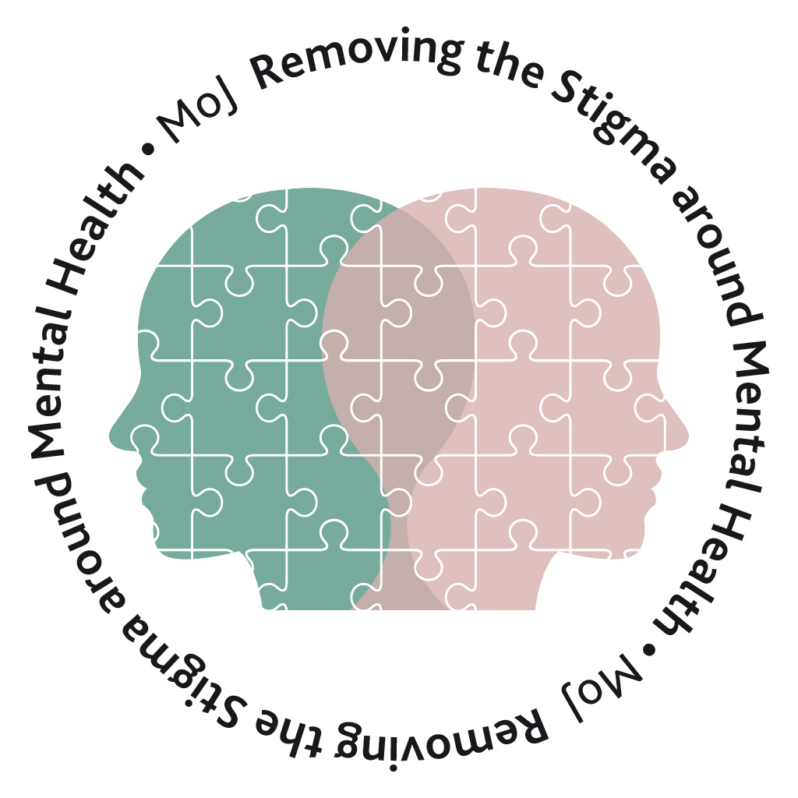

This guide outlines the process and responsibility for co-ordinating training for newly recruited Mental Health Allies, Parts 1,2&3.

**Included:**

* Phase 1 - Pre transitional arrangements (to end of March 2021)
* Phase 2 – Post transitional arrangements

**Phase 1 - Pre transitional arrangements**

Mental health allies training is coordinated **centrally** by [Tracey.Varela@justice.gov.uk](mailto:Tracey.Varela@justice.gov.uk) (HMPPS) and [MentalHealthAllies@Justice.gov.uk](mailto:MentalHealthAllies@Justice.gov.uk) (MOJ) who will:

|  |  |
| --- | --- |
| **Pre workshop** | * Maintain the list of allies waiting to join a workshop * Schedule the workshops (teams and/or dial in facilities) * Invite delegates to join via outlook (inc the teams link and dial in & pin). * Equip attendees with the following (that should be visible either electronically or printed during the Virtual workshop):   + - Part 1 – Pre-Workshop Learning materials     - Part 2 – MHA Workbook     - Part 2 –MHA Virtual Workshop Slides |
| **Post workshop** | * Send the Part 3 - post workshop resources to delegates * Send the evaluation sheet * Review the feedback * Update the list of allies waiting to join a workshop |

**MHA Trainer will:**

|  |  |
| --- | --- |
| **Pre workshop** | * Provide dates and times centrally of availability to deliver a three-hour workshop * Confirm your method of delivery (teams and/or dial in access) |
| **Post workshop** | * Send the names of the delegates who joined to [Tracey.Varela@justice.gov.uk](mailto:Tracey.Varela@justice.gov.uk) and [MentalHealthAllies@Justice.gov.uk](mailto:MentalHealthAllies@Justice.gov.uk) * Share any personal feedback, comments, observations centrally |

**Phase 2 – Post transitional arrangements**

Mental health allies training will be coordinated **locally** by MHAs National Leads (SPOCS) after the end of March 2021 who will:

|  |  |
| --- | --- |
| **Pre workshop** | * Maintain the list of allies waiting to join a workshop * Schedule the workshops (teams and/or dial in facilities) * Invite delegates to join via outlook (inc the teams link and dial in & pin). * Equip attendees with the following (that should be visible either electronically or printed during the Virtual workshop):   + - Part 1 – Pre-Workshop Learning materials     - Part 2 – MHA Workbook     - Part 2 –MHA Virtual Workshop Slides |
| **Post workshop** | * Update the list of allies waiting to join a workshop |

**MHA Trainer Will:**

|  |  |
| --- | --- |
| **Pre workshop** | * Provide dates and times of availability to deliver a three-hour workshop if asked * Confirm your method of delivery (teams and/or or dial in access) |
| **Post workshop** | * Send the Part 3 - post workshop resources to delegates * Send the evaluation sheet * Notify the SPOC of the delegates names * Share any personal feedback, comments, observations centrally |

The Mental Health Allies training materials and resources have been added to the MHAs teams page, trainers workshop materials Parts 1,2,3, files tab at:

**MOJ:** [MHA Trainer Resources and Materials](https://teams.microsoft.com/l/channel/19%3a9abf684ac92d4f99951ecca39c660162%40thread.tacv2/Trainers%2520workshop%2520materials-Parts%25201%252C2%252C3?groupId=e99da212-e008-496c-a048-e5e5c5d5c0b1&tenantId=c6874728-71e6-41fe-a9e1-2e8c36776ad8)

**HMPPS** <http://hmppsintranet.org.uk/resources/mental-health-allies/>

[**MentalHealthAllies@Justice.gov.uk**](mailto:MentalHealthAllies@Justice.gov.uk)