eokboon**Basics of Braille**

**E**

**N**

**K**

**O**

**O**

**O**

**B**

**Introduction to Braille**

Braille was invented by French student Louis Braille, in 1824, when he was 15 years old. Over the next hundred years, this was adopted as the universal method for reading and writing for the blind and visually impaired.

In 2004, after years of research, Unified English Braille was introduced. This was a form of braille that could be used internationally in English-speaking countries, and was officially adopted by the UK in 2011. This is the sort of braille you will find in this book.

**History**

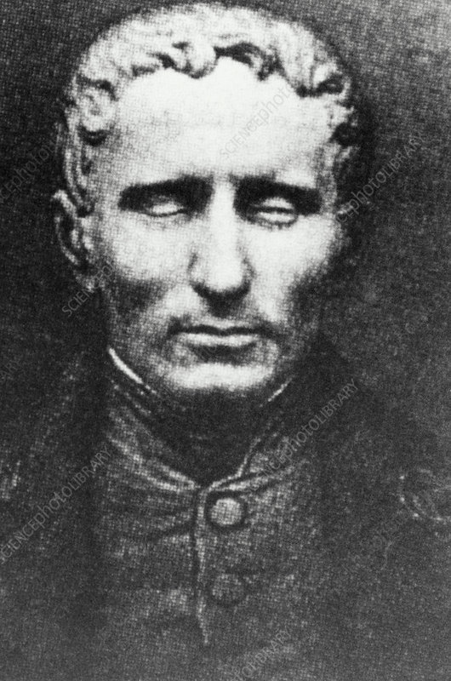

**Louis Braille**

When beginning to learn braille, you’ll use uncontracted braille. This is where each individual letter is represented by an individual braille cell. It spells out words letter by letter, but is slower than contracted braille.

Contracted braille is a short form, where combinations of letters make abbreviated patterns, called contractions. It is much faster to read, but will take more practise.

This book uses uncontracted braille, which is easier for beginners.

**Contracted vs Uncontracted Braille**

**The Braille Cell**

Every character in the braille code is based on an arrangement of one to six raised dots.

Each dot has a numbered position in the braille cell, shown in the picture below.

These characters make up the letters of the alphabet, punctuation marks, numbers and everything else you can do in print.

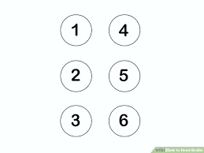

da

**A**

**D**

For example, the letter ‘a’ is written with only **dot 1**. The letter ‘d’ is written with **dots 1, 4 and 5**. Have a look on the next page for the full alphabet.

fcbdega

**G**

**F**

**E**

**D**

**B**

**C**

**A**

nmlhijk

**N**

**M**

**L**

**K**

**J**

**H**

**I**

tuso

**U**

**T**

**S**

**R**

**Q**

**P**

**O**

qrp

xwzyv

**Z**

**Y**

**X**

**W**

**V**

**Reading the Alphabet**

In braille, the first 10 letters of the alphabet form the basis of all the other letters (A – J). These letters only use the top 4 dots in each cell.

The next ten letters (K – T) are made by using the same as the first ten, but adding the **dot 3**.

For the last six letters (U – Z), you use the same as the above (the original dots plus the dot 3), and you add a **dot 6**. The exception to this is ‘w,’ which was not used much when braille was first invented in France.

uka

**A**

**K**

**U**

Braille does not have a separate alphabet for capital letters. Instead, capital letters are indication by placing a **dot 6** in front of the letter to be capitalised. Two capital signs mean the whole word is capitalised.

Dog

adog

DOG

aadog

**Practice**

Write the words below in the blank cells. Make sure to check for capital letters!

**WOW**

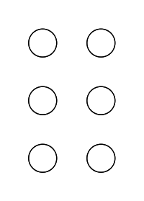



**Nash**



**packs**



**mint**

**Practice**

udbesoWhat do these words say?

r

Answer: ………………………………………………………………..

elliarb

nodnola

Answers are at the back.

Answer: ………………………………………………………………..

Answer: ………………………………………………………………..

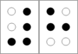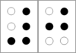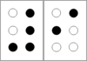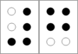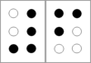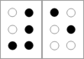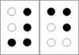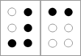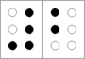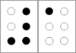

Braille numbers are made of two cells. In the first, you always use the number indicator – **dots 3, 4, 5 and 6**. In the second, it is the same as the first ten letters of the alphabet.

For bigger numbers, use the indicator first and only once, then the next cells as required. For example, 100 is below.

**0**

**6**

**7**

**8**

**9**

**5**

**4**

**3**

**2**

**1**

**Numbers**

jj

**Practice**

Practise writing some numbers. Answer the questions below.

123 + 342 =



What is the next number in the sequence?

765 654 543 432



In what year did England win the World Cup in football?



**Over to You**

Letters and numbers are the basics you need to start reading braille. While this pack can only show you what they look like, rather than the raised text you can touch, they will help you start to identify the symbols.

Practising will help you get used to this – use some of the blank sheets at the back and fill in the cells with what you like. Some ideas are below:

* Your full name (including capitals)
* Your date of birth
* A phrase you use a lot
* Objects around you
* Places you have been

Activities can provide more blank sheets, as well as short texts to read and another booklet with more advanced info, such as contractions and punctuation. Please send an app if you would like any of this.

doog

kucl

**Answers**

mint

**mint**

**packs**

packs

**Nash**

anash

aawow

**WOW**

**What do these words say?**

rosebud

braille

London

**Numbers**

Write the number

fb

**462**

Next in the sequence

ba

**321**

**1966**

iff

Year England won the World Cup

