Taking a moment for yourself…
Festive Distraction Pack

Formulated by Mala Dhakk, Health Inequalities Manager, NHSE&I, Health and Justice (East Midlands) co-produced with LEP Dec 2020
1
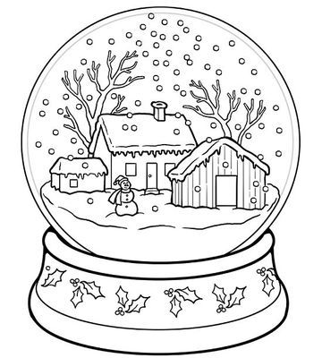

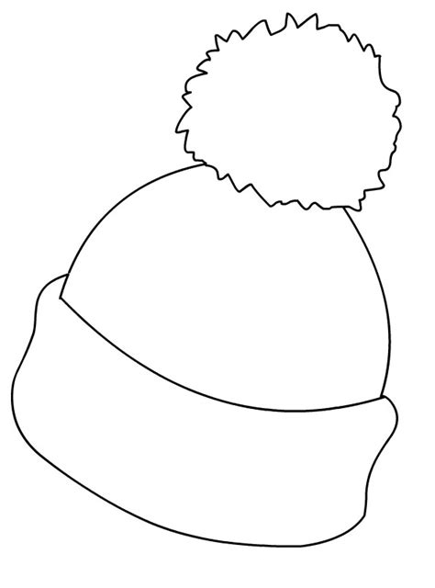
2

3
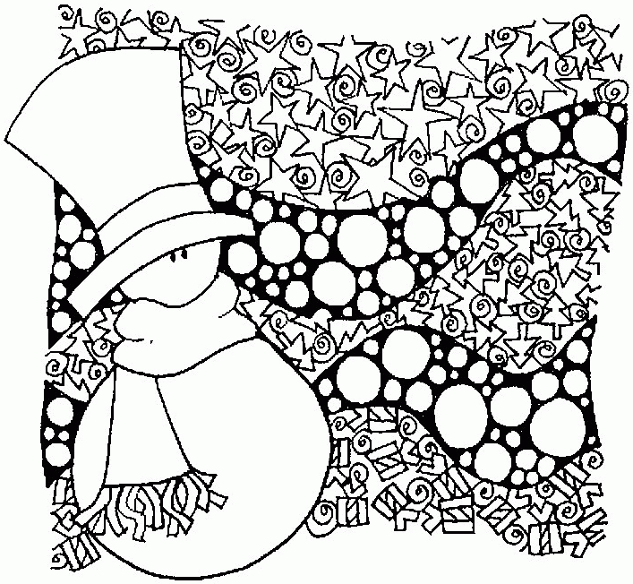

4
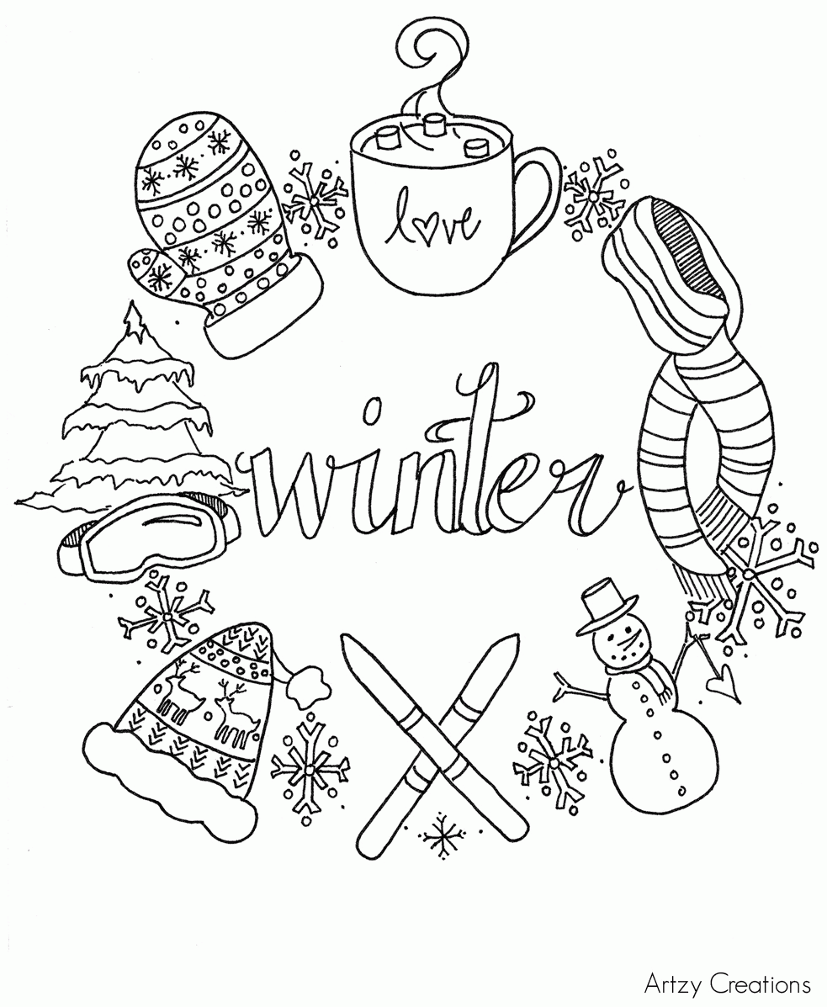

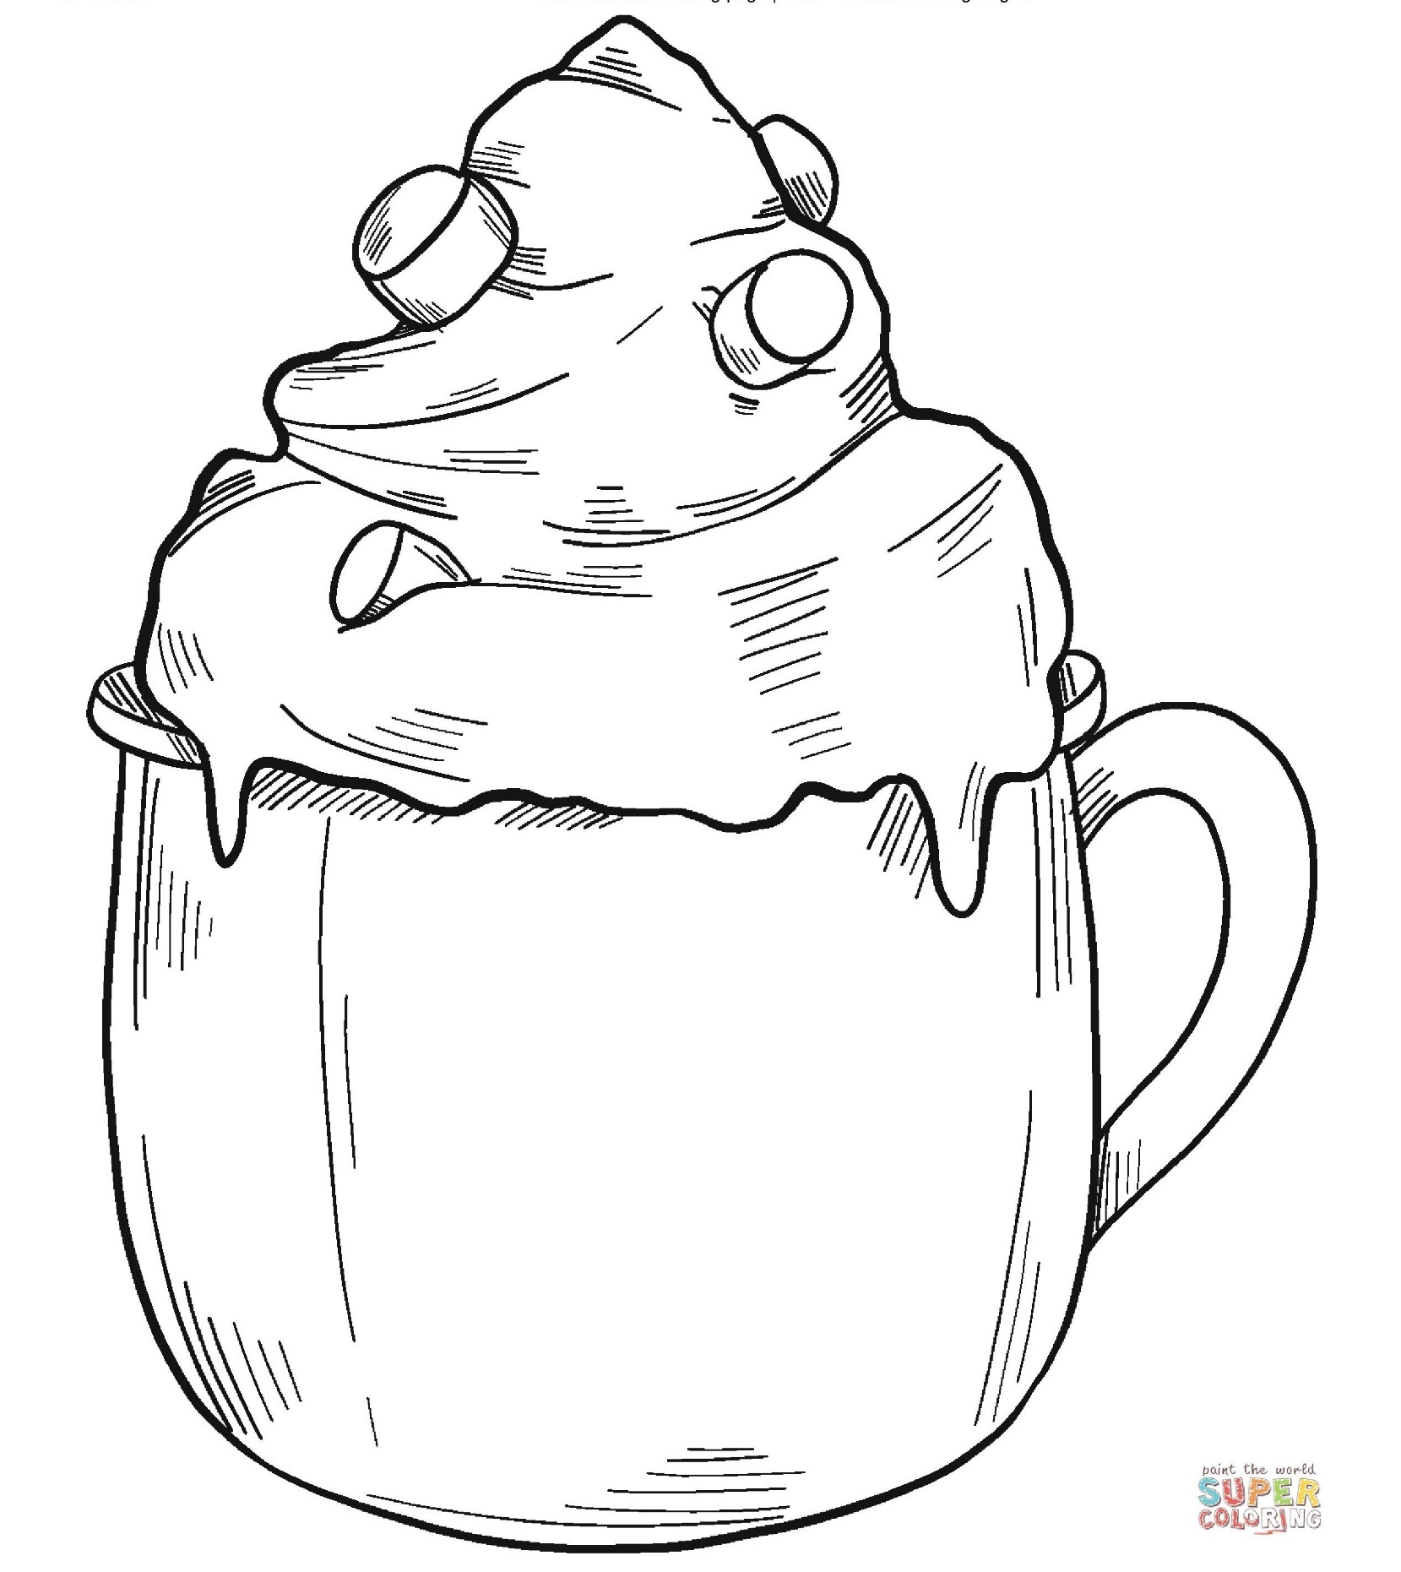
5

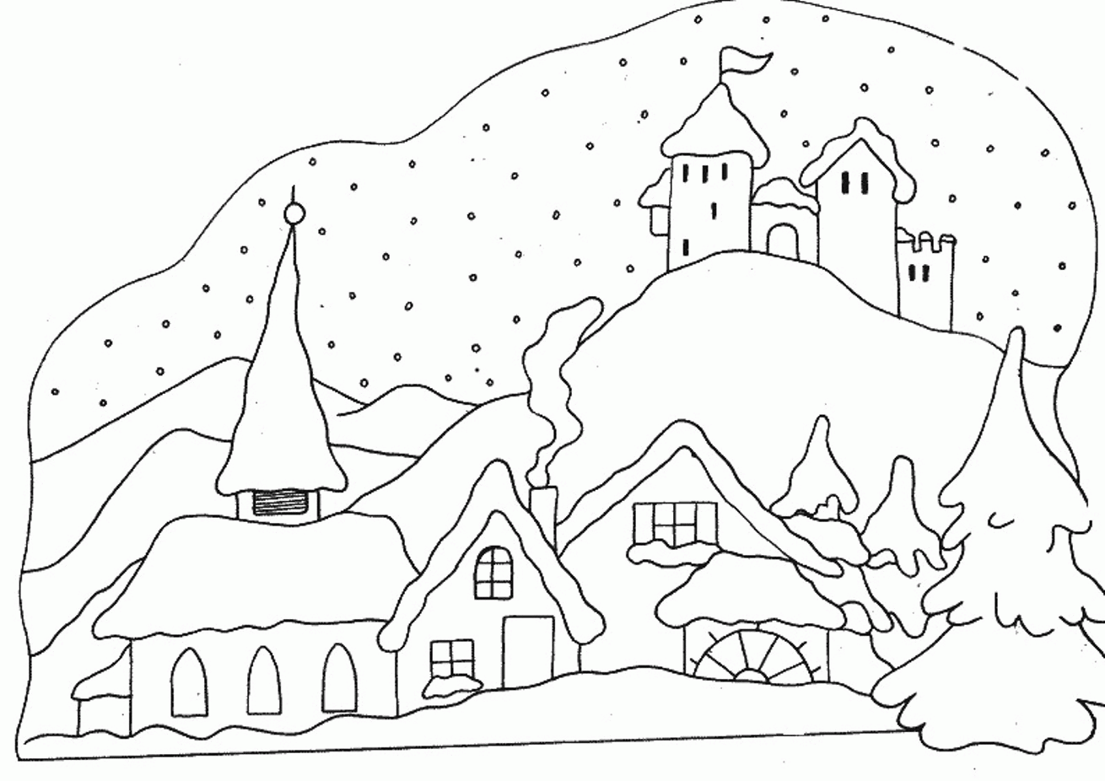
6
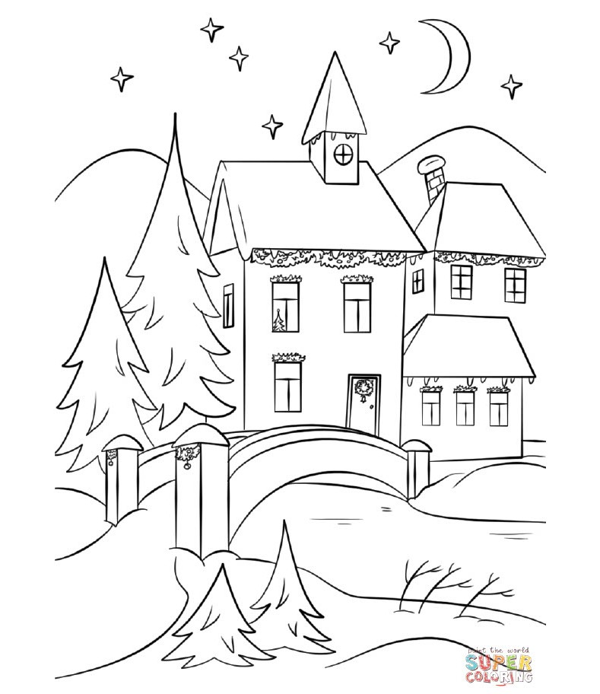
.
7

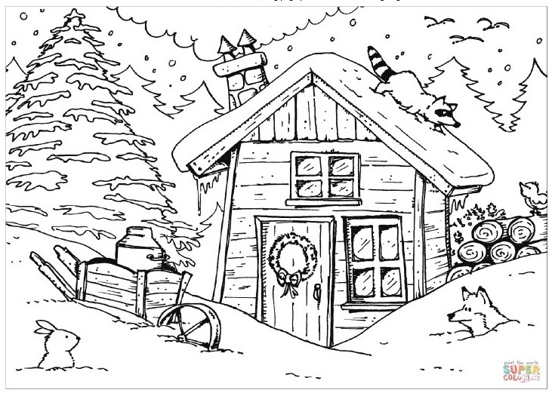
8
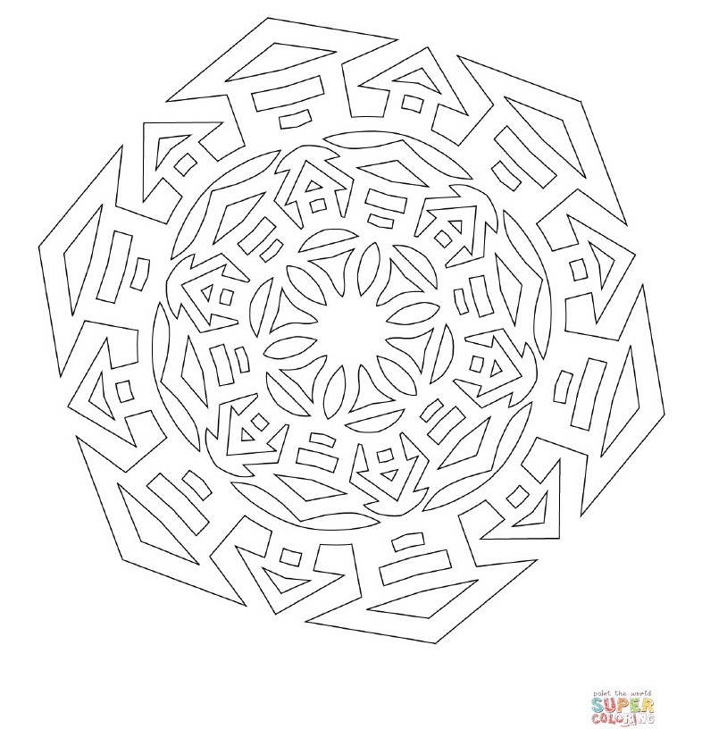
9

10
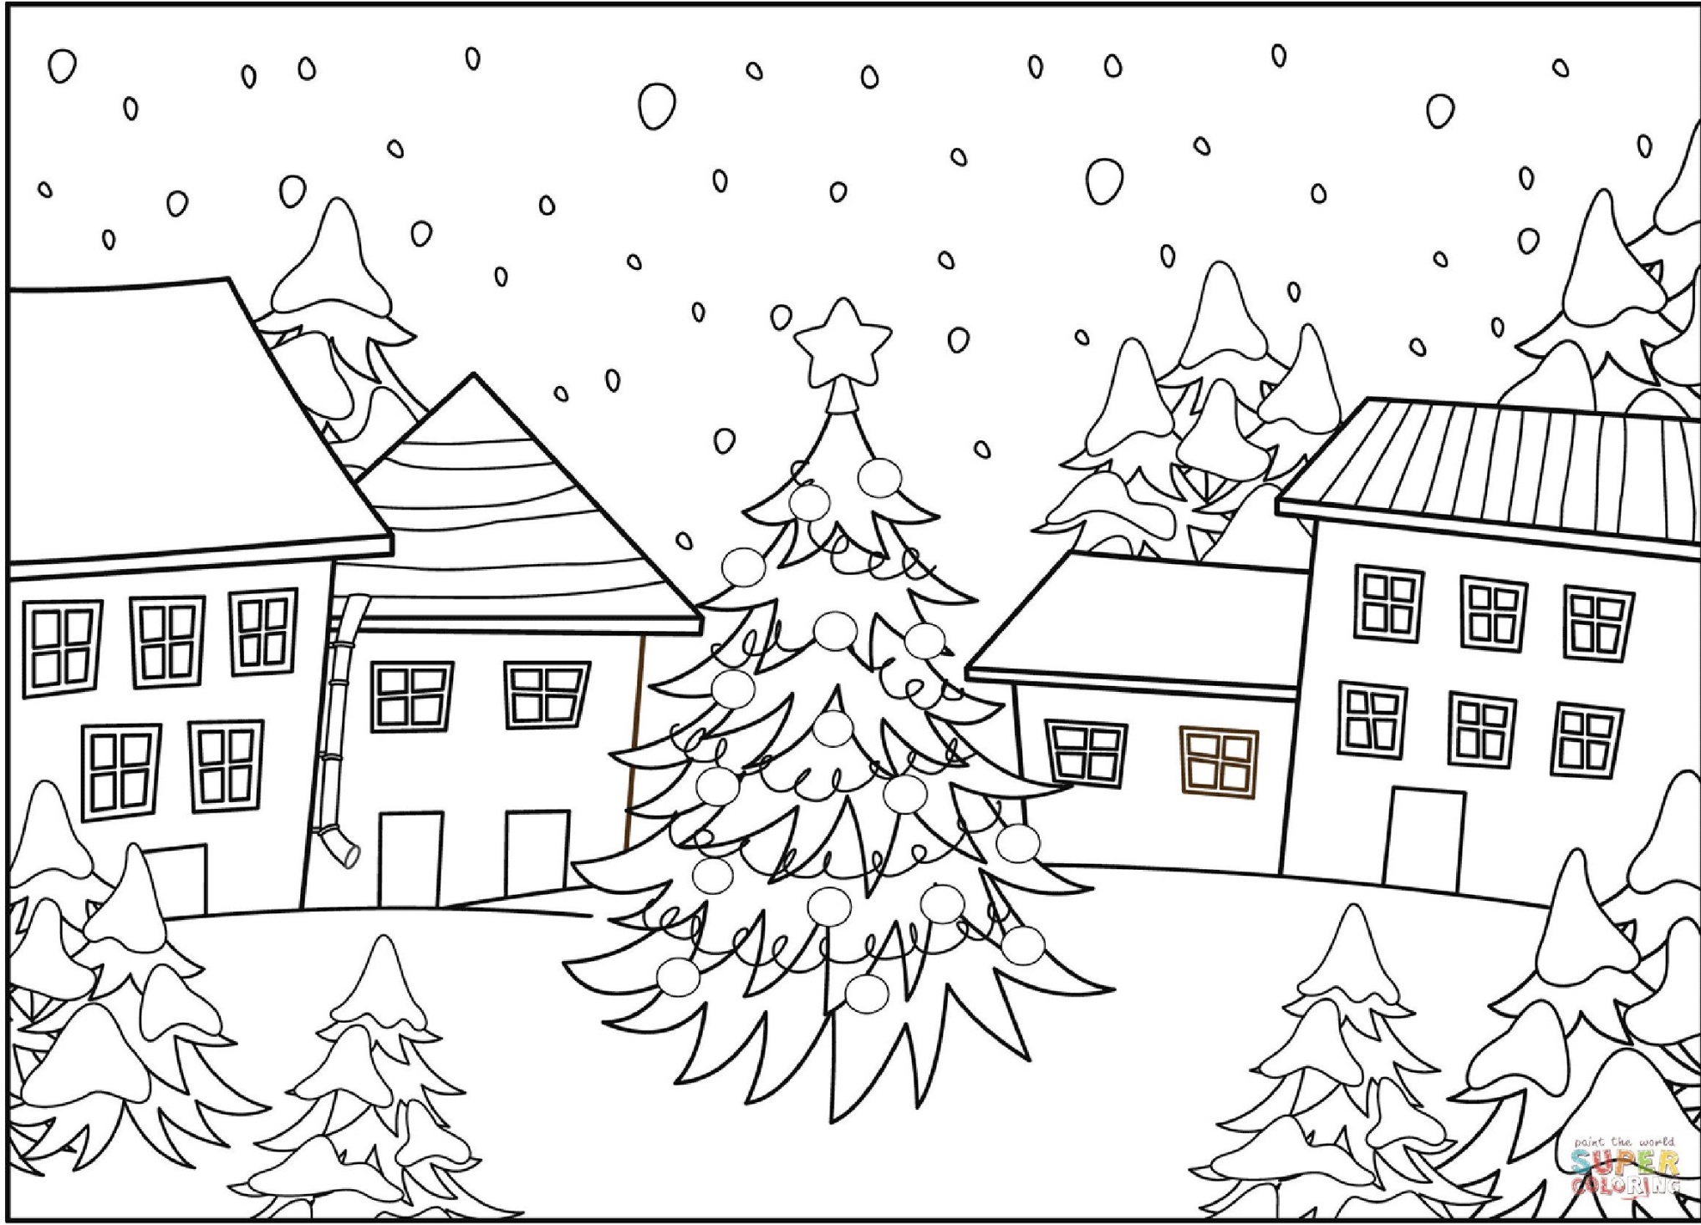
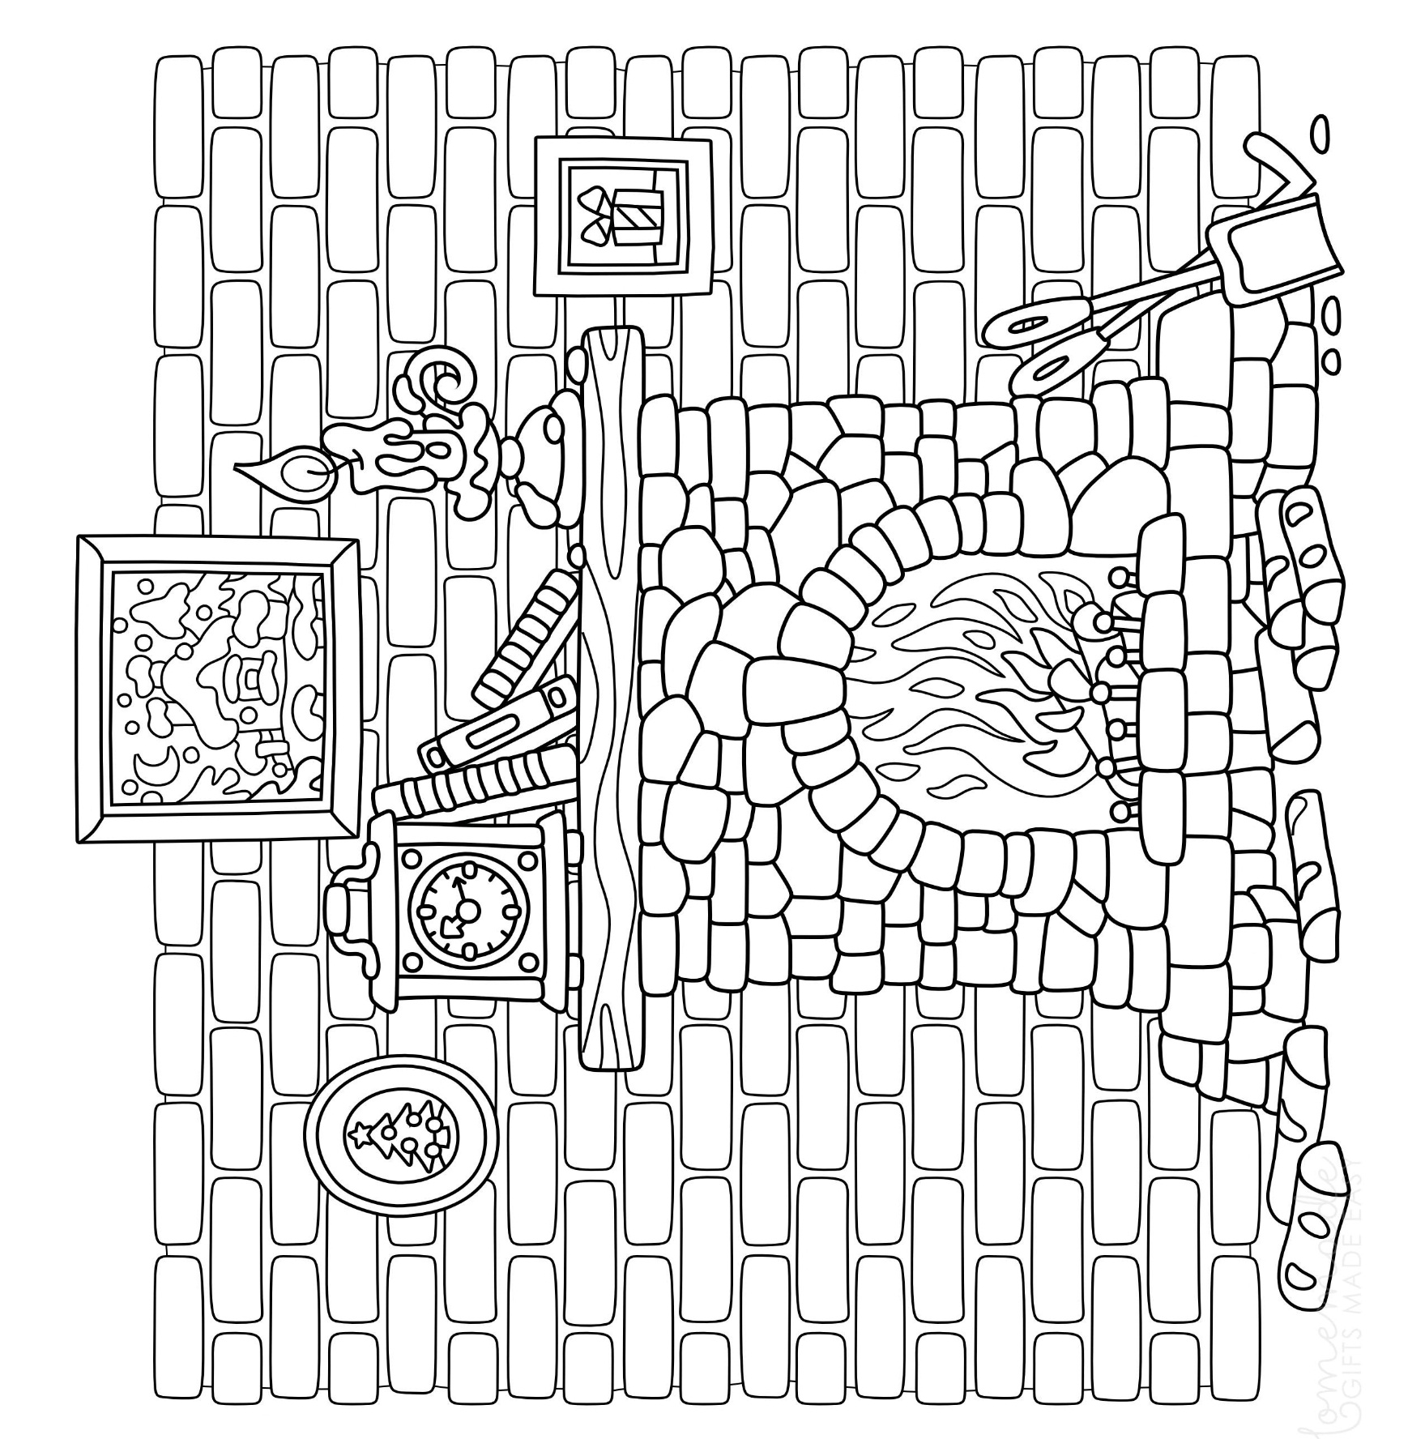
11

The image on the next page can either be coloured normally like the other images or you can also turn it into a festive card by folding along the dotted line!
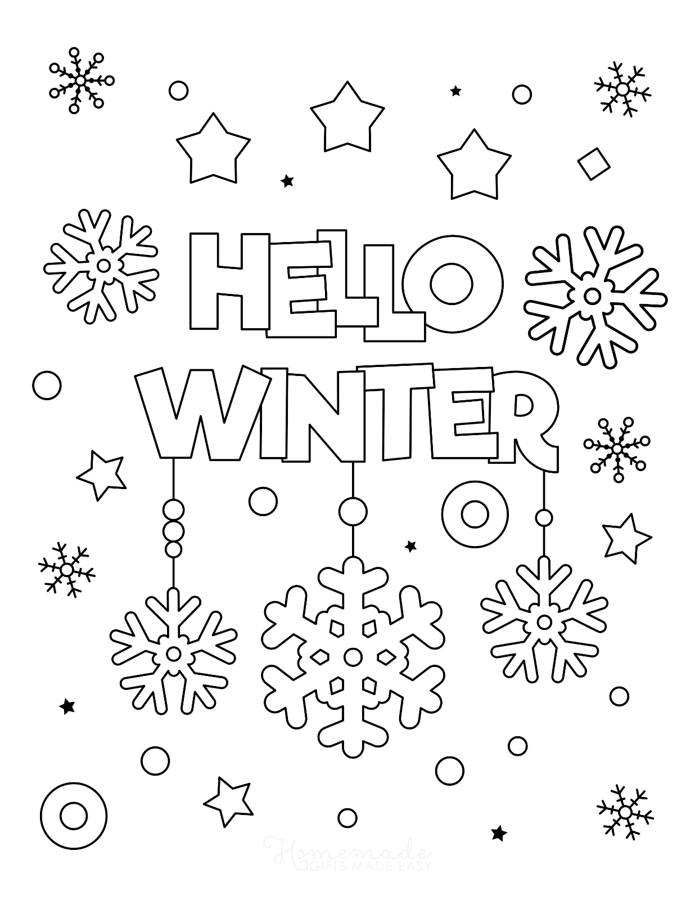

Health and Justice East Midlands Lived Experience Panel Member
A few words….

Everyone who has been to prison knows about boredom and loneliness. During my time in there, I was grateful for any kind of distraction. Talking to friends during association, going to work, education classes, the gym or the library all kept me busy so that I wasn’t ‘thinking’ too much. I was lucky that I had a partner waiting for me on the outside. Some people have no one and it would be easy to become depressed, thinking that no-one cared. But there are people who care. You wouldn’t believe how many people there are out here who are dedicated to making your life better. Not just in prison but also when you return to the community. We raise awareness of issues we see as unfair or unjust; we use our own experiences to illustrate these issues and, because we gain strength through working together, we are listened to. This distraction pack is just one small example of what we can achieve. So, as you sit there in your cell every night, think of us out here who are thinking of you and are willing you to succeed when you leave.

Thank you for reading this.

Festive Jokes

What hospital ward was William Shakespeare on…. 2b or not 2b?

Why are reindeer allowed to travel between countries? … Because they have herd immunity

Did you hear that production was down at Santa’s workshop? … Many of his workers had to elf isolate

Which government scheme supports Christmas dinner? … Eat Sprout to Help Out

What is a bison? … Where posh people wash their hands

Mr and Mrs silly move into a tower block on 12th floor and spent £750 on stair carpet.

What do you call a deer without eyes? … No eye deer!
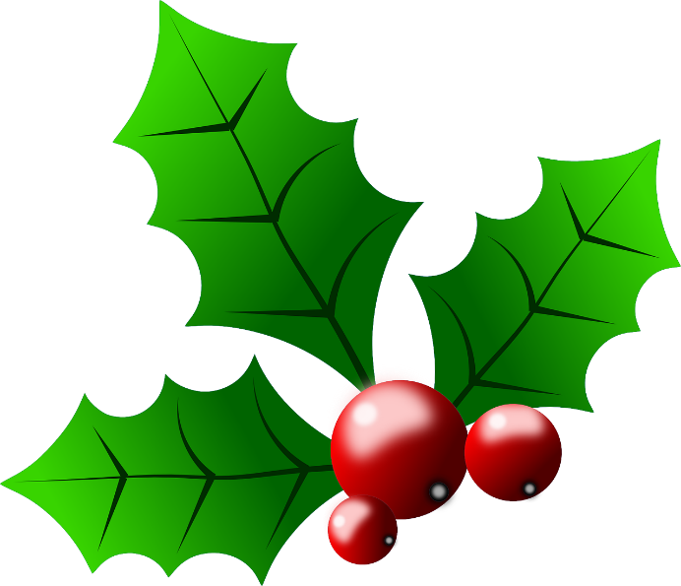
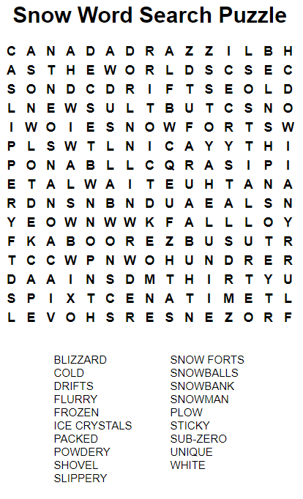
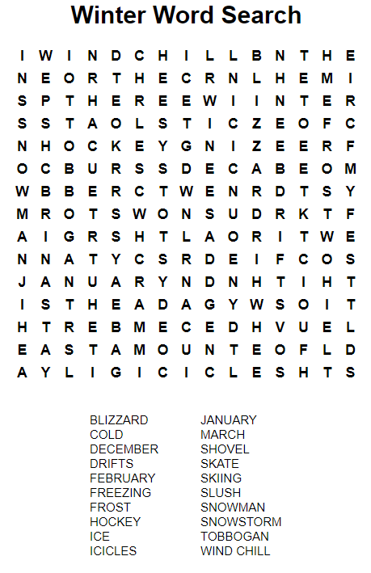
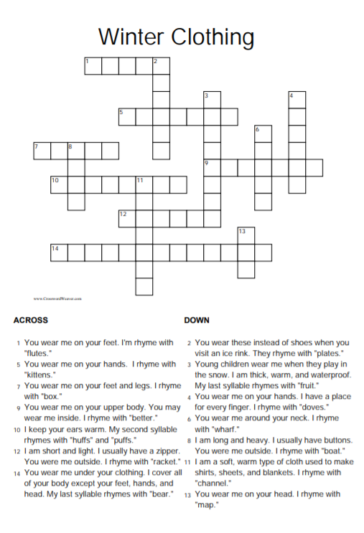
Answers after the crosswords
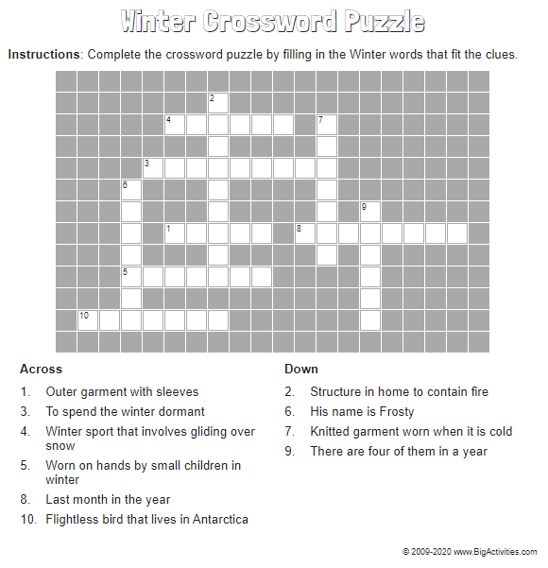

Answers after the crosswords

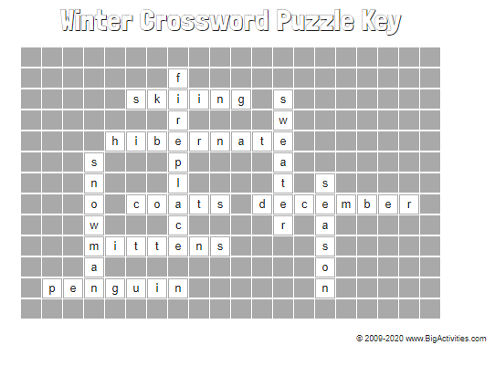
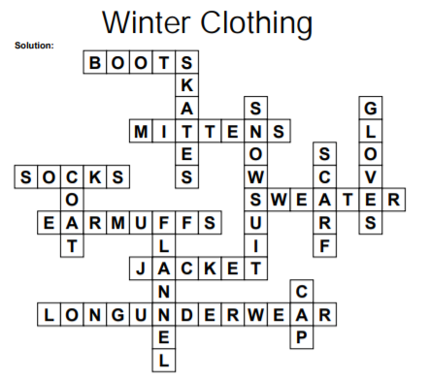
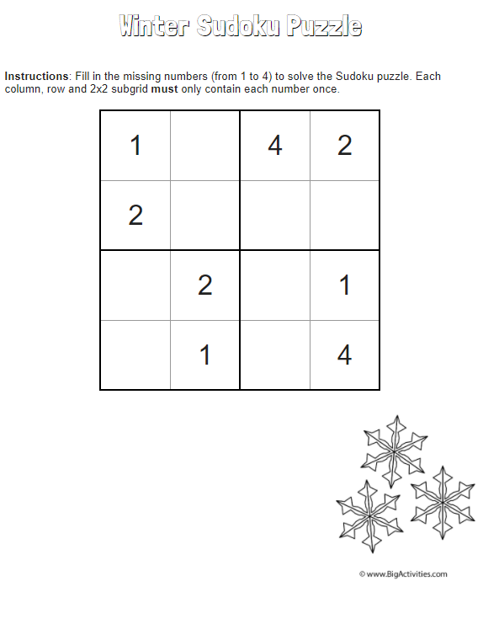
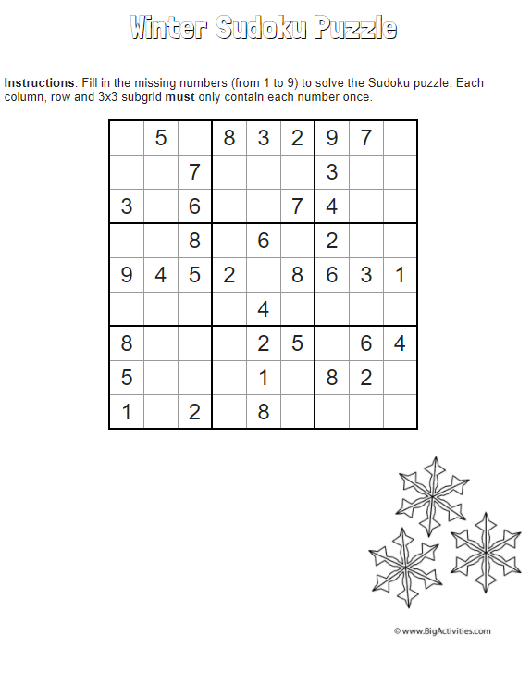

Design your own deck of cards!
You can create a unique design in the middle of the cards.
We’ve also included 8 blank cards as replacement cards and/or as Joker Cards.

♣
A
♣
A

♣
2
♣
2

♣
3
♣
3

♣
4
♣
4

♣
5
♣
5

♣
6
♣
6

♣
7
♣
7

♣
8
♣
8

♣
9
♣
9

♣
10
♣
10

♣
J
♣
J

♣
Q
♣
Q

♣
K
♣
K

♠
A
♠
A

♠
2
♠
2

♠
3
♠
3

♠
4
♠
4

♠
5
♠
5

♠
6
♠
6

♠
7
♠
7

♠
8
♠
8

♠
9
♠
9

♠
10
♠
10

♠
J
♠
J

♠
Q
♠
Q

♠
K
♠
K

♥
A
♥
A

♥
2
♥
2

♥
3
♥
3

♥
4
♥
4

♥
5
♥
5

♥
6
♥
6

♥
7
♥
7

♥
8
♥
8

♥
9
♥
9

♥
10
♥
10

♥
J
♥
J

♥
Q
♥
Q

♥
K
♥
K

♦
A
♦
A

♦
2
♦
2

♦
3
♦
3

♦
4
♦
4

♦
5
♦
5

♦
6
♦
6

♦
7
♦
7

♦
8
♦
8

♦
9
♦
9

♦
10
♦
10

♦
J
♦
J

♦
Q
♦
Q

♦
K
♦
K

Resources sourced in accordance with copyright licences. Attribution provided where required.

