


Taking a moment for yourself…

Formulated by Mala Dhakk, Health Inequalities Manager, NHSE&I, Health and Justice (East Midlands) co-produced with LEP Nov 2020
1
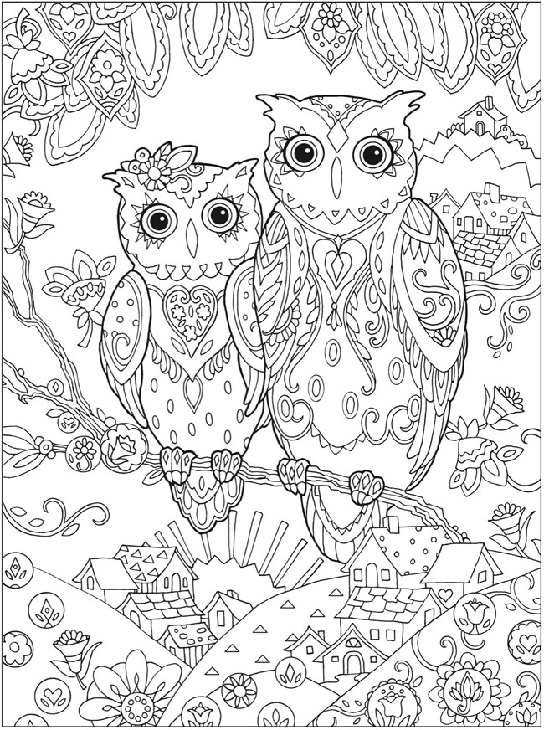

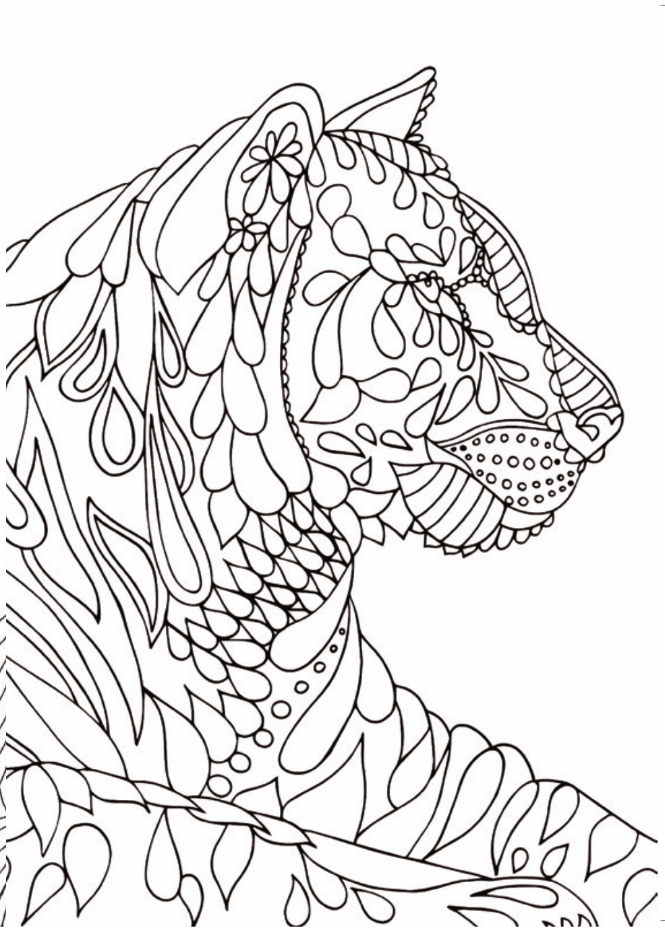
2

3



4

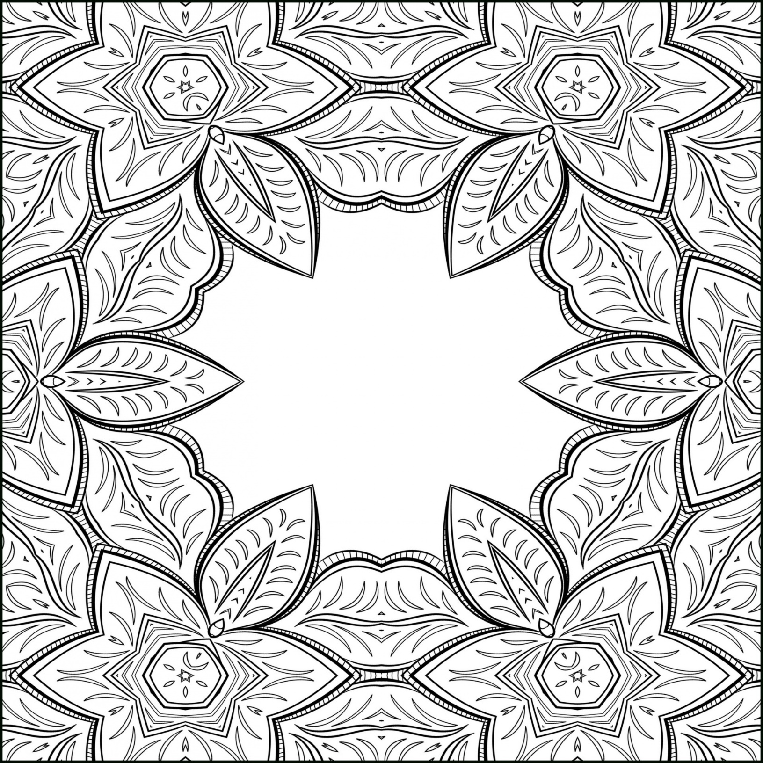

5



6

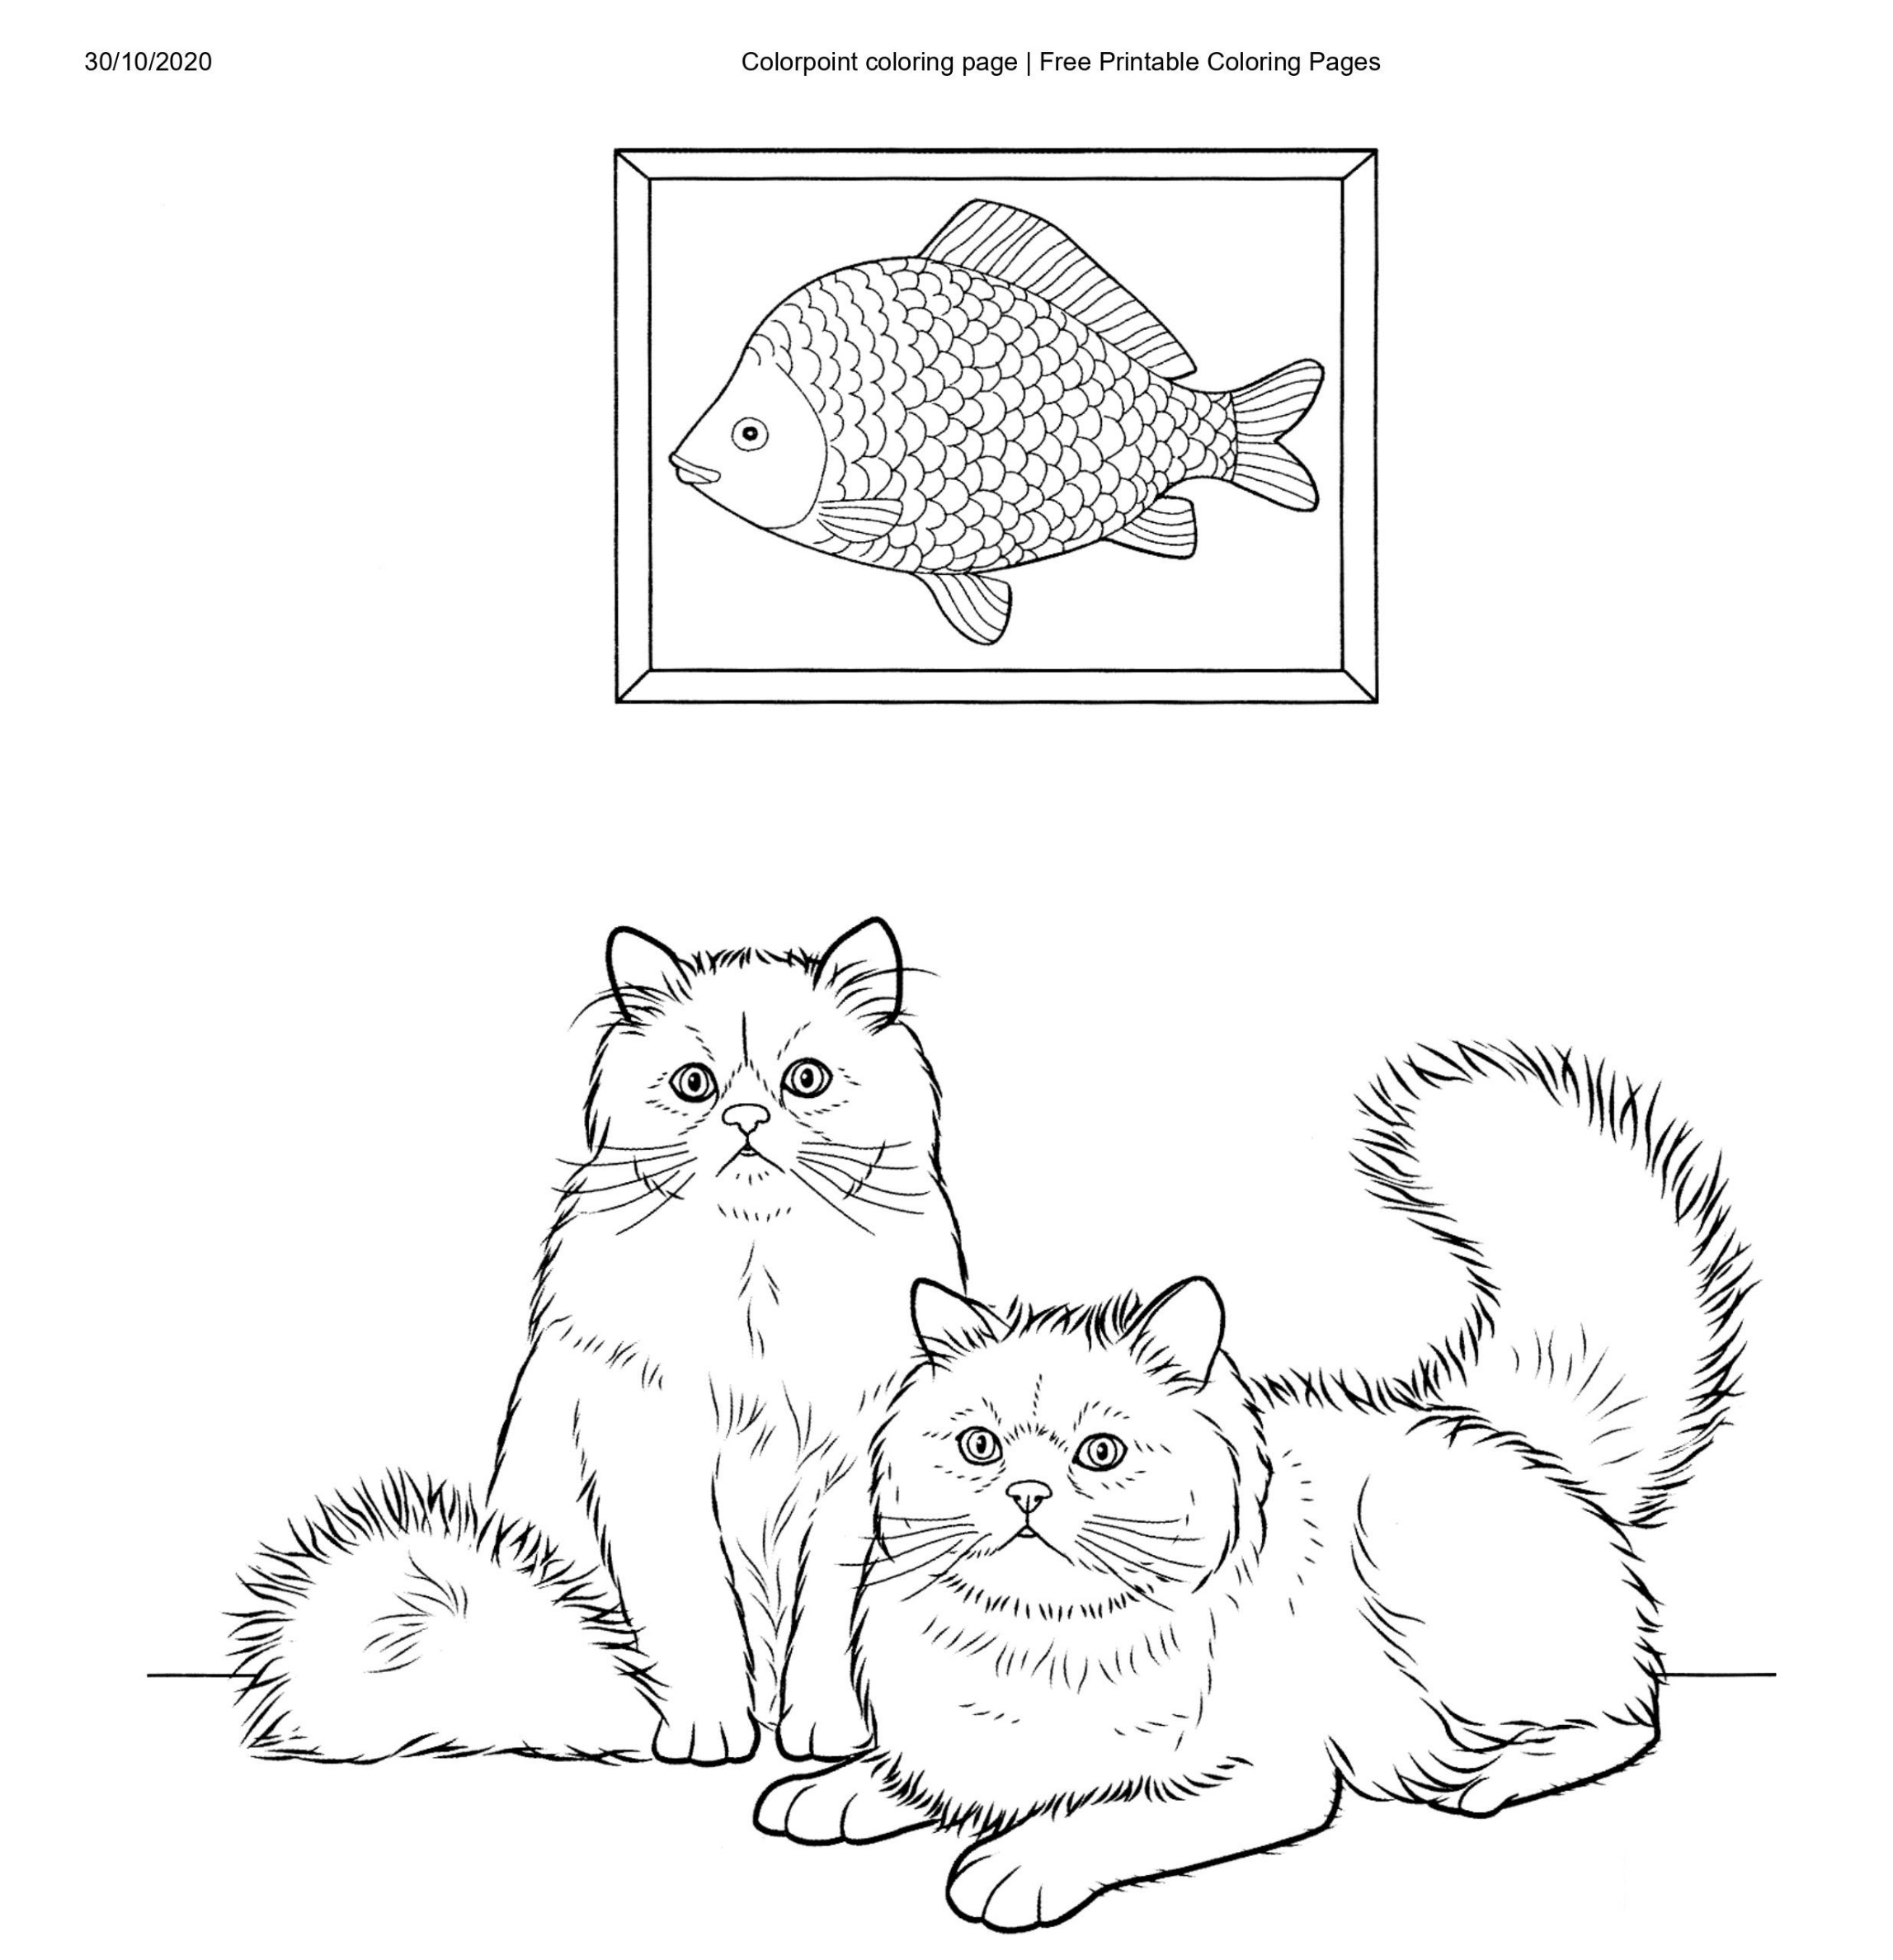

7

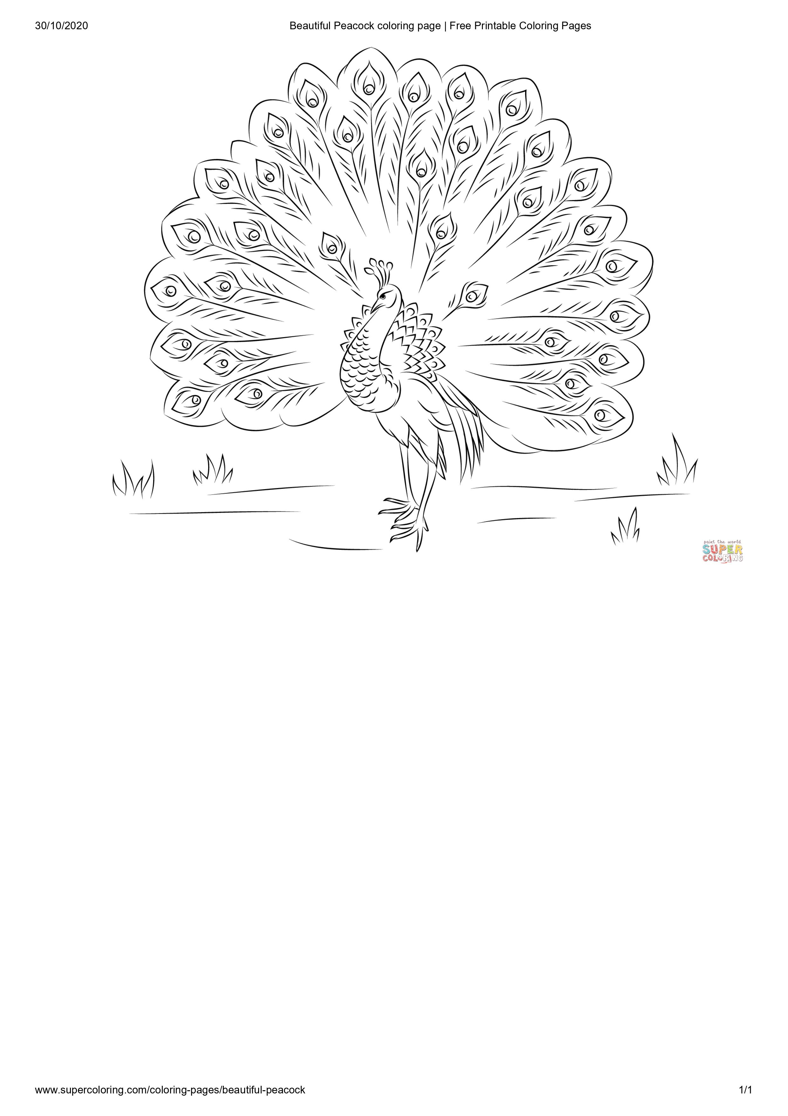

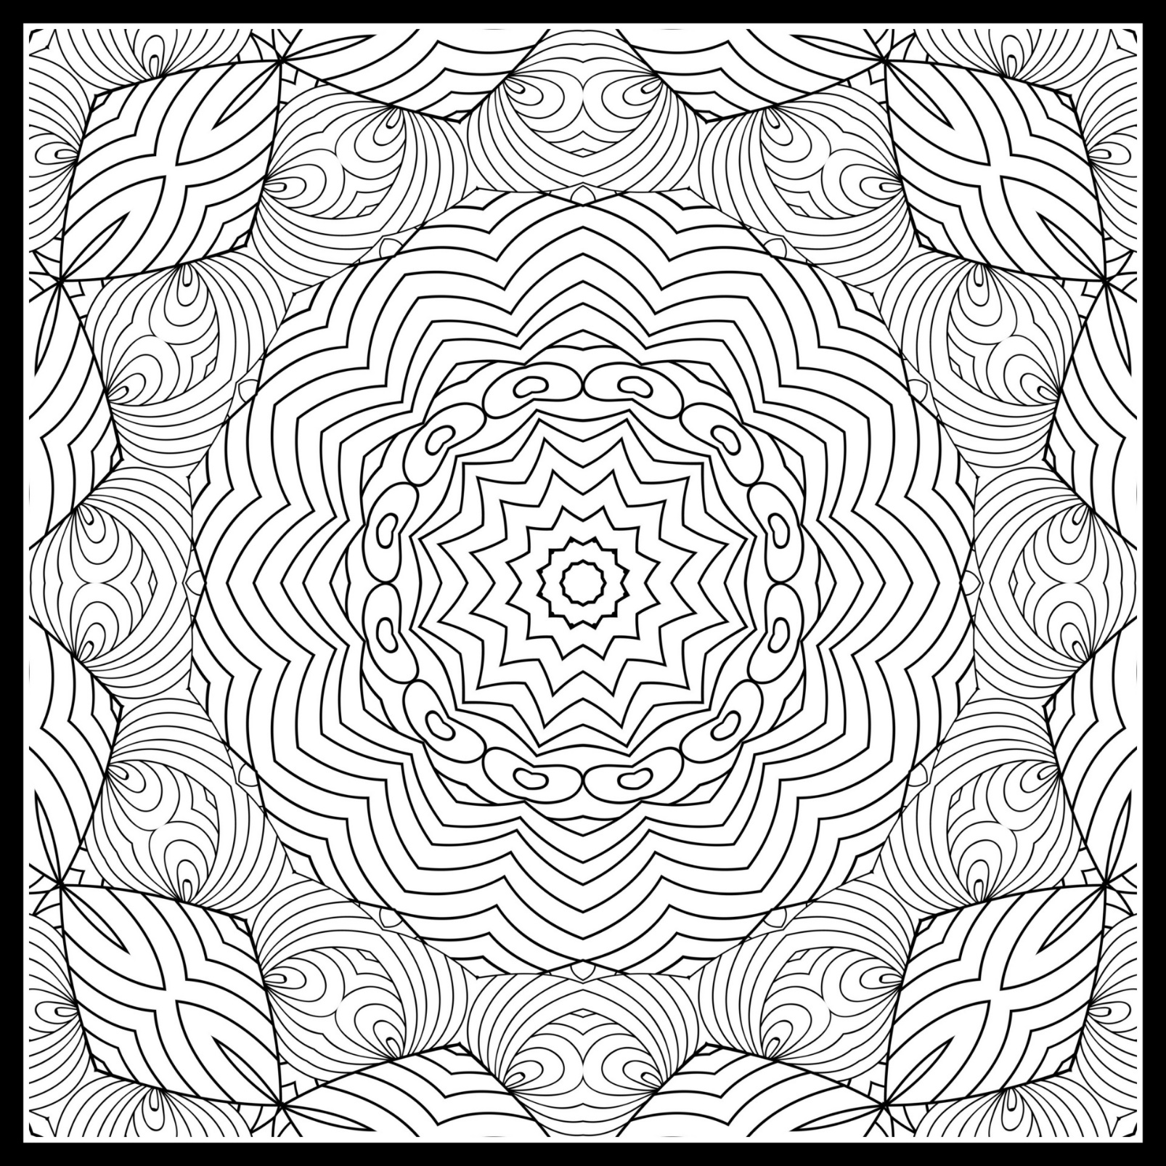
8

Sudoku Puzzles
How to complete a Sudoku
Each puzzle has a grid of boxes. Each row, column and box have different shapes in. You can’t repeat the same shape twice in a row, column or box.
There is an example below of how you fill in the puzzle.

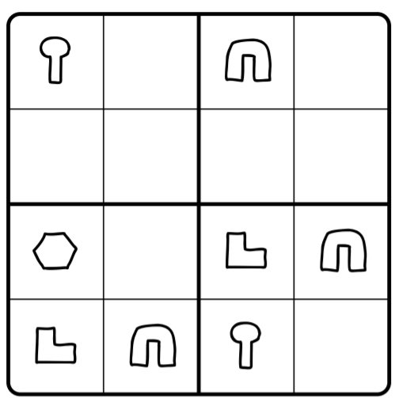

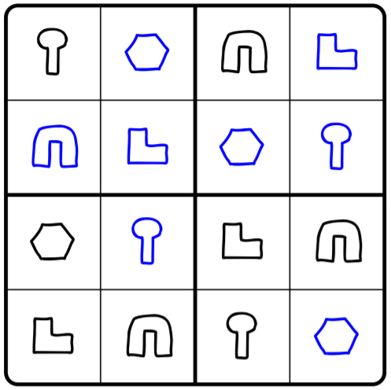

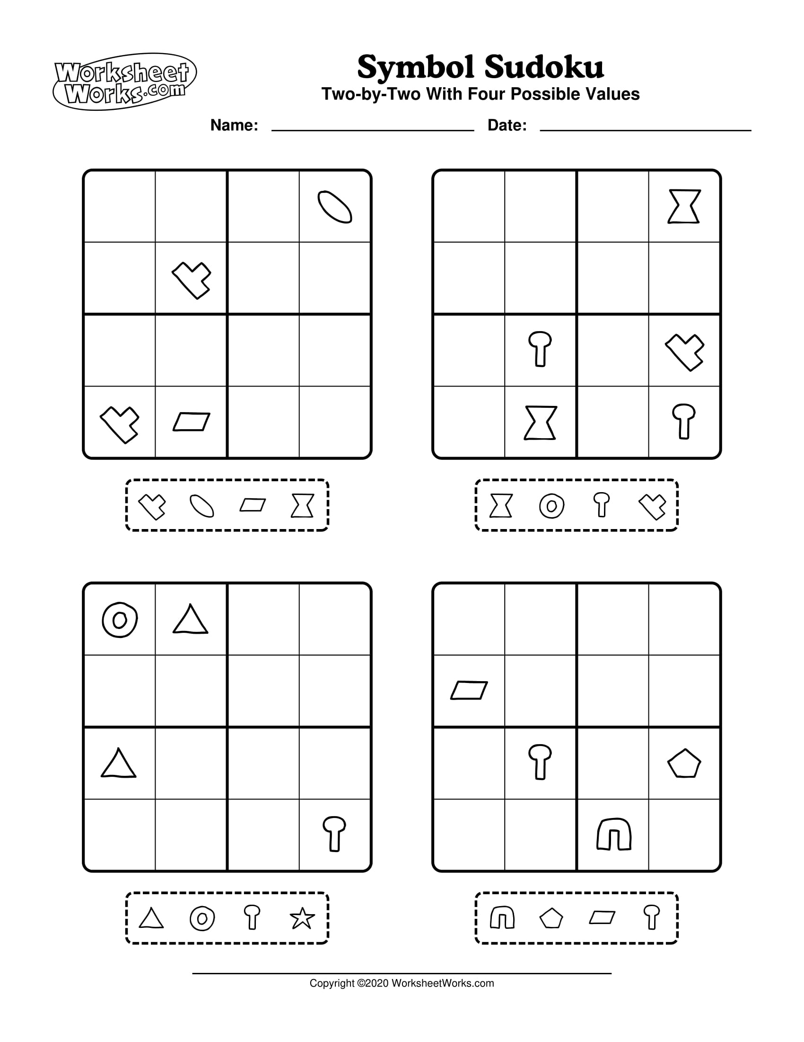

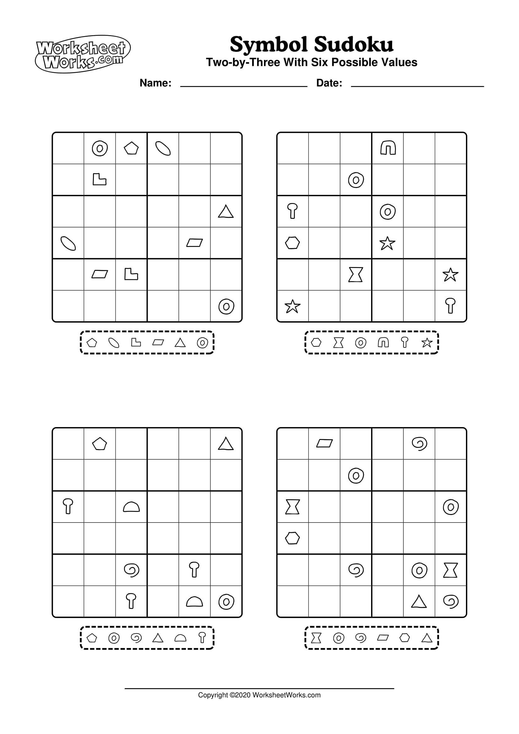

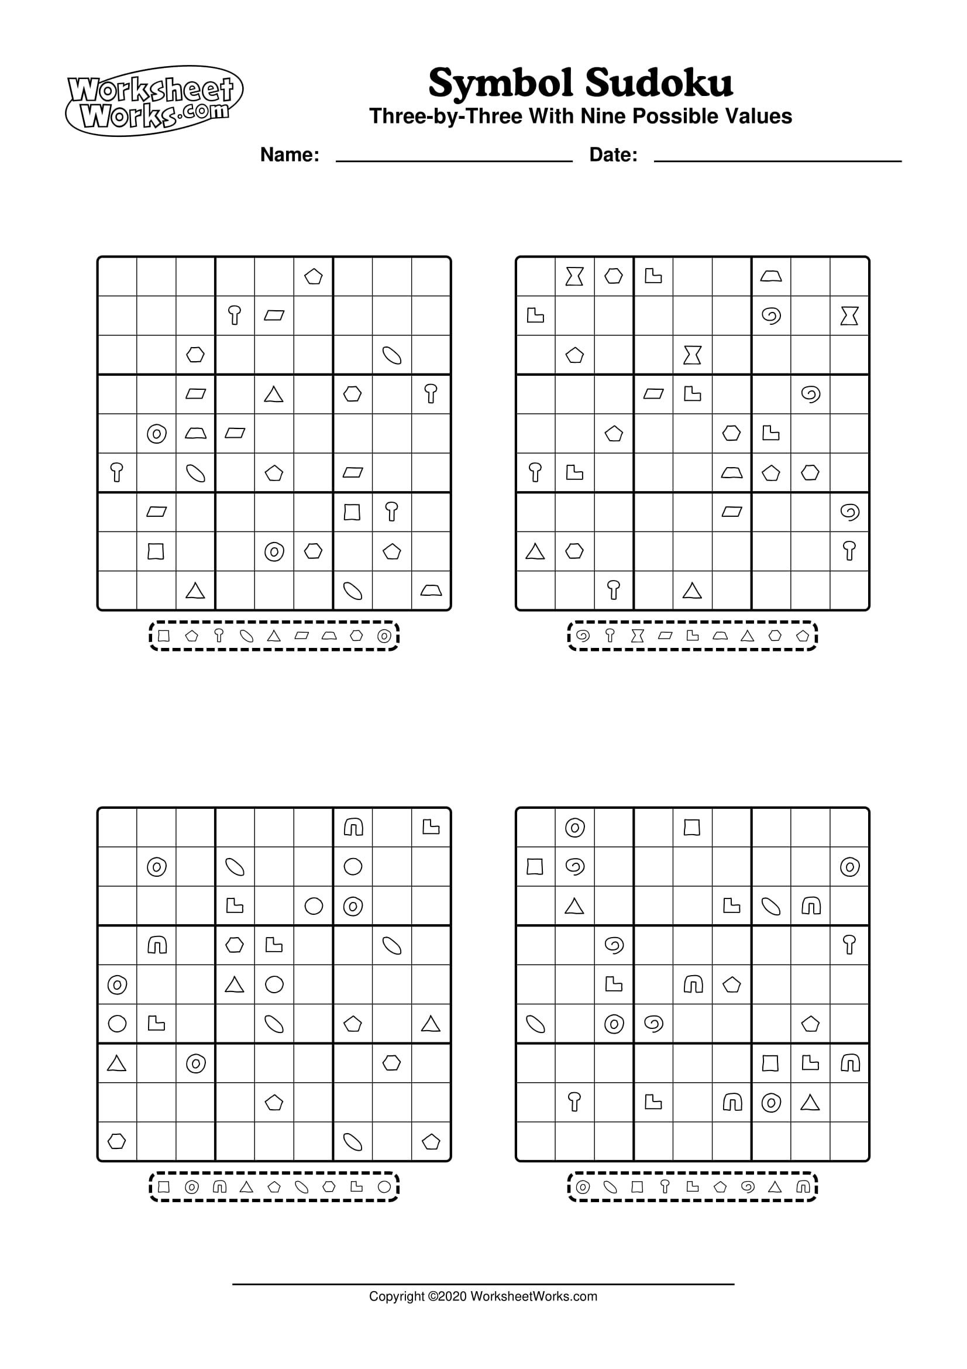



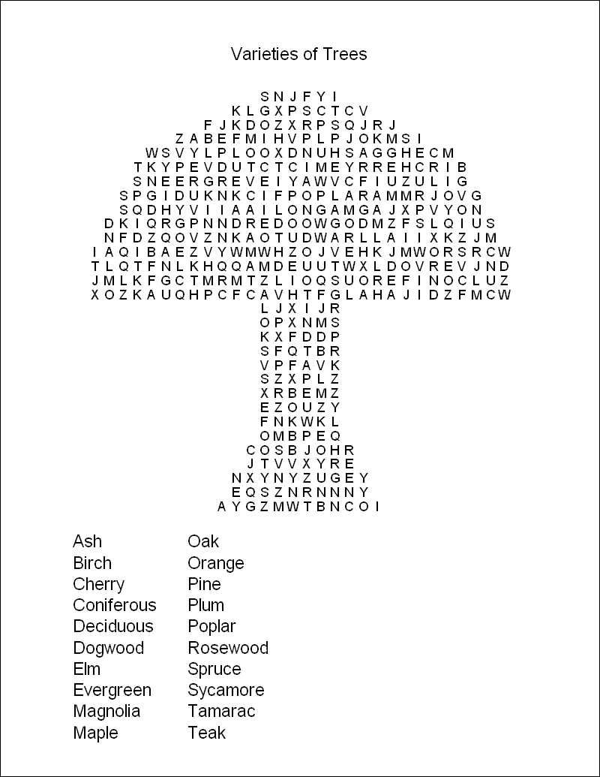


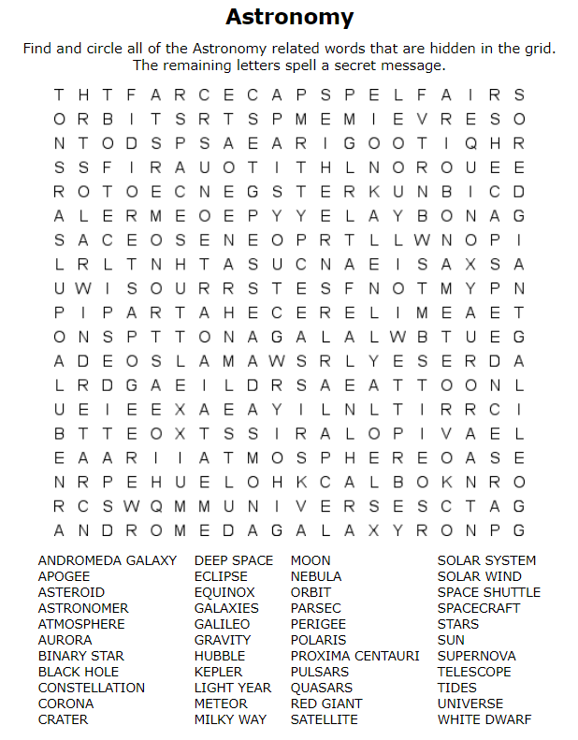
Mindful Breathing
IF YOU’RE UNSURE PLEASE SPEAK TO HEALTHCARE
BEFORE DOING THIS ACTIVITY.
Mindful breathing is to focus your attention on your breathing - in and out. You can stand or sit down or lie in a comfortable position. Your eyes may be open or closed. Whichever helps you to focus. Make some time for this. It can also help to practice it when you’re feeling particularly stressed or anxious.
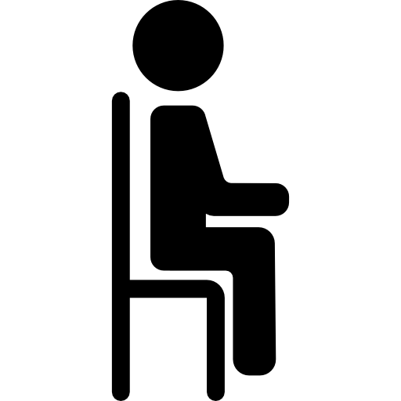
Sometimes, when trying to keep calm; it might help to start by taking an extra When you’re doing this, your mind might wander, distracted by thoughts. Just notice that this is happening and gently bring your attention back to your breath.
- Find a relaxed, comfortable position. You could be seated on a chair or on the floor. Keep your back upright, but not too tight. Hands resting wherever they’re comfortable.
- Notice and relax your body. Try to notice the shape of your body, its weight. Let yourself relax and become curious about your body seated here—the sensations it experiences, the touch, the connection with the floor or the chair. Relax any areas of tightness or tension. Just breathe.

- Tune into your breath. Feel the normal flow of breath—in, out. You don’t need to do anything to your breath. Not long, not short, just normal. Notice where you feel your breath in your body. It might be in your abdomen. It may be in your chest or throat or in your nostrils. See if you can feel the sensations of breath, one breath at a time. When one breath ends, the next breath begins.
- Be kind to your wandering mind. You might notice that your mind may start to wander. You may start thinking about other things. It’s okay. That’s natural. Just notice that your mind has wandered. And then gently draw your attention right back to the breathing.

- Stay here for five to seven minutes. Notice your breath, in silence. From time to time, you’ll get lost in thought, then return to your breath.
- Check in before you check out. After a few minutes, once again notice your body, your whole body, seated here. Let yourself relax and be proud of yourself for doing this breathing today.

Adapted from source - https://www.mindful.org/a-five-minute-breathing-meditation/
All images sourced copyright free/under creative commons licences

