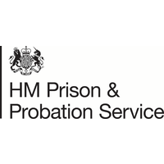

**Mental Health Allies Training**

**Pre-Workshop Material**

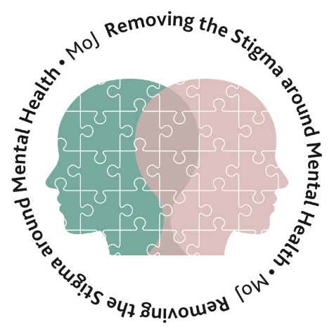



# Contents

Welcome 3

Foreword 3

Purpose of Training 4

Learning Method 4

Part 1 5

Introduction to the Mental Health Allies 5

The Role of a Mental Health Ally 5

Mental Health Allies Activities ………………………………………………………………………………………..7

Mental Health Allies & Care Teams 8

Understanding Mental Health 9

Prevalence 10

What Affects Mental Health? 11

Stigma 12

Mental Ill-Health 13

Best Practice 15

Mental Health Ally Example 16

Summary 17

Be Well logo

# Welcome

## Foreword

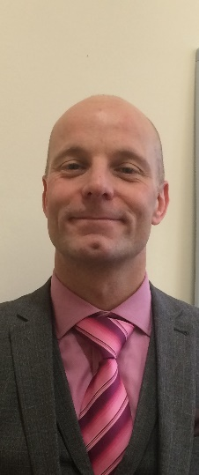Welcome to the MOJ Mental Health Allies Programme. Firstly, huge thanks for volunteering. Your role is incredibly important in reducing the stigma around Mental Health, now more than ever. The Programme offers invaluable and essential support to colleagues by listening, empathising and signposting to professional support services. Since November 2016, Mental Health Allies have been established across the wider MoJ and I am delighted that this is now being rolled out across HMPPS. This is a unique opportunity that I know will add huge value and be well received by your friends and colleagues in work.

I really do hope you enjoy this training. You should feel proud to be involved and making a difference. Thanks again.

**Graeme Goldsmith, SCS Disability Champion, Deputy Director HMCTS**

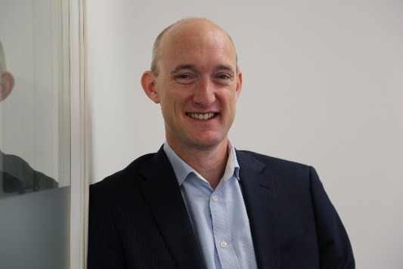I am delighted that we can recommence the Mental Health Allies training programme in HMPPS. I first came across the programme when I visited a Civil Service Live event a couple of years ago and was immediately struck by how it would be of great value in supporting both front line and HQ staff working across HMPPS. At my first meeting as Chair of the HMPPS Wellbeing Group last December, the first guest speaker I invited was the Mental Health Allies project lead to promote this impressive programme. Many thanks for volunteering, supporting your colleagues has never been so important.

**Chris Jennings, Chair of HMPPS Wellbeing Group, Executive Director for HMPPS Wales**

Page 3

## Purpose of Training

The purpose of this training pack is to:

* Provide you with an opportunity to understand your role as a Mental Health Ally.
* Be able to define the term ‘Mental Health’
* Recognise the positive and negative influences on Mental Health
* Understand the signs and symptoms of poor Mental Health
* Identify resources that can be used for promoting positive Mental Health
* Implement tools and techniques to improve **your own**Mental Health and Wellbeing.
* Understand how to promote improvement within your local business unit.
* Know the support that is available to you in your role as an Ally; for example, De-Brief Allies and Mentoring Schemes.



## Learning Method

Your Mental Health Allies Training will take place in two parts: -

**Part 1** (Pre-Workshop Reading Material) will consist of the completion of this workbook where you will be asked to read material; reflect; complete short questions and activities; review training videos and note down your own thoughts and actions. This will be completed individually before Part 2.

**Part 2** will consist of a remote group delivery which will be facilitated by a Workshop Lead from PAM Group or from within the Mental Health Allies Programme. Here, you will meet with other Mental Health Allies from across the Programme to complete short case studies in small groups and reflect on what you’ve learnt so far. You’ll also become aware of ‘What is Next’ on your Mental Health Ally journey.

Page 4

# Part 1

## Introduction to the Mental Health Allies

The Mental Health Allies Programme was established in November 2016. This was initially a pilot undertaken by HMCTS and Legal Aid Agency (LAA) North East. Following an extensive evaluation of the pilot, MOJ Executive Committee approved roll out within the business throughout 2017-2019. In 2019, the MOJ Executive Committee further approved roll out of the programme within HMPPS.

The Programme is a staff-led group of volunteers and are a vital source of information for staff and managers. Allies are a welcome source of support to individuals at a time of need who listen, empathise and signpost to professional support services where appropriate. As of March 2020, there were over 925 MHA’s across the MOJ. It is anticipated that when roll out is complete in HMPPS, the programme will have approximately 1500-1600 Allies.

[MHA team video](https://hmppsintranet.org.uk/video/mha_team/)

### The Role of a Mental Health Ally

For the programme to maintain its integrity and effectiveness, it is important that Allies clearly understand the scope of their role. As each case is unique, it is not always possible to be precise in defining the exact boundary of the role, however, the following principles – as outlined in the Mental Health Allies Framework - should be adhered to:

* Allies do not act in an official capacity, but as part of a staff-led group. The Mental Health Allies programme compliments and sits alongside the role of other staff programmes.
* They do not diagnose mental health conditions nor provide medical or psychiatric advice, nor do they replace support services such as the Employee Assistance Programme.
* Giving information to help employees make informed choices on the options available to them.
* Allies must always abide by the confidentiality rules.
* It is important that Allies should not allow a dependency to develop with individuals. Their role is to empower the individual so that they understand their situation more clearly, and have the confidence to make the choices that are right for them. Allies are there to offer empathy and support, but their relationship is different to a friendship.
* In serious and rare situations, for example, where an individual threatens to harm themselves or others, or cases covered by legal obligations - Allies **must always** follow the procedures shown in the ‘Confidentiality’ section.

* Allies will challenge stigma and raise mental health awareness within the workplace.
* Allies will look out for opportunities to raise awareness of mental health and promote mental wellbeing in their work areas/offices. To maximise impact and reach, this is likely to work best in collaboration with colleagues in wellbeing or diversity & inclusion programmes – the roles are not exclusive and there will be overlapping topics of interest.
* Allies will participate in group telephone and digital conferences to share good practice. Allies are encouraged to get to know other Allies in their region and wider so they get to develop an understanding of the knowledge and skills within the programme should they require support.

Page 5

* As a member of a staff programme an Ally may – in very rare cases - be invited to attend a HR meeting as a companion. However, Allies will not act as an advocate for individuals in HR or management processes and will not pass judgement on management decisions. If this kind of HR support is required, the individual should be signposted to their trade union or to other sources of professional advice.
* Allies’ support to managers can include providing the manager with a greater understanding of mental ill health; advice on constructive conversations; benefits of workplace adjustments; sources of information and professional support that may be relevant to the individual’s circumstances.

**A Mental Health Ally should not:**

* Take an active role in the resolution process (including investigating complaints and grievance proceedings).
* Make judgements or trying to establish the facts of the case.
* Try to influence an employee’s decision about what action to take.
* Accompany an individual to hospital or arranging a home visit.

**Activity:**

**From the description of the role above, can you think of anything that you might already be doing that fits within this role? Think about any activity days you might have at work; any support you already provide to colleagues or friends/family; any awareness days you might already focus on.**

**Secondly, what are the benefits you expect to come from growing a network of Mental Health Allies? Think of the impact this network has on your colleagues and he organization.**

______________________________________________________________________________________________________________________________________________________________________________________________________________________________________________________________________________________________________________________________________________________________________________________________________________________________________________________________________________________________________________________________________________________________________________________________________________________________________________________________________________________________________________________________________________________________________________________________________________________________________________________________________________________________________________________________________________________________________________________________________________________________________________________________________________________________________________________________________________________________________________________________________________________________________________________________________________________________________________________________________________________________________________________________________________________________________________________________________________________________________________________________________________________________________________________________________________________________________________________________________________________________________________________________________________________________________________

Page 6

## Mental Health Allies Activities

Below are just some of the examples of the work that has been completed so far by our Mental Health Allies. This includes sharing of information and available support, lunch ‘n’ learns awareness sessions, ‘Time to Talk’ Away Days, Seminars and Mental Health-themed quizzes for Mental Health Awareness Week.

Picture 1 = MH quiz for mental health awareness week

Picture 2 = MHAs seminar

Picture 3 = MHAs Time to Talk Away Day

Picture 4 = Civil Service Live in Cardiff

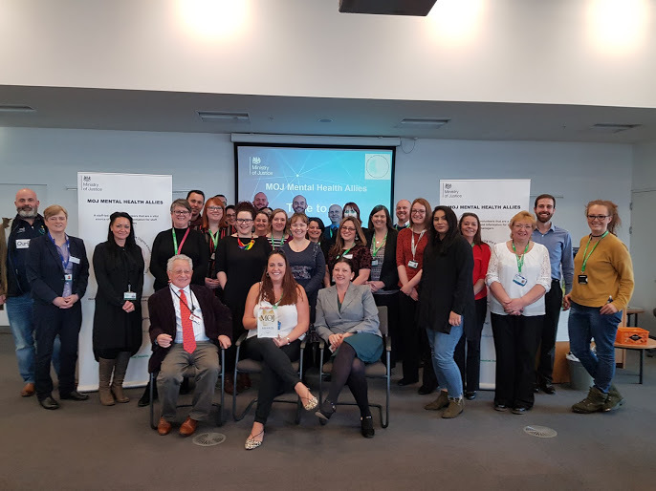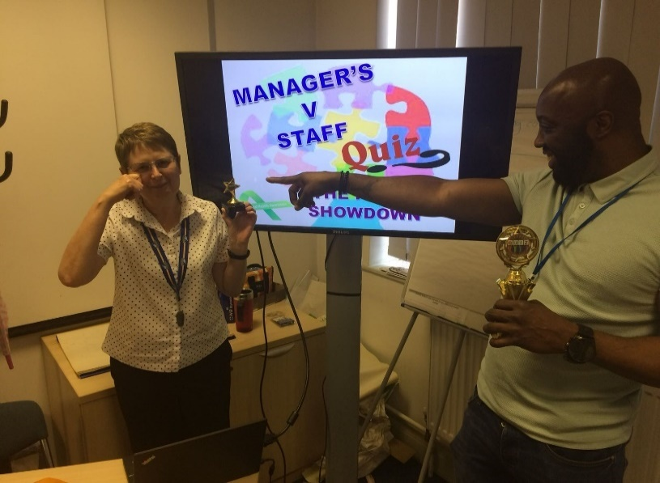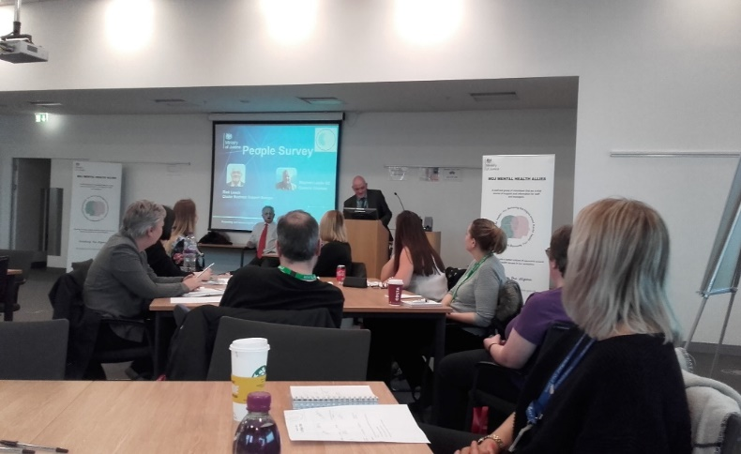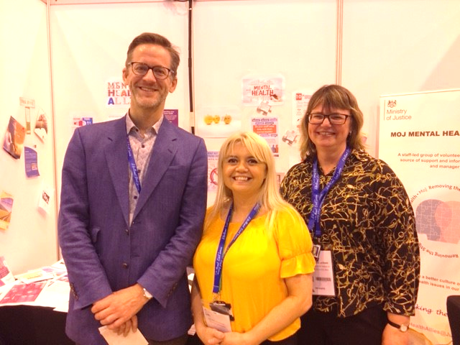

Page7

You may already be completing activities that form part of your role as a Mental Health Ally. A large part of your role will be to raise awareness and this might be through national campaigns such as:

* Time to Change (1st Thursday in February)
* Mental Health Awareness Week in May
* World Health Organisation’s, Mental Health Day on 10th October
* Movember

It’s also important to consider the impact that expanding the programme has. Benefits may include, but are not limited to:

* Raising awareness of Mental Health and reducing stigma
* Creating a positive culture
* Attracting new staff
* Retaining staff
* A diverse programme of Allies available to employees across the organisation
* Reduction in sickness absence
* A happier and healthier workforce

[MHA Allies: work being done so far](https://hmppsintranet.org.uk/video/mha/)

### Mental Health Allies, Care Teams and TRIM

**“compliments, rather than duplicates”**

The core skills of a Mental Health Ally compliment the work of our Care Teams and Trauma Risk Management (TRIM). Table 1 highlights the key features of each role.

Table 1: Features for Care Teams and TRIM, and Mental Health Allies.

|  |  |
| --- | --- |
| Care Teams and TRIM | Mental Health Allies |
| * Care teams are a resource to staff who may want to discuss personal issues to get emotional support through difficult times and are mainly utilised aftera traumatic event. | * Offer a structure of support where staff and managers feel comfortable discussing mental ill health in an open safe and comfortable environment. |
| * TRIM – reactive after a traumatic event. | * Removing stigma through a raised awareness of mental ill health. |
| * Both are reactive in nature with support to help relieve symptoms of post-traumatic stress from a specific incident. | * A **proactive**programme to ensure everyone can access the right support via signposting and being a continuous, constant presence. |

Page 8

**Activity:**

**Before we define the terms, ‘Health’ and ‘Mental Health’, see if you can come up with you own definitions, or key words that you associate with both terms. Write your answers below.**

**Health:**

____________________________________________________________________________________________________________________________________________________________________________________________________________________________________________________________________________________________________________________________________________________________________________________________

**Mental Health:**

____________________________________________________________________________________________________________________________________________________________________________________________________________________________________________________________________________________________________________________________________________________________________________________________

## Understanding Mental Health

Often, when we think of the term, ‘Health’, many of us will see it as simply being our physical state, such as our fitness, endurance, eating habits and so on; however, health is the **complete**state of our physical, mental **and** social wellbeing. There are things that we can do to promote wellbeing, or increase our risk of disease. Like our physical health, our mental health is affected by everything in our lives, and it is important to note that each component of health – namely, physical, mental or social wellbeing – can have an impact on one another. For example, if we are experiencing difficulties with our physical health, this can have a huge impact on our mental wellbeing and/or social wellbeing; and, vice versa.

“**Health** is a state of complete physical, mental and social wellbeing and not merely the absence of disease or infirmity”

World Health Organisation

We all have mental health, just as we all have physical health, and in both cases, we are on a continuum, where our health can vary day to day. The state of our Mental Health affects the way that we think, the way that we feel and the way that we act. It is estimated that one in three people experience a mental health condition in any given year, and that one in six employees are depressed, anxious or suffering from stress-related problems at any one time. The bad news is that work can trigger or exacerbate such issues; the good news is that enlightened organisational practices, such as the Mental Health Allies programme plays a powerful role in fostering wellbeing and sustaining good mental health.

Page 9

“**Mental Health** is a state of mind in which an individual is able to realise his or her own abilities, cope with the normal stresses of life, can work productively and fruitfully, and is able to make a contribution to his or her community”

World Health Organisation

### Prevalence

### 

The most recent statistics from the Mental Health at Work Report (2019) identify that **30%** of the UK workforce have been formally diagnosed with a mental health condition at some point in their lifetime. Specifically, in the workplace, **2 in 5 (39%)** of employees have experienced poor mental health due to work, or where work was a contributing factor.

**Further key statistics from this report highlighted that:**

* + Only 13% of managers have attended specific training that focused on mental health. By comparison, a third of CEOs or Board personnel have received some form of training about mental health.
  + LGBT+ employees are especially likely to have experienced a mental health problem where work was a cause or factor (79% of LGBT+ people, compared to 62% who don’t identify as LGBT+).
  + Worryingly, the proportion of employees who believe their organisation does well in supporting those with poor mental health fell to 41% from 45% over the past year from 2018 to 2019.
  + The three main causes of work-related poor mental health are too much pressure, workload impacting on ability to take leave (leavism*) and a lack of support. Employee mental health is also affected by negative work relationships, and people not feeling able to trust their managers.

It’s important to note that poor mental health can have a huge financial impact in the workplace. Specifically, poor mental health costs the workplace a staggering £34.9 billion per year in the UK. Alongside this, presenteeism costs the workplace £15.1 billion per year in the UK.

**Activity:**

**You’ll notice from the statistics that there was no mention of the prevalence of poor Mental Health across different age groups, or even across different genders. What do you think the prevalence of poor Mental Health would be for these two categories? Write your thoughts below.**

**Age Groups:**

___________________________________________________________________________________________________________________________________________________________________________________________________________________________________________________________________________________________________________________________________________________________________________________________________________________________________________________________________________________________

**Gender:**

___________________________________________________________________________________________________________________________________________________________________________________________________________________________________________________________________________________________________________________________________________________________________________________________________________________________________________________________________________________________

Leavism is a term used to describe employees using flexitime, annual leave, rest days and other leave entitlement schemes to have time off when they are in fact too unwell to go to work.

Page 10

**Mental Health Statistics: Men & Women and Children & Young People**

Mental health problems affect both men and women, but not in equal measure:

* In England, **women are more likely than man to have a common mental health problem.**
* In 2013, 6233 suicides were recorded in the UK for people aged 15 and older – **78% were male and 22% were female.**

When we consider the prevalence across age groups:

* **50%** of mental health problems are established by age 14 and **75%** by age 24.

To understand more about these statistics, click here (<https://www.mentalhealth.org.uk/sites/default/files/fundamental-facts-about-mental-health-2016.pdf>)

### 

### What Affects Mental Health?

Our mental health is affected by just about anything and everything in our lives. Figure 1 outlines the biopsychosocial model – this was developed by George Engel in 1977 and suggests that to understand a person’s condition, an interconnection between biology, psychology and socio-environmental factors need to be considered.

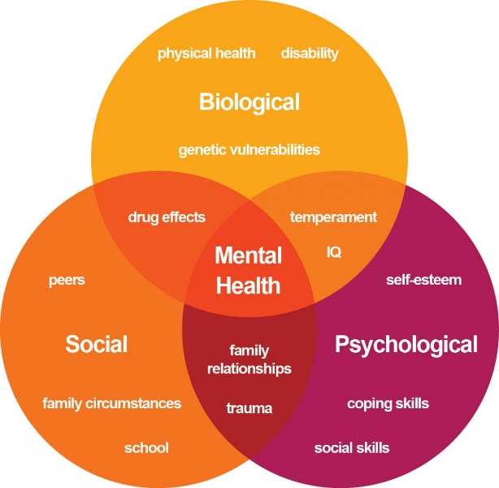

Figure 1: The biopsychosocial model by George Engel (1977).

From this model, it is important to be aware of personal and work-related circumstances that may increase vulnerability of experiencing stress or poor mental wellbeing. Table 2 outlines circumstances that may increase this vulnerability.

Page 11

 **Top Tip:** as a Mental Health Ally you will want to be mindful of resources that can help the individual with Personal Circumstances as it is largely these topics that conversations will be based upon. The ‘Hub of Hope’ is a helpful resource for identifying external support: <https://hubofhope.co.uk/>

**Table 2:** Outline of personal and work-related circumstances that will increase the vulnerability of experiencing poor mental wellbeing.

|  |  |
| --- | --- |
| Personal Circumstances | Work-Related Circumstances |
| Bereavement | Organisational Change |
| Marital Issues | Change in Work Role |
| Financial Issues | Increase Workload |
| Illness & Disease | Reduced Resourcing |
| Family Care Responsibilities (both children and elderly relatives) | Bullying & Harassment |

### Stigma

Even with so many people affected by poor mental health, there is still a strong social stigma attached to mental ill health. Ask yourself; **why does stigma exist?**Society in general has stereotyped views about mental illness and how it affects people and this can generally be due to lack of knowledge, our own experiences and the media. A key element of your role as a Mental Health Ally is to stamp out this stigma – this is vitally important because nearly nine out of ten people with a mental health condition say that stigma and discrimination has a negative effect on their lives and can even be worse than the condition itself.

Thinking about the language we use when describing mental health can be a great starting point for reducing stigma and creating a culture in your workplace where your colleagues feel comfortable and open to talk about their Mental Health. Try the alternative suggestions below from Time to Change:

**Avoid using:**

* ‘a psycho’ or ‘a schizo’
* ‘a schizophrenic’ or ‘a depressive’
* ‘lunatic’ ‘nutter’ 'unhinged' 'maniac' 'mad'
* ‘the mentally ill’, ‘a person suffering from’ ‘a sufferer’, a ‘victim’ or ‘the afflicted’
* 'prisoners’ or ‘inmates’ (in a psychiatric hospital)
* ‘released’ (from a hospital)
* 'happy pills'

**Instead try:**

* ‘a person who has experienced psychosis’ or 'a person who has schizophrenia'
* someone who ‘has a diagnosis of’ is ‘currently experiencing' or ‘is being treated for…
* ‘a person with a mental health problem’
* ‘mental health patients’ or ‘people with mental health problems’
* ‘patients’, ‘service users’ or clients
* ‘discharged’
* ‘antidepressants', 'medication' or 'prescription drugs'

Page 12

**Activity:**

**Think about where you work and the culture in your local business unit:**

**What are you not doing that you need to start doing to promote an open culture?**

____________________________________________________________________________________________________________________________________________________________________________________________________________________________________________________________________________________________________________________________________________________________________

**What are you doing which you need to stop to promote a more open culture?**

____________________________________________________________________________________________________________________________________________________________________________________________________________________________________________________________________________________________________________________________________________________________________

**Lastly, what are you doing now which you should continue to promote a more open culture?**

____________________________________________________________________________________________________________________________________________________________________________________________________________________________________________________________________________________________________________________________________________________________________

### Mental Ill-Health

As a Mental Health Ally, you are not expected to diagnose, identify or treat those experiencing poor Mental Health, however, it is valuable to understand what someone is experiencing poor mental health. There are many types of mental ill-health conditions and symptoms are common to more than one diagnosis. Specifically, we’ll review anxiety and depression, but for an A-Z on Mental Ill-Health, you can click here to visit MIND. (link: <https://www.mind.org.uk/information-support/types-of-mental-health-problems/>)

**Depression**

Everyone can feel “sad or blue”, but when this mood lasts for a long time and affects your everyday life, it may be depression. In its mildest form, depression can just mean being in low spirits – it won’t stop a person from leading a normal life but it can make things harder to do and seem less worthwhile. At its most severe, depression can be life-threatening and it can make you feel suicidal.

There are many different types of depression, with common types including:

* **Seasonal affective disorder (SAD)** – depression that occurs at a particular time of year, or during a particular season.
* **Dysthymia** – continuous mild depression that lasts for two years or more. Also called persistent depressive disorder or chronic depression.
* **Prenatal depression** – depression that occurs during pregnancy. This is sometimes also called antenatal depression.
* **Postnatal depression (PND)** – depression that occurs in the first year after giving birth.

See the table below for common signs and symptoms of depression.

Page 13

**Table 3:** Common signs and symptoms of depression. Adapted from mind.org.uk

|  |  |
| --- | --- |
| **How a Person May Feel** | **How a Person May Behave** |
| * Restless, agitated or irritable * Guilty * Worthless * Low self confidence * Empty and numb * Isolated and unable to relate to other people * Finding no pleasure in life or things you usually enjoy * Disconnected * Low self esteem * Hopeless and despairing * Suicidal * Tearful * Rapidly changing mood swings | Avoiding of social events and activities   * Self-harming or suicidal behaviour * Difficulty thinking clearly * Loss of interest in relationships * Difficulty concentrating * Substance abuse * Insomnia * Withdrawn * Appetite changes * Illness with no obvious cause * Moving at a slow or very fast pace * Erratic mood swings * A change in sense of humour |

**Activity:**

**Spend a moment watching “I had a black dog, his name was depression” by the world Health Organisation. At its worst, depression can be a frightening, debilitating condition. Millions of people around the world live with depression. Many of these individuals and their families are afraid to talk about their struggles, and don’t know where to turn for help. However, depression is largely treatable and preventable.**

**As you watch the** [video](https://hmppsintranet.org.uk/video/I-had-a-black-dog-his-name-was-depression/)**, see if you can identify and list below, the positive tools and techniques promoting recovery.**

_________________________________________________________________________________________________________________________________________________________________________________________________________________________________________________________________________________________________________________________________________________________________________________________________________________________________________________________________________________________________________________________________________________________________________________________________________________________________________________________________________________________________________________________________________________________________________________________________________________________________________________________________________________________________________________________________________________________________________________________________________________________________________________________________________________________________________________________________________________________________________________________________________________________________________________________

______________________________________________________________________________________________________________________________________________________________________________________________________________________________________________________________________________________________________________________________________________________________________________________________________________________________________________________________________________________________________________________________________________________________________________

Page 14

**Anxiety**

When there is perceived danger ahead, our bodies start what we call a ‘fight or flight’ response. This might cause us to worry, feel tense or even afraid. Anxiety is a natural human response to a situation which can be experienced through our thoughts, feelings and physical sensations.

Anxiety can become a mental health problem if it impacts on your ability to live your life as fully as you want to. For example, it may be a problem for you if:

* your feelings of anxiety are very strong or last for a long time
* your fears or worries are out of proportion to the situation
* you avoid situations that might cause you to feel anxious
* your worries feel very distressing or are hard to control
* you regularly experience symptoms of anxiety
* you find it hard to go about your everyday life or do things you enjoy.

See the table below for common signs and symptoms of anxiety.

**Table 4:** Common signs and symptoms of anxiety. Adapted from mind.org.uk

|  |  |
| --- | --- |
| Physical Sensations | Psychological Sensations |
| * Nausea (feeling sick) * Tense muscles * Headaches * Pins and needles * Feeling light headed or dizzy * Rapid breathing * Sweating or hot flushes * Increased heart beat * Raised blood pressure * Difficulty sleeping * Needing the toilet more frequently, or less frequently * Churning in the pit of your stomach * Panic attacks | * Feeling tense, nervous and on edge * Having a sense of dread, or fearing the worst * Feeling like the world is speeding up or slowing down * Feeling like other people can see you’re anxious and are looking at you * Feeling your mind is really busy with thoughts * Dwelling on negative experiences, or thinking over a situation again and again (this is called rumination) * Feeling restless and not being able to concentrate * Feeling numb |

## Best Practice

On the next page you will be able to read a personal story from one of our Mental Health Allies and SPOC’s to give an insight into their journey so far and what they’ve learnt in their roles.

Page 15

### Mental Health Ally Example

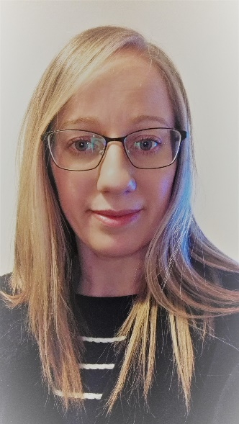Dear Mental Health Allies,

My name is Kim Trelease and I work for HMCTS in the North East. I was extremely fortunate to have been one of the original Mental Health Allies when the programme began as a pilot in November 2016 with only 10 members. Three and a half years later we have 100 MHAs in HMCTS North East and over 900 across the MoJ Nationally (excluding HMPPS). It is amazing to see that so many people want to be part of a programme that truly does make a difference and it makes me proud to wear a green lanyard.

Over recent years my role as a MHA has been varied, and that makes the role even more interesting. First and foremost, I am there to support and signpost colleagues to resources and information to enable them to make a decision that is right for them and/or their team member. I often find that giving the time to have a quality conversation outside of the workspace is the most effective method of support. Something so simple can really make a difference with very little impact to my core business role.

I am the SPOC for the region, which means that I am responsible for leading the group of 100 volunteers, ensuring each has received an induction, training and any support required to fulfil their role. I liaise with these volunteers to deliver activities and awareness events across the region to align with MoJ key dates and national calendar events. This may appear to be a significant challenge in addition to the “day job” however the national structure of the MHA Programme means that the organisation of these events has already been complete and as SPOC I simply facilitate the plans. To assist me in my role as SPOC I have created a hierarchical structure within the region, where each Cluster has a Lead MHA, and each Lead MHA has a team of site MHAs. It works extremely well in ensuring the 1500+ staff in the region have access to all mental health information and activities in a timely manner.

For the past 12 months I have been working towards the alignment of the MHA structure within the Regional Health & Wellbeing structure, as it was recognised that there is a lot of topic cross over. In doing this we now have a functioning Wellbeing and Mental Health Working Group that meets each quarter, working in partnership to better support the region. It has reduced any duplication that may have existed before. We have combined and streamlined our communications into one monthly TIB-it. Staff at sites work together to support their teams and have autonomy to organise single activities that will benefit their individual teams, outside of any national / regional plans. In doing this we are encouraging our teams to be more involved with their own mental health and wellbeing.

Of all the roles that I have had in my working life the role of an Ally has been the most rewarding. I have supported people through some difficult times and seen them benefit from using the signposting options. I have seen significant shift in the approach to mental health across the organisation, moving from a sense of silence or apprehension to a feeling of openness and support. As I walk through the offices at work, my lanyard is a conversation starter or a prompt for people to ask a question that they have been “meaning to ask for a while”. I can hear people being open and honest about their own mental health journey and I see colleagues supporting one another. It gives me a sense of pride to see that for myself, knowing that I am a part of this truly amazing programme that really does make a difference.

Page 16

## Summary

You’ve now successfully completed Part 1 of your Mental Health Allies training.

To summarise your learning so far:

* A Mental Health Ally is part of a peer support programme designed to “listen, empathise and help a person realise they are not alone in facing anxiety, depression or any other associated mental health condition” by empowering employees and giving them the confidence to improve their own mental health and wellbeing by being aware of the support and resources available to them.
* A large part of the Mental Health Ally role is to raise awareness and challenge stigma within the workplace.
* Our Mental Health affects the way that we think, act and feel and is defined as “a state of mind in which an individual is able to realise his or her own abilities, cope with the normal stresses of life, can work productively and fruitfully, and is able to make a contribution to his or her community”.
* Our Mental Health is affected by anything and everything, but there are personal and work-related circumstances which may increase one’s vulnerability of experiencing stress or poor mental health.
* Stigma can be more debilitating than a mental health condition, itself; therefore, our attitude towards mental health could change someone’s life.
* Be mindful of the language that you use to describe mental health in the workplace, as what we say is the foundation for creating an open culture.

**You have now completed your pre-workshop material. We will look forward to welcoming you to Part 2 – The Virtual Workshop, in the coming weeks. An invitation to your specific workshop will be sent directly to you.**

Page 17