|  |  |
| --- | --- |
| Wellbeing |  |
|  |  |

Mindfulness and ground techniques

Forensic Psychological Services, HMPPS in Wales

**Contents**

Five Senses exercise Page 3

Body scan Page 4

Gratitude group exercise Page 5

Writing for self-compassion Page 6

Be the pebble exercise Page 7

Appreciating your accomplishments worksheet Page 8

The raisin exercise Page 9

Mindful colouring Pages 10-13

“I am thankful for” tree exercise Page 14

4-7-8 breathing Page 15

Feeling good about supporting others worksheet Page 16

Guided imagery Page 17

Leaves on a stream Page 18

My self-care plan Page 19

Acknowledging your fear/anxiety worksheet Page 20

Happy Now worksheet Page 21

Sources of information Page 22

**Five Senses**

**5-10 minutes**

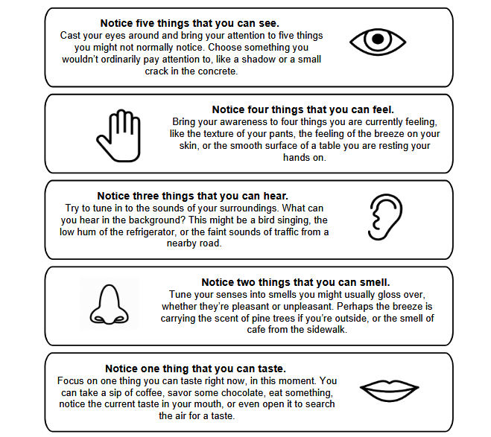The five sense exercise is a simple, versatile way to evoke a mindful state wherever you are. The goal of this exercise is to practice being aware in the present moment throughout the day whenever formal mindfulness practice such as meditation or a body scan might not be practical. It is simply a guide to help you become attuned to the five senses

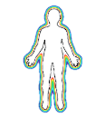**Body Scan**

**10-15 minutes**

**Key message:**

Having an awareness of your body and how it is feeling is important. Your body reflects your mind and your mind reflects your body. Most of us only pay attention when something goes wrong like when we ache, or our back hurts or our neck is in pain or even we notice that we want to go to the loo! Most of us rarely stop and properly take care of ourselves until our body shouts at us in some way. Mindful awareness enables us to be more conscious of our body’s signal and take action early enough to prevent some problems from happening whilst also maintaining wellbeing. If we are aware of our body then we are likely to be at our peak in terms of performance and productivity

**What to do:**

* You can start with noticing your feet, wriggling your toes and getting a real sense of your feet. Noticing how they feel.
* Bring your attention to your ankles, then up to your knees and thighs so that you can scan your whole leg.
* Bring your attention to your hips and lower back.
* Take your attention to the top of your back and shoulders.
* Take your attention to the top of your arms going down to elbows, then wrists, then hands and fingers.
* Finally bring your attention to your chests and stomach. This part of the body is very expressive and so may feel heavy / anxious etc. Ask yourself if you feel heavy or anxious or worried then you should let that out as you breathe out.

**Ask yourself:**

Is your breath shallow?

Place one hand on your belly, the other on your chest. Watch your hands rise and fall with each breath. Notice when you breathe fully or when you "forget" to breathe

**Gratitude Group Exercise**

**5-10 minutes**

**Key message**

***“When you realize there is nothing lacking, the whole world belongs to you.”*** (Lao Tzu)

Sometimes we can end up focusing on what we don’t have and feel miserable for it. This can then feed our fears and other negative feelings. Gratitude helps put things in perspective by getting you to focus on things that you do have and as a result can help make us happier, benefit our relationships, improve health and reduce stress.

**What to do:**

Group activity where everyone on rotation has to state something they feel grateful about and this rotation will keep rotating. This could be anything, like breathing, having a comfortable bed, wearing favourite shoes etc. Initially it might be difficult but the more you rotate the easier it gets! This could have a positive impact on person’s outlook.

**You will need:**

A group of people who want to be grateful for all the good things they have in their life.

**Discussion point:**

Discuss how people are feeling and then a take away action can be to write or mentally note at least 5 things that person is grateful for every night.

** Writing for self-compassion**

**10-15 minutes**

**Key message:**

A lack of self-compassion is common in our highly competitive society. By learning to treat ourselves with kindness and compassion we can increase our contentment, emotional well-being, resilience, and courage. This exercise is designed to help cultivate and promote self-compassion through writing.

**What to do:**

* First, write about an aspect of yourself that you judge and dislike (Examples may include appearance, career, relationships, health, etc)
* Write in detail about how this perceived inadequacy makes you feel. What thoughts, images, emotions, or stories arise when you think about it?
* Now, recall or imagine a friend or family member who is unconditionally loving, accepting, and supportive. Imagine that this person knows everything about you, including your background, genes, upbringing, and who you really are as a person. Imagine they know all if the various factors and events that have lead up to your life right now.
* Now write a letter to yourself from that friend about how they view and explain your perceived shortcoming. Write from a place of deep kindness, understanding and non-judgmental.
* After you finish writing, read the letter aloud to yourself and pay attention to how it makes you feel.
* Later read the letter again, practicing taking in the good and experiencing how it feels in your body, heart, and mind. Feel the love, compassion, and acceptance that exist within you

***Don’t be discouraged if you do not immediately feel compassion for yourself after writing this letter. Self-compassion takes time to develop and you are taking steps to cultivate it by doing this exercise.***

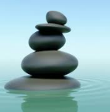** Be the pebble**  **10-15 minutes**

**Key message:**

Sometimes, stress can get our minds so active and ‘wound up’ that they are like a choppy ocean. If you’ve ever gone out to sea on waters like that, you know that getting seasick is no fun. For many, having a mind that is as choppy and turbulent as that water can have very much the same effect. But what if you were a pebble that could drop below the surface of that tumultuous water and get down to where the water was still, calm, and peaceful? The pebble wouldn’t be experiencing the chaos up above. It would just be at rest, peaceful and snug on the bottom of the ocean floor.

**What to do**

* To begin, you’ll want to choose a word or short phrase that you can focus on and repeat in your mind, over and over. The words or phrases you can use for this practice are infinite. Some examples include pebble, peace or quiet mind. It’s also a good idea to avoid words that associate you with a particular memory. If you find that a word stimulates memory or intrudes by creating more thoughts, you can choose a more neutral word.
* Once you begin to focus on the word, allow yourself at least 10 minutes of quiet time to reflect on your word or phrase. It helps to find a quiet place to sit, either indoors or outside. While you can do this practice lying down, it’s better to sit up, because it will be easier to stay awake
* Now, sitting quietly, close your eyes. While repeating your word, you will be placing about 10-15% of your awareness on the breath. Make sure you breathe evenly, and into the belly.
* As you think of your word, do not concentrate hard; this is not about forcing or creating too much effort. This is a gentle and effortless way of resting in the stillness beneath the water. Imagine that you are just preferring or favouring your chosen word over other thoughts.
* If your mind wanders off into thinking about the past or the future for a while, that’s okay. Even if you get drowsy, that’s okay, too. Just gently return to your word again.
* Sometimes, strong feelings or emotions may occur while you are repeating your word. If you experience a strong negative feeling, see what it is like to sit with it until it passes.
* If for any reason it doesn’t dissolve away and you get uncomfortable, you can always stop the practice by opening your eyes, distracting yourself, or just resting. Know that you can always return to this practice later.



**Appreciating your accomplishments**

Date / Time:



1. How will this accomplishment move forward?
2. How did you decide to accomplish this?
3. How does it make you feel?
4. What did you accomplish today?

**The Raisin Exercise**



**5** -**10 minutes**

**Key message:**

By focusing on the raisin in your hand and making a point to notice everything about it, you are unlikely to be expending energy, time, and attention on worrying or ruminating about other parts of your lives.

What do I do?

* Take a raisin and hold it in one hand, then concentrate on it as if you've never seen one before. Look at it searchingly. Notice how many grooves there are in it. How many little raised bobbles. Whether the colour is the same throughout. Whether it's symmetrical or misshapen. Use your eyes to really, examine it intently.
* After a minute or so, alter your focus to the feel of it. You might want to close your eyes. Does it feel smooth? Soft? Sticky? Rough where the grooves are? Roll it between your middle finger and your thumb. Concentrate on what you are feeling as you touch and hold it.
* Now lift the raisin to your nose. Is there any scent to it? Breathe in slowly and notice any aroma.
* Next gently place your raisin in your mouth. Just let it lie on your tongue for a while. Then move it around inside your mouth. Gently play with it. Ponder on the vague taste of it.
* Eventually, press your teeth onto it without biting through it. What do you notice? A change of smell? A building sense of sweetness? Focus on the experience and how intense the flavour is. Then, gently bite right through it – and become aware of how the taste increases and lingers on your tongue. Suck gently, noticing how fruity your saliva is as the raisin loses its shape and form. When you are ready, swallow it.
* Sit awhile, noticing the sensation as the raisin begins its journey down to your stomach. Become aware of the taste and smell that remains in your mouth and the slight stickiness on your fingers.

Breathe in and out slowly.

 **Mindful colouring 1**



**Mindful colouring 2**

 **Mindful colouring 3**

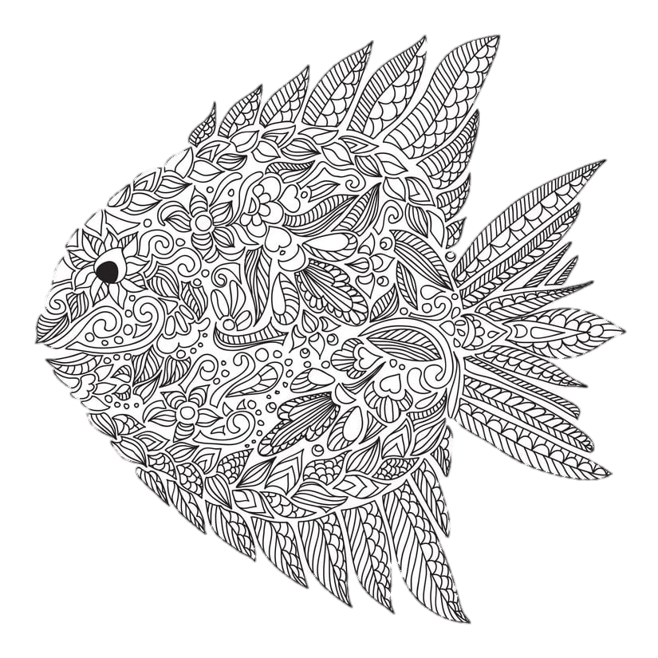

**Mindful colouring 4**





I am thankful for…





**4-7-8 Breathing**



**5 minutes**

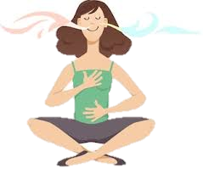

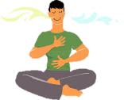

The 4-7-8 breathing exercise is utterly simple, takes no time, requires no equipment and can be done anywhere. Although you can do the exercise in any position, sit with your back straight while learning the exercise. This breathing exercise is a natural tranquilizer for the nervous system. This exercise is subtle when you first try it, but gains in power with repetition and practice.

**What to do:**

* Exhale completely through your mouth, making a whoosh sound. Close your mouth and inhale quietly through your nose to a mental count of four.
* Hold your breath for a count of seven.
* Exhale completely through your mouth, making a whoosh sound to a count of eight. This is one breath.
* Now inhale again and repeat the cycle three more times for a total of four breaths.

**Feeling good about supporting others**

Date/Time



1. What action will you take forward?
2. How did you decide to provide this support?
3. What outcome/ impact did your support further?
4. What specific support did you provide for others today?

**Guided Imagery**





**5-10 minutes**

**Key message:**

Guided imagery can reduce stress by physically relaxing the body. It's pleasant and not difficult to learn but does take practice. Top tips might include using accompanying music to compliment your imagery.

**What to do:**

* Get yourself into a relaxed state
* Begin to envision yourself in the midst of the most relaxing environment you can imagine. You may want to remember a time and place when you felt wonderful and relaxed (a "happy place" in your memory), a vividly-described scene from a book you love, or the way you imagine a place you've always wanted to visit.
* Use deep breathing and close your eyes, focusing on breathing in peace and breathing out stress.
* As you imagine your scene, try to involve all of your senses. What does it look like? How does it feel? What can you smell?
* Stay here for as long as you like. Enjoy your ‘surroundings’, and let yourself be far from what stresses you.
* When you’re ready to come back to reality, count back from ten or twenty, and tell yourself that when you get to ‘one’, you’ll feel serene and alert.

**Leaves on a stream**





**10 -15 minutes**

**What to do:**

* Sit in a comfortable position and either close your eyes or rest them gently on a fixed spot in the room. Visualize yourself sitting beside a gently flowing stream with leaves floating along the surface of the water.

Pause 10 seconds.

* For the next few minutes, take each thought that enters your mind and place it on a leaf... let it float by. Do this with each thought pleasurable, painful, or neutral. Even if you have joyous or enthusiastic thoughts, place them on a leaf and let them float by.
* If your thoughts momentarily stop, continue to watch the stream. Sooner or later, your thoughts will start up again.

Pause 20 seconds.

* Allow the stream to flow at its own pace. Don’t try to speed it up and rush your thoughts along. You’re not trying to rush the leaves along or “get rid” of your thoughts. You are allowing them to come and go at their own pace.
* If your mind says “This is dumb,” “I’m bored,” or “I’m not doing this right” place those thoughts on leaves, too, and let them pass.

Pause 20 seconds.

* If a leaf gets stuck, allow it to hang around until it’s ready to float by. If the thought comes up again, watch it float by another time.

Pause 20 seconds.

* If a difficult or painful feeling arises, simply acknowledge it. Say to yourself, “I notice myself having a feeling of boredom/impatience/frustration.” Place those thoughts on leaves and allow them float along.
* From time to time your thoughts may hook you and distract you from being fully present in this exercise. This is normal. As soon as you realize that you have become side tracked, gently bring your attention back to the visualization exercise.

**My self-care plan**

I can exercise my body by…

I can eat healthy foods….

Important people who I trust...

I can make myself happy by…..

This is me

My hopes and wishes……

I can relax my body and mind by…



Dreading future plans or situations can heap anxiety and fear right into your lap. If there’s something that’s worrying you, share it here.

…………………………………………………………………………………………………………………………………………………………………………………………………………………………………………………………………………………………………………………………………………………………………………………………………………………………………………………………………………………………………………

What can you do or change to help diminish this fear?

………………………………………………………………………………………………………………………………………………………………………………………………………………………………………………………………………………………………………………………………………………………………………………………………………………………………………………………………………………………………………….

Great – do it! If you can’t make any changes, accept that, but know you DO have the strength and determination to get through what is ahead. Colour in the rising sunshine to add a bit of joy to your upcoming scenario.

**Happy Now**

We can slow down our own experience and savour what life has to offer if we just sit in the now a little more often. In the present, our minds are clearer and not crammed tight with past and future anxieties. We can make decisions from a place of clarity and feel calm even when things seem chaotic around us. Stress is reduced and the feeling of being overwhelmed fades into the background. To me, that feels like a happy place to be.

*Stop worrying about the past and fearing the future and get into the NOW!*

Don’t overthink these answers. Write down what instinctively comes to mind in the very moment.

Pick one thing you can see around you…

…………………………………………………………………………………………………………………………………………………………………………………………………………………………………………………….

What can you smell?

……………………………………………………………………………………………………………………………………………………………………………………………………………………………………………………

How does your body feel?

…………………………………………………………………………………………………………………………………………………………………………………………………………………………………………………..

What’s positive about this very moment?

……………………………………………………………………………………………………………………………………………………………………………………………………………………………………………………

**Sources of Information**



**Internal Sources**

* PAM Assist / PAM life app (information accessible through individual establishments)
* POA
* Line managers/work colleagues
* Friends and family

**Additional support**

Further support/information around mindfulness practice can be found online at:-

* Mind mental health charity: <https://www.mind.org.uk/>
* Public Health England <https://www.nhs.uk/oneyou/every-mind-matters/>
* NHS <https://www.nhs.uk/conditions/stress-anxiety-depression/mindfulness/>
* Headspace <https://www.headspace.com/>
* Mental Health Foundation <https://www.mentalhealth.org.uk/a-to-z/m/mindfulness>
* Dewis Cymru (to find services local to your area): <https://www.dewis.wales/>