

**Wellbeing**

**Distraction Pack**



**Fitness In cell workout (Lower Body)**

Each workout will start with 25 reps but every set you must drop a rep e.gSet 1, 25 reps, Set 2, 24 reps etc. Keep going down in reps until you get to 5 reps. Try and time it so you can aim to beat your time in the future.

***Hint - Rest when you need to but try for no longer than 10 seconds.***

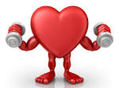**Workouts**

Split squat

Knees to feet

Calf raises

Bridges

High knee slaps

**Split squats**

Start with your feet together then jump up and land with your feet in the normal squat position, on landing squat down and then jump up again and land with your feet together.

**Knees to feet**

Without using your hands get onto your knees and then back to your feet

**Calf raises**

Place the balls of your feet on the edge of a block/step and let your heels drop down towards the floor as far as possible. Then slowly **raise** your heels up as **high** as possible, squeezing your **calves** and hold.

**Bridges**

Lay on your back with your knees up but feet still on the floor. Drive through your feet so your bottom and lower back come off the floor.

**High knee slaps**

While on the ball of your feet (tip toeing) bring your knees up to your waist one after another. You can put your hands out so that your knees have to touch your hands each time.

All body workout; after each workout have a 30 second jogging rest. Make each rep slow and controlled and think about your form.

***Hint; for squats you can sit on your bed and jut stand up.***

|  |  |  |  |
| --- | --- | --- | --- |
| **Workout** | **Set 1** | **Set 2** | **Set 3** |
| **Press Up** | 10 | 15 | 10 |
| **Sit Up** | 10 | 15 | 10 |
| **Squats** | 10 | 15 | 10 |
| **Dips** | 10 | 15 | 10 |
| **Knee to chest** | 10 | 15 | 10 |
| **Star Jumps** | 10 | 15 | 10 |

**Dips**

Have your hands facing forward on the edge of your bed with your legs flat out in front of you. Then bend at the elbows and go as low as you can before pushing back up.

**Knees to chest**

Sit on the edge on your bed with your hands at your side, lean back slightly and bring your knees to your chest.

**In Cell Workout**

**Burpee Bonanza**

This is a quick 4 minute workout with 20 seconds of workout and 10 seconds rest. Do 8 sets of burpees. Go as flat out as you can and in your resting period write down your number of reps for future reference. You can adapt this format to any workout.

**Other workouts to do;**

Crunches

Press ups

Squat jumps

Dips

Star jumps

Planks

**Squat Jump example Jumping Jacks example**

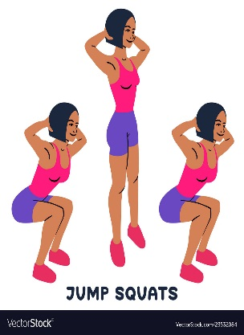 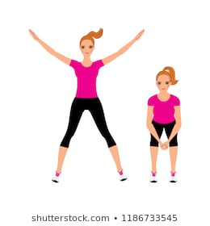

**High knees example Dips example**

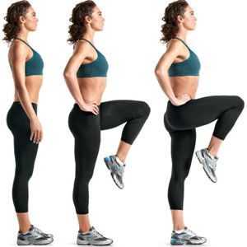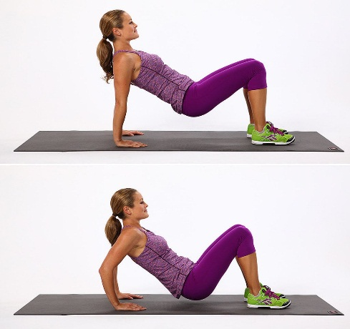

**30 x Jumping Jacks**

**5 x Push Ups**

**25 x High Knees**

**7 x Burpees**

**10 x Sit Ups**

**7 x Squats**

**5 x Push Ups**

**10 x Sit Ups**

**5 x Push Ups**

**7 x Squats**

**30 x Jumping Jacks**

**1 Minute Wall Sit**

**5 x Push Ups**

**25 High Knees**

**\*REPEAT 3-5 TIMES FOR MAXIMUM RESULTS\***

**Squat example Burpees example Wall sit example**

