MINDFULNESS PACK  
  
The Fens Unit  
HMP WHITEMOOR

How to silence the mind with breath counting

When the mind concentrates on one point- the counting of the breath- it will slowly stop running away with itself like a wild horse. This will not happen instantly.

“We may have to sit through intense periods of terror, lust, perversion, fantasy, grief, guilt, greed, pride, loneliness.. whatever furniture happens to be stored away in here.. taking up our peace”

When we become aware of these feelings and thoughts, we just allow them to be and gently return our full focus onto counting the breath.

We learn not to get sucked into the garbage of these distractions. We can always return to the breath.

It can get frustrating at times but that’s just one more distraction!

With time our resistance melts. So do our demons!

Counting the breath

* Breathe naturally and watch the breath.
* Never try to breathe differently.
* Count each in-breath and each out-breath up to 10.
* The first in-breath is 1, the first out-breath is 2, the second in-breath is 3, the second out-breath is 4 and so on.
* Once you have reached 10 go back to 1. Slowly you become aware that you and your breath are on.



Difficulties you may find in mindfulness

Fear- people don’t often lower their eyes in prison so you may feel afraid at first. But you can create a safe space for yourself. Mindfulness will become a time when you can leave any fear behind.

Dizziness- Most often this is caused by breathing wrongly. Spend time getting a solid body position so you *‘sit like a mountain’*, then breathe naturally- not too deeply, not too slowly.

A Buzz- a buzz alters your consciousness. It is not a good idea to seek a buzz in the hope of enjoyment. During mindfulness, when anything other than breath awareness enter the mind, gently bring your mind back to your natural breath.

Inner noise- At some point breath counting may become too noisy for you. Then you are ready to sit BE-ING the breath. If you have come this far then you will understand what this means and able to do it. Well done. You are on the way to finding out who you are.

The benefits of mindfulness

1. Our energies that have been all over the place, come together

1. We start to gain some control over our super-active minds.
2. Tension is released
3. Nerves become relaxed
4. Our health begins to improve
5. We become more aware of our emotions
6. Our will gets stronger
7. We begin to feel an inner balance
8. Gradually our hang-ups melt away
9. Compassion, serenity, selfless and concern for others come to us more easily.

Body Scan Mindfulness Practice

The body scan can be performed while lying down, sitting, or in other postures. The steps below are a guided mindfulness designed to be done while sitting.

Begin by bringing your attention into your body.

You can close your eyes if that’s comfortable for you.

You can notice your body seated wherever you’re seated, feeling the weight of your body on the chair, on the floor.

Take a few deep breaths.

And as you take a deep breath, bring in more oxygen enlivening the body. And as you exhale, have a sense of relaxing more deeply.

You can notice your feet on the floor, notice the sensations of your feet touching the floor. The weight and pressure, vibration, heat.

You can notice your legs against the chair, pressure, pulsing, heaviness, lightness.

Notice your back against the chair.

Bring your attention into your stomach area. If your stomach is tense or tight, let it soften. Take a breath.

Notice your hands. Are your hands tense or tight. See if you can allow them to soften.

Notice your arms. Feel any sensation in your arms. Let your shoulders be soft.

Notice your neck and throat. Let them be soft. Relax.

Soften your jaw. Let your face and facial muscles be soft.

Then notice your whole-body present. Take one more breath.

Be aware of your whole body as best you can. Take a breath. And then when you’re ready, you can open your eyes.

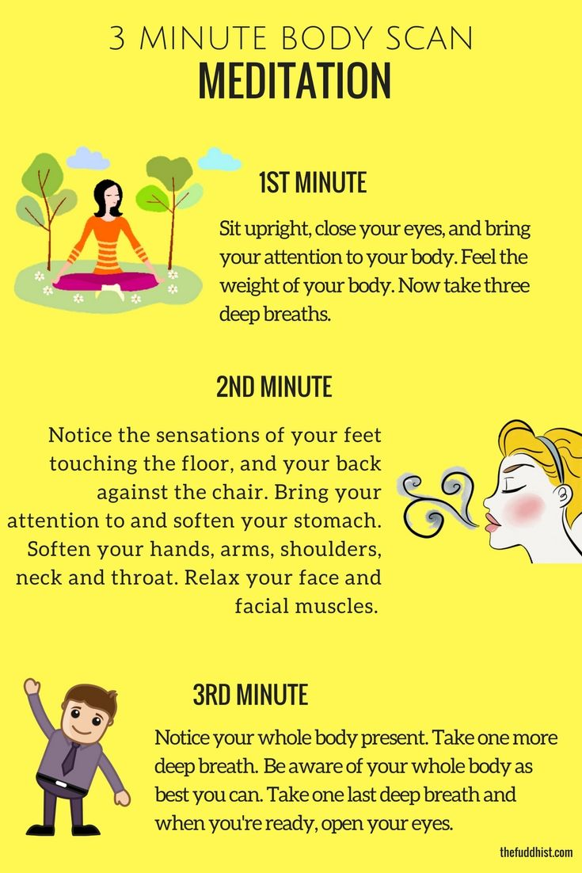

Opening to Emotions Mindfully

Mindfulness of emotions are part of the human experience. They are neither good nor bad, so becoming mindful of them does not have to entail condemnation, judgment, or suppression. Opening to our emotions mindfully is possible only from a place of unconditional love.

1. Turn towards the emotion.

There is a common tendency to move away from difficult emotions when they arise. While this may have once served as an effective defence mechanism, we can help ourselves to move through the emotion more effectively by turning towards it.

By [taking a few deep breaths](https://mindfulnessexercises.com/6-mindful-breathing-exercises/) and gently opening ourselves to whatever is present, we are able to transition through our emotional landscape with greater understanding and acceptance.

2. Create space by identifying the emotion(s) – without judgment.

It is easy to become caught up in the story associated with the emotion – why we feel it, who is responsible, and how it could have been avoided. While there is a time and place for this inquiry, it can be useful to detach from the mindfulness of emotions when we are in the heat of them.

We can practice this by becoming aware of what exactly is moving through us. Rather than saying to ourselves, “I am angry,” which often leads to, “because…” we can instead simply notice what is present. Simply witness ‘anger’, ‘grief’, ‘sadness’, or whatever is the case as though it were a separate entity. Open to this energetic presence with compassion and curiosity, noticing if the mind intervenes with judgment. Come back to an open heart.

3. Feel into any bodily sensations that are present.

When we become caught up in mindfulness of emotions, [we can open our awareness to the entire body.](https://mindfulnessexercises.com/downloads/working-with-emotions-in-your-body/) What do we notice? Where do we sense increased or decreased activity? Even numbness can be observed. Feeling into the way the emotion presents itself in the body can help us to create some sort of distance in-between ourselves and the energy moving through us. As we practice creating this distance, strengthening our awareness of it, we come to realize that our emotions are just a happening that can be witnessed from a quieter, more peaceful place.

4. Become aware of the impermanence of this state.

Feelings, thoughts, and sensations all come and go; such is the nature of life. When mindfulness of emotions rise, we can heighten our awareness of the transitory nature of our experience. Through this opening to the flow of our emotions, we become less consumed by them. We start to loosen our grip on the beliefs we hold about them. We come to realize that we are not, in fact, our emotions; and through this realization we find strength to journey through the storm in our sails.

Observing your thoughts

* Take a few breaths to ground yourself into the present moment, observing any sensations as you inhale and as you exhale.
* Continue to breathe mindfully as you expand your awareness to note the surface beneath you and the air around you. Without judgment, simply become aware of what you observe, using your senses to draw your mind into the body.
* As thoughts arise, begin to view them as if you are an outside observer. There is no need to condemn or criticize your thoughts; simply open your awareness to them, detaching yourself from the stories they attempt to weave.
* A close up of a logo

  Description automatically generatedWhenever a thought arises, observe what is moving by noting its associated action. For instance, you might note, “planning,” “thinking,” “fearing,” or “rejecting.” Keep these notes action-based, refraining from attaching any sense of the I-self to them.
* Notice the body and mind beginning to relax as you practice. Continue this for as long as is necessary to bring yourself into a greater sense of peace and comfort.

The Five Senses

Use this Five Senses Exercise as a simple, versatile way to evoke a mindful state wherever you are. The goal of this exercise is to practice being aware in the present moment throughout the day whenever formal mindfulness practice such as meditation or a body scan might not be practical.   
  
It is simply a guide to help you or your client become attuned to the **five senses.**



**Notice five things that you can see.**   
Cast your eyes around and bring your attention to five things you might not normally notice. Choose something you wouldn’t ordinarily pay attention to, like a shadow or a small crack in the concrete.

**Notice four things that you can feel.**   
Bring your awareness to four things you are currently feeling, like the texture of your pants, the feeling of the breeze on your skin, or the smooth surface of a table you are resting your hands on.

**Notice three things that you can hear.**   
Try to tune in to the sounds of your surroundings. What can you hear in the background? This might be a bird singing, the low hum of the refrigerator, or the faint sounds of traffic from a nearby road.



**Notice two things that you can smell.**   
Tune your senses into smells you might usually gloss over, whether they’re pleasant or unpleasant. Perhaps the breeze is carrying the scent of pine trees if you’re outside, or the smell of cafe from the sidewalk.

**Notice one thing that you can taste.**   
Focus on one thing you can taste right now, in this moment. You can take a sip of coffee, savor some chocolate, eat something, notice the current taste in your mouth, or even open it to search the air for a taste.

Mindful Observation

This exercise is simple but incredibly powerful because it helps you notice and appreciate seemingly simple elements of your environment in a more profound way.

The exercise is designed to connect us with the beauty of the natural environment, something that is easily missed when we are rushing around in auto pilot and are not paying attention to the objects around us.

1. Choose a natural object from within your immediate environment and focus on watching it for a minute or two. This could be a photograph, music instrument or even the clouds or the moon outside of your window.
2. A picture containing drawing

   Description automatically generatedDon’t do anything except notice the thing you are looking at. Simply relax into watching for as long as your concentration allows.
3. Look at this object as if you are seeing it for the first time.
4. Visually explore every aspect of its formation and allow yourself to be consumed by its presence.
5. Allow yourself to connect with its energy and its purpose within the natural world.

Mindful Immersion

The intention of this exercise is to cultivate contentment in the moment and escape the persistent striving we find ourselves caught up in on a daily basis.

Rather than anxiously wanting to finish an everyday routine task in order to get on with doing something else, take that regular routine and fully experience it like never before.

For example: if you are cleaning your cell or spur, pay attention to every detail of the activity.

Rather than treat this as a regular chore, create an entirely new experience by noticing every aspect of your actions:

Feel and become the motion when sweeping the floor, sense the muscles you use when scrubbing the dishes, develop a more efficient way of wiping the windows clean.

The idea is to get creative and discover new experiences within a familiar routine task.

Instead of labouring through and constantly thinking about finishing the task, become aware of every step and fully immerse yourself in the progress. Take the activity beyond a routine by aligning yourself with it physically, mentally and spiritually

Who knows, you might even enjoy the cleaning for once!

Mindful Appreciation

The point of this exercise is to simply give thanks and appreciate the seemingly insignificant things in life, the things that support our existence but rarely get a second thought amidst our desire for bigger and better things.

For example: electricity powers your kettle, the postman delivers your mail, your clothes provide you warmth, your nose lets you smell the flowers in the park, your ears let you hear the birds in the tree. but…

* Do you know how these things/processes came to exist, or how they really work?
* A close up of a logo

  Description automatically generatedHave you ever properly acknowledged how these things benefit your life and the lives of others?
* Have you ever thought about what life might be like without these things?
* Have you ever stopped to notice their finer, more intricate details?
* Have you ever sat down and thought about the relationships between these things and how together they play an interconnected role in the functioning of the earth?

Once you have identified your 5 things, make it your duty to find out everything you can about their creation and purpose to truly appreciate the way in which they support your life.