**HMP OAKWOOD**

**IN CELL DISTRACTION BOOKLET**

**Fitness In cell workout (Lower Body)**

Each workout will start with 25 reps but every set you must drop a rep e.g Set 1, 25 reps, Set 2, 24 reps etc. Keep going down in reps until you get to 5 reps. Try and time it so you can aim to beat your time in the future.

***Hint - Rest when you need to but try for no longer than 10 seconds.***

**Workouts**

Split squat

Knees to feet

Calf raises

 Bridges

High knee slaps

**Split squats**

Start with your feet together then jump up and land with your feet in the normal squat position, on landing squat down and then jump up again and land with your feet together.

**Knees to feet**

Without using your hands get onto your knees and then back to your feet

**Calf raises**

Place the balls of your feet on the edge of a block/step and let your heels drop down towards the floor as far as possible. Then slowly **raise** your heels up as **high** as possible, squeezing your **calves** and hold.

**Bridges**

Lay on your back with your knees up but feet still on the floor. Drive through your feet so your bottom and lower back come off the floor.

**High knee slaps**

While on the ball of your feet (tip toeing) bring your knees up to your waist one after another. You can put your hands out so that your knees have to touch your hands each time.

All body workout; after each workout have a 30 second jogging rest. Make each rep slow and controlled and think about your form.

***Hint; for squats you can sit on your bed and jut stand up.***

|  |  |  |  |
| --- | --- | --- | --- |
| **Workout** | **Set 1** | **Set 2** | **Set 3** |
| **Press Up** | 10 | 15 | 10 |
| **Sit Up** | 10 | 15 | 10 |
| **Squats** | 10 | 15 | 10 |
| **Dips** | 10 | 15 | 10 |
| **Knee to chest** | 10 | 15 | 10 |
| **Star Jumps** | 10 | 15 | 10 |

**Dips**

Have your hands facing forward on the edge of your bed with your legs flat out in front of you. Then bend at the elbows and go as low as you can before pushing back up.

**Knees to chest**

Sit on the edge on your bed with your hands at your side, lean back slightly and bring your knees to your chest.

**Sudoku**

Fill in each grid so that every row, every column and every 3 x 3 box contains the numbers 1-9

Handy Tips

* Sudoku puzzles are based on logic. You do not need to guess where numbers go to solve the puzzles.
* A good place to start a puzzle is where there is a group of numbers together
* Lightly pencil numbers into the grid, unless you are certain that you are right.

Sometimes you will find it helpful to pencil in the possibilities. For example, if you already know seven of the numbers in a row of nine, then the 2 unused numbers MUST be the ones to fill in the two empty spaces. In those either/or situations a pencil note may serve as a handy reminder of the options open to you.

|  |
| --- |
| sudoku puzzle |
| spacer |
|  |

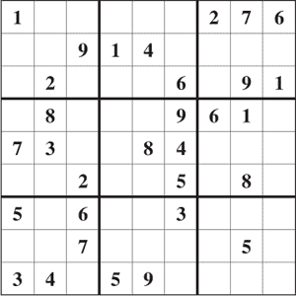

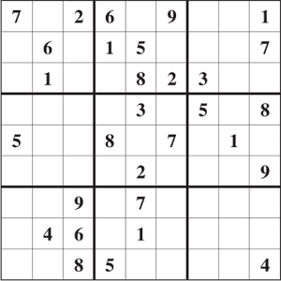

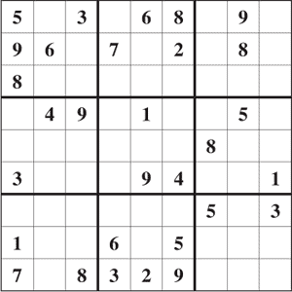

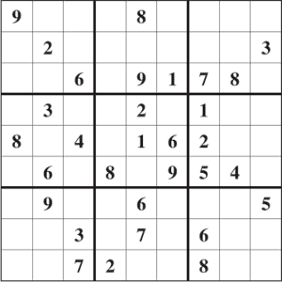

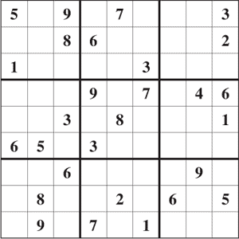

|  |
| --- |
|  |
| spacer |
|  |
| word search puzzle   |  |  |  |  |  | | --- | --- | --- | --- | --- | | **AMSTERDAM (Netherlands) ANDORRA LA VELLA (Andorra) ANKARA (Turkey) ATHENS (Greece) BAKU (Azerbaijan) BELFAST (Northern Ireland) BELGRADE (Serbia/Montenegro) BERLIN (Germany) BERN (Switzerland) BRATISLAVA (Slovakia) BRUSSELS (Belgium) BUCHAREST (Romania) BUDAPEST (Hungary) CARDIFF (Wales) CHISINAU (Moldova) COPENHAGEN (Denmark) DUBLIN (Ireland)** | **spacer** | **EDINBURGH (Scotland) HELSINKI (Finland) KIEV (Ukraine) LISBON (Portugal) LJUBLJANA (Slovenia) LONDON (England) LUXEMBOURG (Luxembourg) MADRID (Spain) MINSK (Belarus) MONACO (Monaco) MOSCOW (Russian Federation) NICOSIA (Cyprus) OSLO (Norway) PARIS (France) PRAGUE (Czech Republic) REYKJAVIK (Iceland) RIGA (Latvia)** | **spacer** | **ROME (Italy) SAN MARINO (San Marino) SARAJEVO (Bosnia-Herzegovina) SKOPJE (Macedonia) SOFIA (Bulgaria) STOCKHOLM (Sweden) TALLINN (Estonia) TBILISI (Georgia) TIRANE (Albania) VADUZ (Liechtenstein) VALLETTA (Malta) VATICAN CITY (Vatican City) VIENNA (Austria) VILNIUS (Lithuania) WARSAW (Poland) YEREVAN (Armenia) ZAGREB (Croatia)** | |

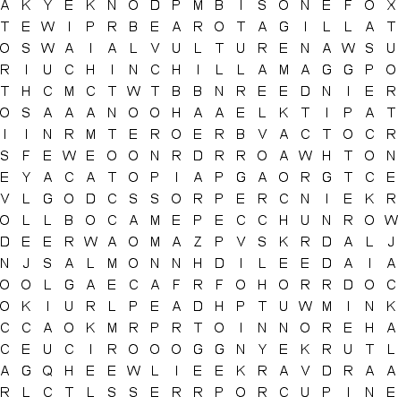

|  |  |  |  |  |  |  |  |  |
| --- | --- | --- | --- | --- | --- | --- | --- | --- |
| **AARDVARK ALLIGATOR BABOON BARRACUDA BEAR BISON CAMEL CHIMPANZEE CHINCHILLA COBRA COUGAR CROW** | **spacer** | **DONKEY DOVE EAGLE ELK FERRET FOX GECKO GOAT GOPHER HAMSTER HAWK HERON** | **spacer** | **HIPPOPOTAMUS JACKAL JELLYFISH KIWI LEOPARD LION LLAMA MACAW MEADOWLARK MINK MOOSE NIGHTINGALE** | **spacer** | **OTTER PANTHER PARROT PEACOCK PELICAN PIG PORCUPINE QUAIL RACCOON RAVEN REINDEER ROADRUNNER** | **spacer** | **SALMON SLOTH SWAN SWORDFISH TIGER TORTOISE TROUT TURKEY VULTURE WOLVERINE WOODPECKER WREN** |

