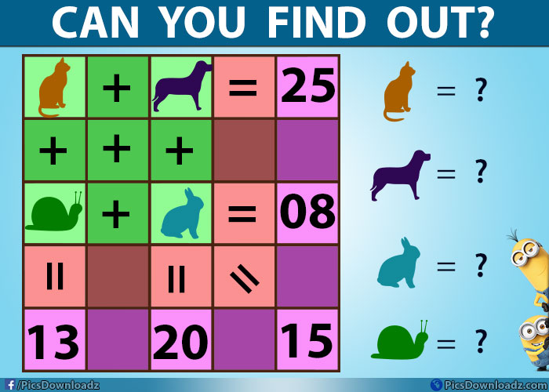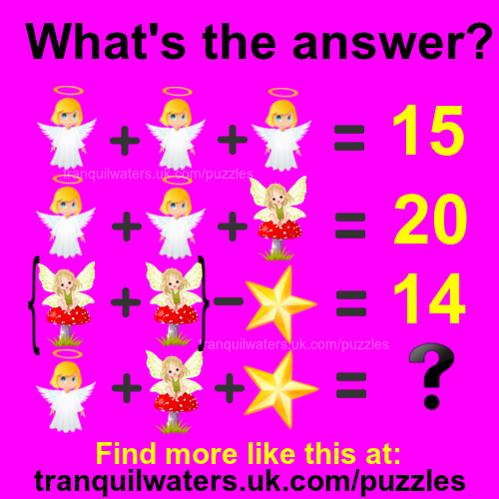

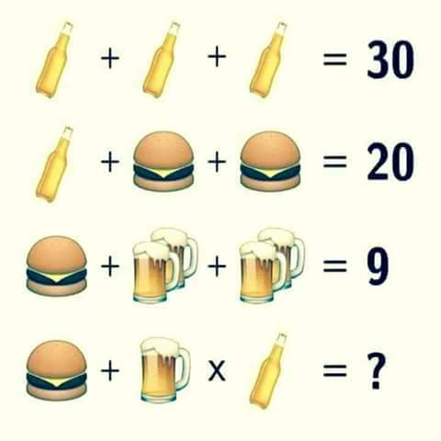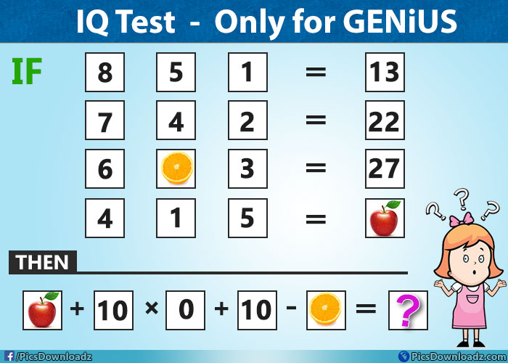

|  |  |  |  |  |  |  |  |  |  |  |  |  |  |  |  |  |  |  |  |  |  |  |  |  |
| --- | --- | --- | --- | --- | --- | --- | --- | --- | --- | --- | --- | --- | --- | --- | --- | --- | --- | --- | --- | --- | --- | --- | --- | --- |
| A | V | N | O | I | T | A | T | U | P | E | R | O | N | D | H | O | N | O | U | R | U | Q | G | S |
| P | S | X | A | T | T | I | T | U | D | E | P | S | V | X | Z | Y | T | I | N | U | M | M | O | C |
| H | O | N | E | S | T | Y | S | F | J | L | X | T | A | U | T | H | O | R | I | T | Y | E | V | I |
| S | P | E | Q | V | E | I | T | R | O | P | P | U | S | E | W | C | E | S | I | A | R | P | M | M |
| V | P | X | Q | P | O | S | I | T | I | V | E | N | C | E | E | G | A | R | U | O | C | N | E | P |
| S | O | A | D | R | E | A | M | S | E | C | D | E | T | E | R | M | I | N | A | T | I | O | N | R |
| L | R | M | M | O | M | T | T | I | T | N | E | M | N | I | A | T | T | A | W | E | I | P | N | O |
| A | T | I | V | S | W | N | P | X | A | C | H | I | E | V | E | M | E | N | T | S | T | Y | O | V |
| O | U | N | D | P | K | E | J | A | X | O | N | G | L | O | V | E | V | I | S | I | O | N | I | E |
| G | N | A | O | E | R | M | C | R | E | S | P | O | N | S | I | B | I | L | I | T | I | E | S | M |
| E | I | T | W | C | S | Y | I | W | S | N | W | O | R | K | B | I | S | D | A | T | N | I | U | E |
| I | T | I | A | T | Y | O | P | G | R | O | K | D | W | N | S | M | I | L | E | M | S | A | L | N |
| L | I | O | O | S | I | L | U | C | E | I | C | L | B | A | E | T | C | S | J | Z | P | B | C | T |
| M | E | N | P | A | D | P | L | S | H | T | S | P | A | E | S | T | A | T | U | S | I | I | N | V |
| Y | S | S | L | W | W | M | M | E | U | A | O | O | R | H | A | P | P | Y | N | G | R | L | I | N |
| E | P | R | O | G | R | E | S | S | I | C | R | E | F | I | A | S | I | R | O | P | E | I | M | M |
| E | X | C | E | L | L | E | N | C | E | I | I | A | S | B | D | W | A | R | V | S | T | T | D | B |
| V | B | E | H | A | V | I | O | U | R | F | Y | V | C | S | O | E | P | E | A | E | N | I | M | R |
| E | J | E | M | O | T | I | V | A | T | I | O | N | D | T | R | E | A | S | L | T | C | E | R | E |
| I | S | H | I | L | P | E | Q | U | A | L | I | T | Y | O | E | T | E | P | U | P | I | S | I | M |
| L | H | S | I | L | P | M | O | C | C | A | O | A | N | M | W | R | Q | E | E | P | E | O | E | O |
| E | E | I | O | S | U | C | N | H | S | U | C | C | E | S | S | C | H | C | S | A | I | W | N | R |
| B | G | N | I | N | R | A | E | L | K | Q | M | A | H | T | N | E | R | T | P | E | G | J | P | S |
| P | O | S | S | I | B | I | L | I | T | I | E | S | O | S | I |  | T | E | G | R | I | T | Y | E |

Responsibilities Good Behaviour Attitude Prospects Qualifications Work

Positive Aspirations Motivation Determination Character Integrity Vision

Dreams Possibilities Abilities Progress Improvement Authority Inclusion

Believe Respect Opportunities Honesty Honour Employment

Success Goals Achievements Accomplish Reputation Status

Remorse Excellence Pride Values Examinations Support GCSE

Inspire Attainment Learning Praise Community Encourage Equality

Can you also find the secret words???

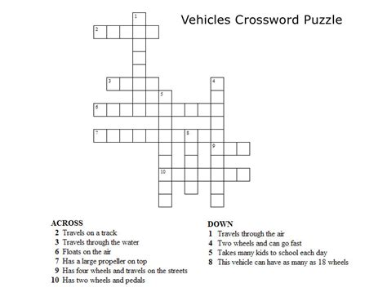

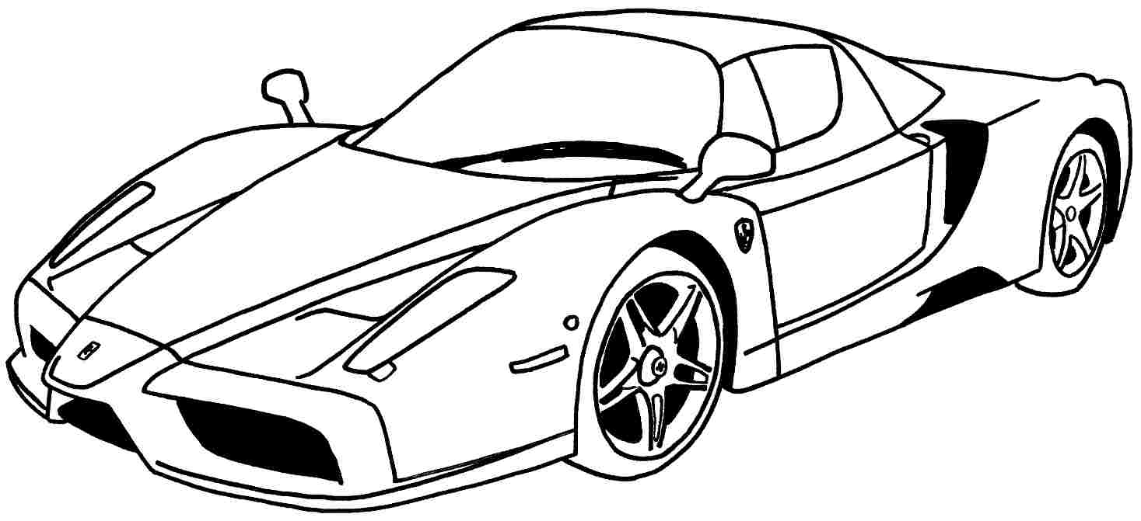

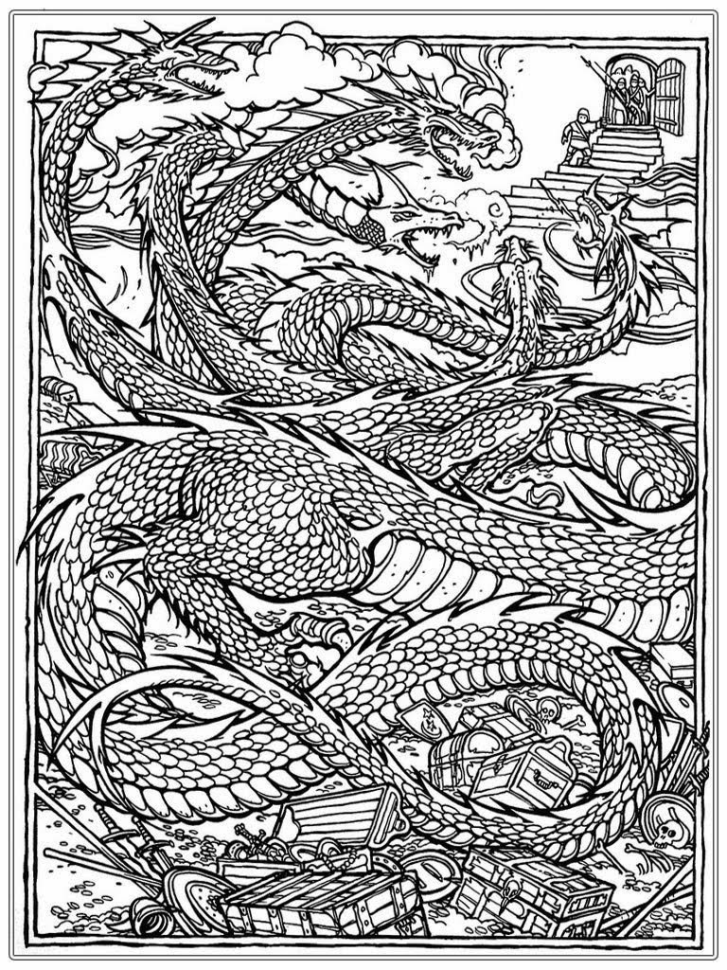

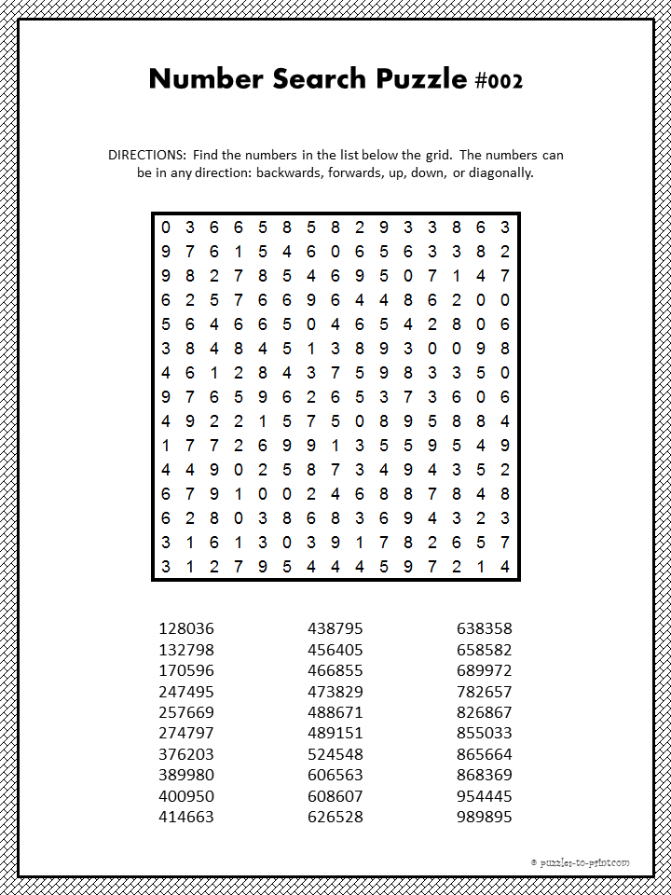

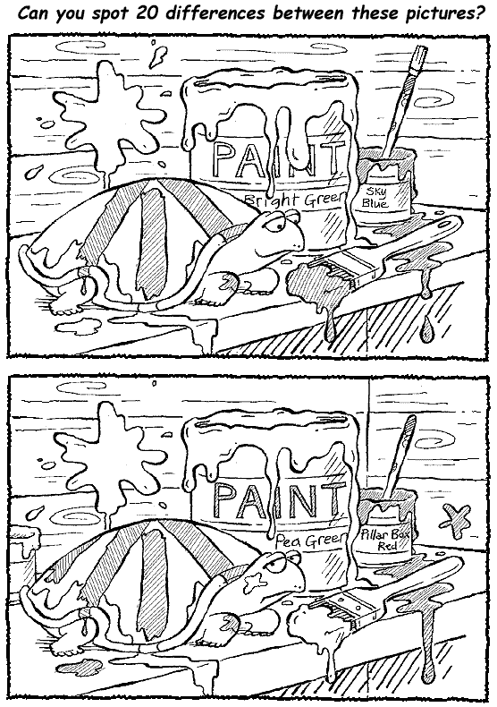

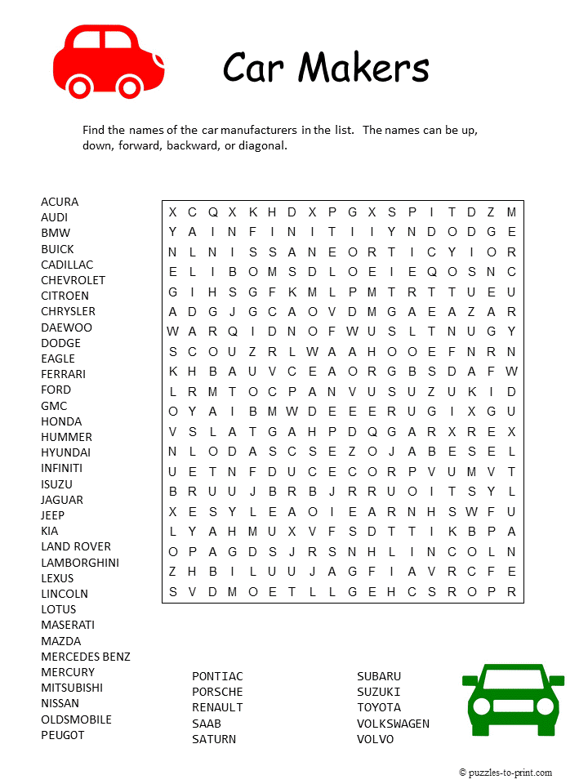

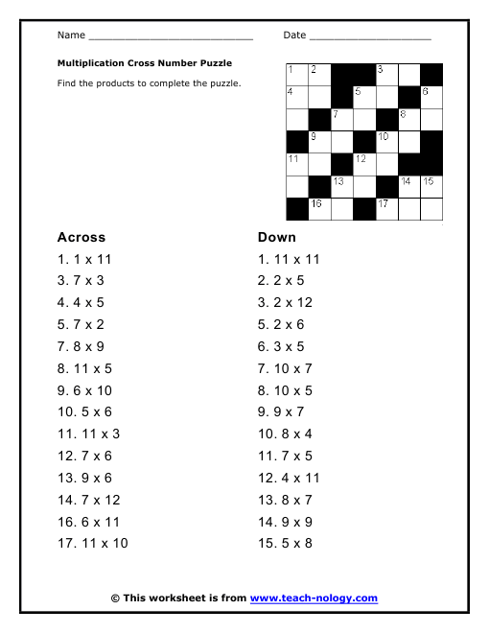

Image result for prison jokesImage result for prison jokesImage result for prison jokes Image result for prison jokes

**Animal Word Search**

|  |  |  |  |  |  |  |  |  |  |  |  |  |  |  |  |
| --- | --- | --- | --- | --- | --- | --- | --- | --- | --- | --- | --- | --- | --- | --- | --- |
| R | E | D | O | G | V | U | Y | V | O | S | C | S | A | D | M |
| T | A | F | H | V | I | U | G | E | R | W | S | V | E | O | O |
| A | V | B | F | A | L | L | I | R | O | G | O | M | L | L | U |
| R | V | L | B | A | K | A | Z | C | T | K | O | C | I | P | S |
| O | V | N | Q | I | R | O | L | A | L | N | P | T | D | H | E |
| O | D | S | G | L | T | I | T | L | K | M | K | B | O | I | B |
| U | O | O | R | Z | B | N | G | E | I | C | Y | G | C | N | D |
| H | N | G | Z | E | A | D | Y | Y | U | G | O | O | O | E | Q |
| O | K | V | P | H | G | K | W | D | K | R | A | X | R | E | B |
| X | E | U | P | I | C | I | A | X | F | X | X | T | C | B | H |
| G | Y | E | Q | Q | F | B | T | F | W | V | K | S | O | N | V |
| U | L | T | Z | U | I | N | O | I | L | T | W | Q | A | R | W |
| E | J | D | W | R | O | Y | Z | W | A | F | J | S | Z | E | U |
| Q | W | T | D | K | B | D | Q | C | D | X | O | O | W | K | C |

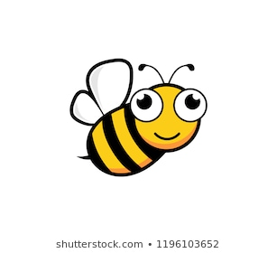

|  |
| --- |
|  |
| ALLIGATOR | BEE | BIRD |
| CAT | COW | CROCODILE |
| DOG | DOLPHIN | DONKEY |
| DUCK | ELEPHANT | FROG |
| GIRAFFE | GORILLA | LION |
| MONKEY | MOUSE | RABBIT |
| RAT | TIGER |  |

**Food Word Search**

|  |  |  |  |  |  |  |  |  |  |  |  |  |  |  |  |
| --- | --- | --- | --- | --- | --- | --- | --- | --- | --- | --- | --- | --- | --- | --- | --- |
| W | W | E | I | S | J | W | E | P | Y | A | I | R | P | T | H |
| G | X | B | Q | J | M | F | Z | B | I | D | X | E | A | I | V |
| V | I | J | R | V | V | M | Y | T | I | E | L | G | P | U | L |
| Y | R | R | E | B | W | A | R | T | S | E | C | R | P | R | Y |
| J | C | T | H | Y | T | N | Z | G | T | H | O | U | L | F | P |
| N | Q | W | D | O | V | M | V | T | E | E | G | B | E | E | M |
| G | N | N | M | M | D | R | U | E | P | C | Q | M | F | L | X |
| S | A | A | T | P | X | C | S | O | A | I | L | A | Q | B | B |
| C | T | K | I | Z | E | E | I | R | R | E | Z | H | X | A | C |
| O | B | A | N | A | N | A | R | H | A | A | C | Z | Q | T | O |
| O | T | A | T | O | P | O | P | U | O | S | N | I | A | E | R |
| N | O | C | A | B | T | D | A | E | R | B | E | G | R | G | N |
| G | F | H | W | N | L | K | D | Z | J | Z | R | A | E | E | W |
| B | T | X | A | K | V | Q | A | B | G | Q | Q | N | A | V | Z |

|  |  |  |
| --- | --- | --- |
| APPLE | BACON | BANANA |
| BREAD | CANDY | CARROT |
| CHEESE | CORN | FRUIT |
| HAMBURGER | LETTUCE | ORANGE |
| PIE | PIZZA | POTATO |
| RICE | SOUP | STRAWBERRY |
| TOMATO | VEGETABLE |  |

