**HMP OAKWOOD**

**IN CELL DISTRACTION**

**BOOKLET 2**

**In Cell Workout Burpee Bonanza**

This is a quick 4 minute workout with 20 seconds of workout and 10 seconds rest. Do 8 sets of burpees. Go as flat out as you can and in your resting period write down your number of reps for future reference. You can adapt this format to any workout.

**Other workouts to do;**

Crunches

Press ups

Squat jumps

Dips

Star jumps

Planks

**Squat Jump example Jumping Jacks example**

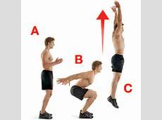 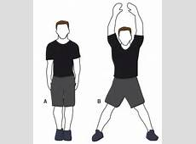

**High knees example Dips example**

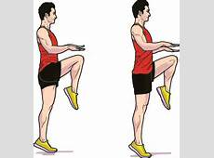 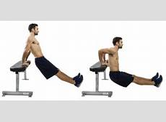

**30 x Jumping Jacks**

**5 x Push Ups**

**25 x High Knees**

**7 x Burpees**

**10 x Sit Ups**

**7 x Squats**

**5 x Push Ups**

**10 x Sit Ups**

**5 x Push Ups**

**7 x Squats**

**30 x Jumping Jacks**

**1 Minute Wall Sit**

**5 x Push Ups**

**25 High Knees**

**\*REPEAT 3-5 TIMES FOR MAXIMUM RESULTS\***

**Wall sit example Burpees example Squat example**

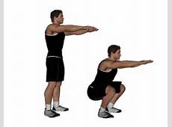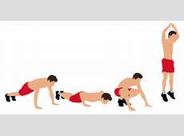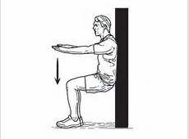

**Football Trivia Quiz**

1. Can you name the top 10 all-time premier league goal scorers?
2. As of November 2016, the bet365 Stadium is the official home of which Premier League club?
3. Which Liverpool player was top goal scorer in the 2013-2014 premier league season.
4. Wayne Rooney scored a hat trick on his Manchester United debut against which club? a) Fenerbahce b) Galatasaray c) Besiktas
5. Who is Chelsea’s all-time leading premier league goal scorer with 145 goals?
6. From 1993-2013, How many times did Sir Alex Ferguson win the premier league manager of the year award?
7. Who wore the Number 9 shirt for Manchester United from 2008-2012?
8. Who is the all-time top premier league appearances holder for Liverpool with 501 appearances?
9. Who Scored Englands goals in their 2-1 win over Wales at the Euro’s in June 2016?
10. Who did Everton Buy for £24,000,000 from Manchester united in the January transfer window?
11. West ham Utd signed Robert Snodgrass in the January transfer window, but from which club?
12. Which Country does Chelsea goalkeeper Asmir Begovic represent?
13. What is the Nickname of the football club Juventus?
14. Which player took over the Number 14 shirt famously wore by Thierry Henry for Arsenal?
15. Can you name the five Belgian players who at some point have won the premier league player of the month award?

**Football Quiz Answers**

1. Alan Shearer, Wayne Rooney, Andrew Cole, Thierry Henry, Frank Lampard, Robbie Fowler, Jermaine Defoe, Michael Owen, Les Ferdinand, Teddy Sheringham.
2. Stoke City
3. Luis Suarez
4. Fenerbache
5. Frank Lampard
6. 11
7. Dimitar Berbatov
8. Jamie Carragher
9. Jamie Vardy, Daniel Sturridge
10. Morgan Schneiderlin
11. Hull City
12. Bosnia and Herzegovina
13. The Old Lady
14. Theo Walcott
15. Marouane Fellani, Jan Vertonghen, Christian Benteke, Eden Hazard, Romelu Lukaku

|  |
| --- |
| Find and circle all of the 1990's songs that are hidden in the grid. The remaining letters spell an additional song. |
| spacer |
| word search puzzle |
| spacer |
| |  |  |  |  |  |  |  | | --- | --- | --- | --- | --- | --- | --- | | ADIA ALRIGHT ANGEL ANYTHING ANYWHERE BIG POPPA BLACK CAT CRAZY CREEP DEAR MAMA DECEMBER DISAPPEAR | spacer | DISARM EVERLONG EVERYTHING FINALLY FOOLISH GAMES HERO I KNOW I SWEAR INFORMER JUMP AROUND JUMPER LAST KISS | spacer | LATELY LOUNGIN MASTERPIECE MISSING MR. JONES NO DIGGITY NO RAIN NOBODY KNOWS NOT TONIGHT RUN-AROUND RUNAWAY TRAIN SAVE TONIGHT | spacer | SAY IT SLIDE SUKIYAKI TELL ME TIME TOO CLOSE TWO PRINCES UNBELIEVABLE WANNABE WHO DAT WITHOUT YOU YOU'LL SEE | |

**Colour Quiz**

**All answers have a colour in them**

1. What ball is worth three points in snooker?
2. Name Francis Drake's ship, in which he circumnavigated the globe, 1577-80?
3. What skin and eye colouring is associated with jaundice?
4. What is Mick Hucknell's band?
5. Ireland is known as The 'what' Isle?
6. What term refers to a plan or template? (from the 1800s design-print process which used blue lines on a white background, or vice-versa)
7. Name the renowned shirt maker in Jermyn Street, London?
8. What was mined extensively in Cyprus in Roman times, which took its name from the country?
9. Name Jepser Christiensen's character in the James Bond films Casino Royale and Quantum of Solace?
10. Hyacinthoides is the scientific name for what protected (in the UK) spring flowering plant?
11. The equal combination of green and blue light, and the C in CMYK color printing, are what?
12. If this were a cryptic crossword clue it could be 'Poetic Irish county'?
13. What is the common name of the Bubonic Plague in the Middle Ages?
14. What is a tone of photography which results from or gives the effect of age?
15. What sea has the port city Arkhangelsk (Archangel in English) and Onega Bay? (an inlet of the Barents Sea, north west Russia, close to Finland)
16. What is the longest river in South Africa?
17. What comes from the seed of the tropical Theobroma cacao tree?
18. What semi-precious stone decorated Tutankhamun's burial mask, and is the colour of the American Robin's eggs?
19. Name the London borough and Royal Observatory site which marks international time?
20. Prince Andrew served for twenty-two years with what organization?

**Colour quiz Answers**

1. Green
2. Golden Hind
3. Yellow
4. Simply red
5. Emerald
6. Blueprint
7. Thomas Pink
8. Copper
9. Mr White
10. Bluebell
11. Cyan
12. Limerick
13. The Black Death
14. Sepia
15. White sea
16. Orange River
17. Chocolate
18. Turquoise
19. Greenwich
20. Royal Navy

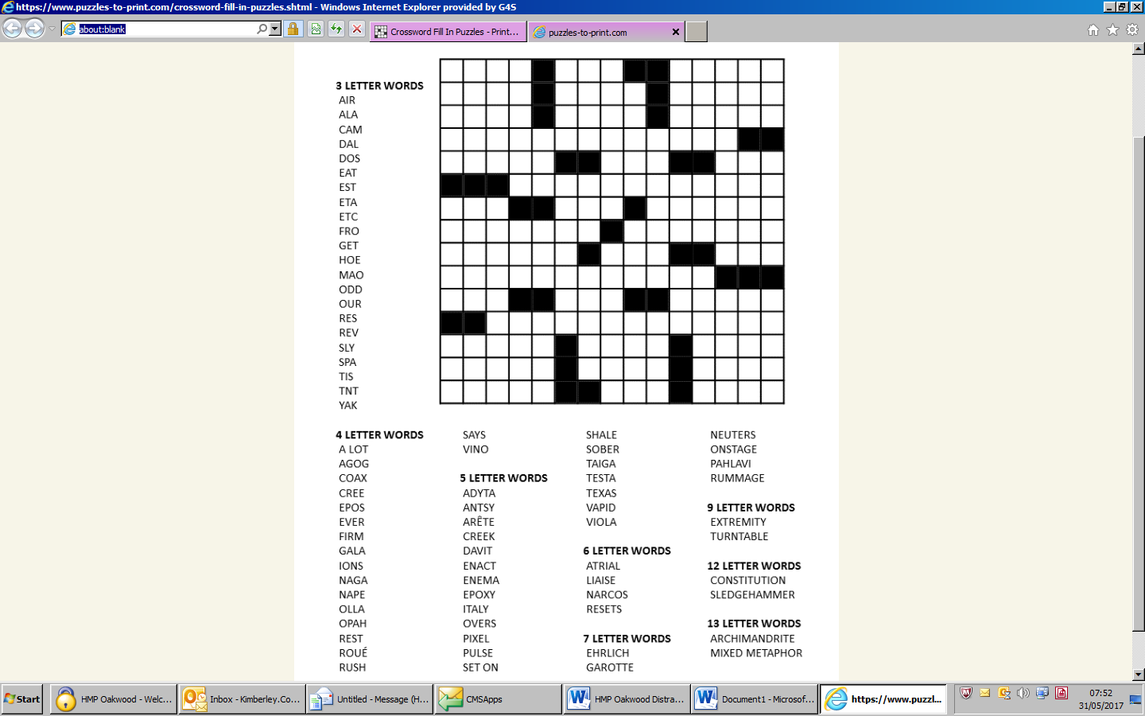

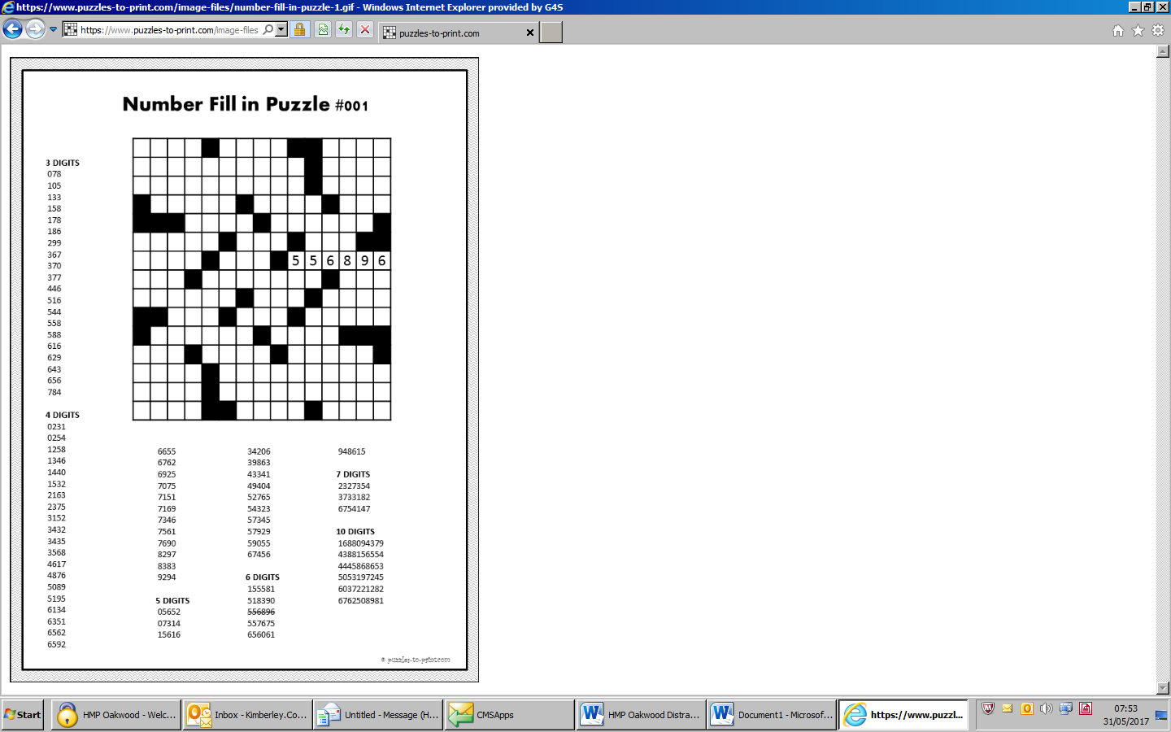

**Sudoku Jigsaw puzzle**

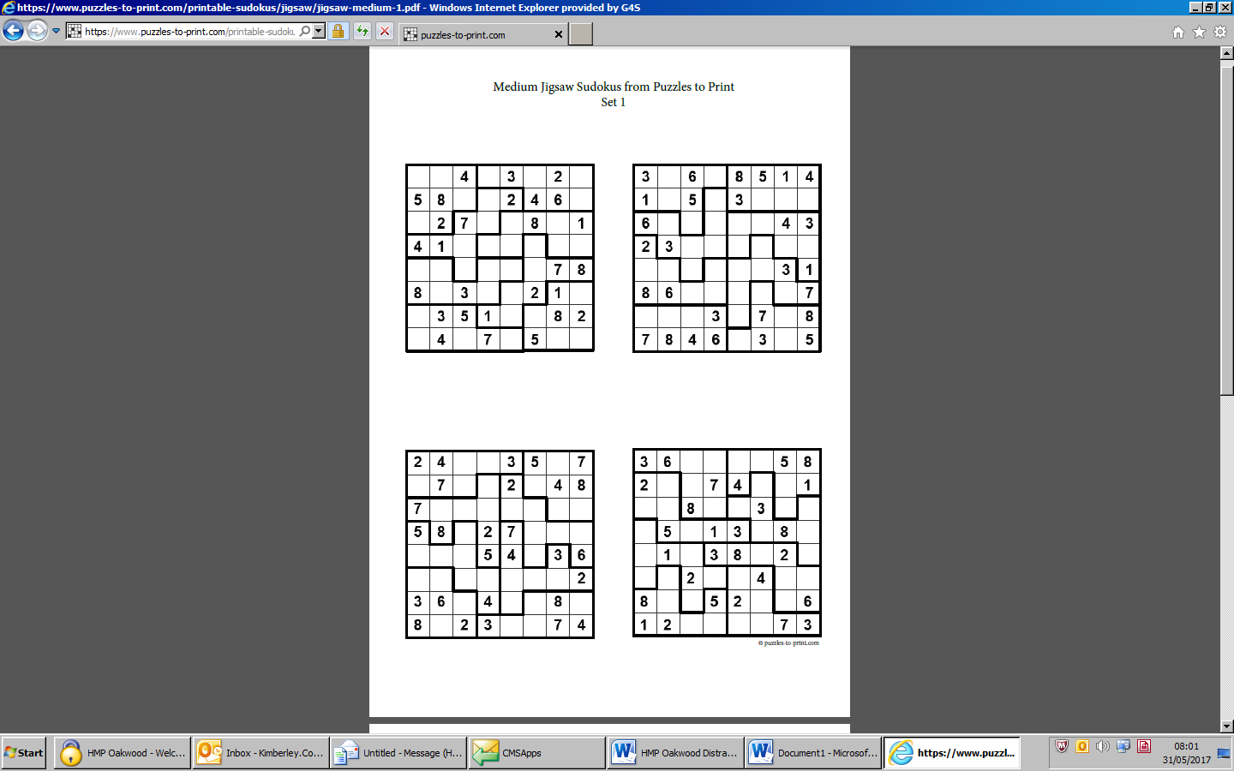

**Brain Teasers**

1. You are a cyclist in a cross country race. Just before the crossing finish line you overtake the person in second place. What place did you finish in?
2. In a year there are 12 months. 7 months have 31 days. How many months have 28 days.
3. A plane crashes on the border of the US and Canada. Where do you bury the survivors?
4. I do not have any special powers, but I can predict the score of any football game before it begins. How do I do this?
5. You are on the bank of a river. You have to get a fox, a hen and corn to the other side of the river. If left alone, the fox will eat the hen, and the hen will eat the corn. The boat is only big enough to take you and one other to the other side. How do you get all 3 across intact?

**Breathing Techniques for Nicotine Withdrawal**

Breathing properly is an absolutely crucial tool in the first days and weeks of smoking cessation.

When you first quit, you tend to take far more shallow breaths, the opposite of what you should be doing in order to stay focused and calm. It is amazing how profoundly and immediately a deep breath will calm one's nerves.

Place your tongue on the roof of your mouth and breathe in through your nose. Keep breathing in until your lower stomach starts to rise. Then, put your lips together as if you are blowing up a balloon. Blow all the air out slowly in a controlled manner until it is all gone.

Breathing out should take almost twice as long as breathing in.

Now for the 'magic'. When you have practiced this breathing technique and understand what to do, you will start to feel a change in your body. It is important that you take notice of this -- the drop of the shoulders, the loosening of the face, and any other feelings you may have.

When you have mastered this, each time you take a deep breath, you can say a word. It can be any word, such as RELAX, CALM, PEACE, QUIET, or anything else that has meaning for you. The word should be repeated over and over again in your mind as you breathe out.

Very shortly, all you will have to do is say the word and your body and mind will instantly return to that calm state. You can do this anywhere and at any time and no one will even know you are doing anything differently.

The control of breathing is important. The faster one breathes, the more oxygen is being taken from the brain and the more anxiety is felt.

Control your breathing and you will release the brains' own 'feel good' chemicals called endorphins. With practice, you will be able to change your mood whenever you want.

In a way, smoking is like a negative deep breathing exercise. You say the word 'cigarette' and your body reacts by becoming tense and anxious. You light a cigarette, and by taking that first deep breath, you are doing exactly the same as taking a deep breath without a cigarette, though as a smoker, you attribute the change in feeling to the cigarette itself, which actually hasn't done anything.

This next one tends to take the edge off of whatever stressful or tense day you may be having in life.

Stand up, (or if you can't, then sit up straight with both feet firmly planted on the ground). Lift your arms as high up as you can. Now close your eyes and think of something you love, something or someone that tickles your soul; a child, a puppy, a warm summer day in a wheat field. Now, breathe it in. Breathe in all of that sunlight and warmth and love and preciousness and feel it infuse your entire being and pool at your feet.

How you choose to react to thoughts of smoking can either increase or decrease their power over you. The next time a smoking urge hits, try a little reverse psychology. Instead of tensing up for a struggle, relax and mentally lean into the craving. Let it wash over you while you focus on your breathing. The urge will run its course and pass. Practice makes perfect with this technique. You'll get the hang of it with time and will find it empowering.

**Brain Teaser Answers**

1. Second Place. If you pass the person in second, you take second place, and they become third.
2. They all do.
3. You don't bury the SURVIVORS!
4. I can predict the score BEFORE it begins. Well, the score before any football game is always zero to zero!
5. First take the hen across. Leave the hen. Go back and get the fox. Take the fox to the other side. Leave the fox there, but take the hen with you back to get the corn. Leave the hen and take the corn to the other side. Drop the corn off with the fox, then go back to get the hen. Bring the hen to the other side. All 3 make it fully intact!

**Maze Puzzle**

**Start**

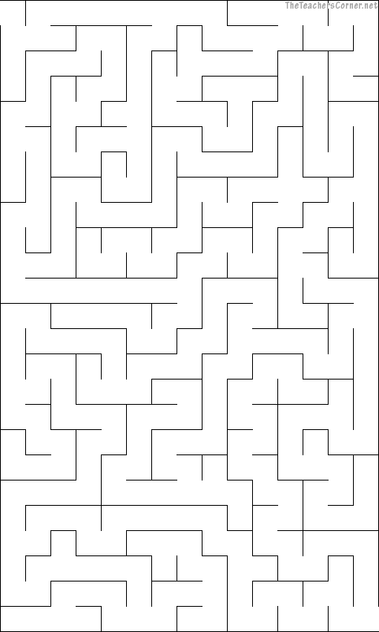

**Finish**

**Maze Puzzle**

**Start**

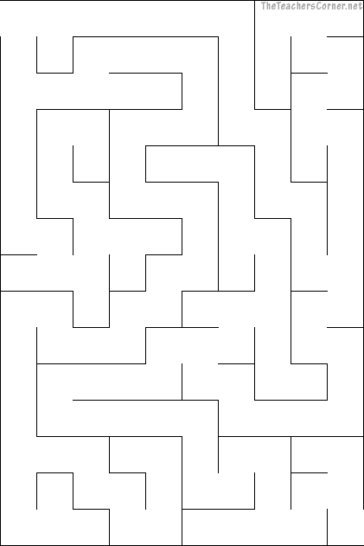

**Finish**